

Thurston Climate Mitigation Collaborative
“Energize Thurston”
2025 Campaign Evaluation Report

Prepared by the Energize Thurston Project Team:

Julia Downing, USDOE Community Energy Fellow
Rebecca Harvey, Climate Mitigation Senior Program Manager, Thurston County
Dominic Jones, Building Decarbonization Program Manager, City of Olympia

January 15th, 2026

Table of Contents
Executive Summary 2
Introduction & Campaign Overview 3
Campaign Goals 5
Campaign Partnerships 5
Campaign Budget 6
Installer Selection Process 7
Incentives, Rebates, & Financing 8
Community Outreach & Education 9
Summary of Campaign Participation & Installations 12
Participant Survey Results 18
Installation Partners’ Feedback 22
Lessons Learned & Suggestions for Improvement 23
Appendices 24
Appendix A – Department of Housing and Urban Development Data for Area Median Income Table 25
Appendix B – City of Tumwater Statistics 25
Appendix C – City of Lacey Statistics 27
Appendix D – City of Olympia Statistics 29
Appendix E – Thurston County Statistics 31
Appendix F – Energize Thurston Contracting Structure 33
Appendix G – 2025 Energize Thurston Final Request for Proposals 34
Appendix H – RFP Scoring Template 68
Appendix I – Energize Thurston 2025 Proposer Interview Questions 69
Appendix J - Outreach Tabling Metrics 72
Appendix K – Workshop Slide Deck 73
Appendix L –Workshop Series Metrics 75

Executive Summary
The Thurston Climate Mitigation Collaborative (TCMC) is a regional partnership among Thurston County and the cities of Lacey, Olympia, and Tumwater to identify and implement actions to reduce locally generated greenhouse gas (GHG) emissions. In 2024, the TCMC prioritized the development of a Residential Energy Efficiency and Electrification Campaign (EEE Campaign) as one of its regional initiatives. Regional initiatives implemented by the TCMC are guided by the Thurston Climate Mitigation Plan (TCMP), which includes 22 strategies across five sectors that aim to meet GHG emission reduction targets in alignment with established community goals.
The EEE Campaign supports implementation efforts of TCMP Strategy B1: Reduce energy use in existing residential buildings. Based on the TCMC’s most recent (2022) GHG emissions inventory, residential energy use accounted for 26% of countywide emissions, the second largest source of emissions after transportation (36%). These data underscore the importance of advancing a regionally coordinated initiative to reduce residential building emissions if we are to meet our goals.
The TCMC’s EEE Campaign, now known as “Energize Thurston,” was a multifaceted outreach and incentive program to advance electrification and energy efficiency in existing residential buildings throughout the Thurston region.
Energize Thurston was built on the foundation of two existing local and regional campaigns:
- The City of Olympia’s Energize Olympia campaign, which has provided discounted and subsidized ductless heat pumps to City residents in 2023-2024.
- The Switch Is On web platform, which provides education about electric home appliances and location-based tools to find incentives and vetted contractors.
The Staff Team completed tasks and deliverables laid out in the Energize Thurston Launch & Implementation Plan to implement the Energize Thurston campaign in Q1 2025, with the goal of providing educational and financial incentives to accelerate the adoption of heat pump space conditioning systems (hereafter “heat pumps”) and heat pump water heaters (“HPWH”) for households throughout Thurston County.
To do so, Energize Thurston provided outreach and education, access to rebates and incentives, and installation services from vetted Installation Partners who offered a pre-negotiated group purchase discount for all participants in the program. The campaign emphasized engagement with underserved and disadvantaged communities, particularly low-to moderate-income households, by offering a limited number of fully and partially subsidized installations. Campaign highlights include:
- 188 contacts with Thurston County residents during in-person outreach events
- 521 residents engaged through the campaign’s educational workshop series
- 227 total heat pump and water heater installations
- 177 fully or partially subsidized heat pump and water heater installations for low- and moderate-income households
- 50 streamlined and discounted heat pump and water heater installations for self-funded households
- 115 households converted to electricity as their energy source for space heating
- 145 households gained access to cooling
- $141,707 saved through rebates and discounts for self-funded participants
- $2,081,322 total spent on fully and partially subsidized installations for low-and moderate-income households
- 2,579 MTCO2e total estimated greenhouse gas emissions avoided through 2025 campaign
This evaluation report provides an overview of the campaign structure, established goals, and partnerships; and a summary of campaign outcomes. It also documents lessons learned and suggestions for improvement, based on participant and partner feedback, for future iterations of Energize Thurston.

Introduction & Campaign Overview
Energize Thurston 2025 was a heat pump group purchase campaign offered by Thurston County and the cities of Lacey, Olympia, Tumwater, and Tenino (Partner Jurisdictions) in partnership with South Puget Sound Habitat for Humanity (SPSHFH). The campaign consisted of five primary activities:
- Recruiting, vetting, and selecting four qualified Installation Partners (“installers”).
- Negotiating a “group purchase” discount for all equipment and installations.
- Conducting community outreach and hosting educational workshops.
- Providing customer support and guidance.
- Installing heat pumps and HPWH for Thurston County residents.
The 2025 Energize Thurston campaign offered two pathways: self-funded and Low- and Moderate Income (LMI).
The first pathway, the Self-Funded (aka “Market Rate”) Pathway, was available to any Thurston County households and offered a group purchase discount of at least 10% and all applicable rebates as time-of-sale discounts. Self-funded participants also received education on heat pump technology, a free site assessment, streamlined installations, customer support, and guidance on incentives and financing. The Energize Thurston project team administered the Self-Funded Pathway and provided case management and installer oversight for all participants.
The LMI Pathway (aka Subsidized Pathway), administered by SPHFH, provided subsidized equipment and installation services to income-qualified participants. Energize Thurston subsidized the cost of the equipment and installation services for LMI participants at two different levels, based on household income qualification:
- Full Cost Coverage for Low-Income Households: Households under 80% AMI were eligible for 100% cost coverage of equipment and installation services. To prioritize energy equity, 60% of the available campaign funding was reserved for this pool of applicants on a first-come, first-served basis.
- Partial Cost Coverage for Moderate-Income Households: Households with an annual income of at least 80% AMI but less than 120% AMI were eligible for partial cost coverage of equipment and installation services. Moderate-income households contributed 20% of the total equipment and installation costs, up to a maximum of $2,500 per household.
All participants progressed through the campaign as follows:
- Registered and attended an educational workshop (either in-person or virtual).
- Submitted a general campaign application that included the following information:
  - General participant information (name, email, site address, etc.);
  - Whether they were applying for the LMI Pathway or the Self-Funded Pathway; and
  - If they were requesting a site assessment for a heat pump, HPWH, or both.
- Campaign staff verified site eligibility and homeowner status of all participants. LMI Pathway applicant income verification was completed by SPSHFH.
- Campaign staff and SPSHFH provided participants with a status update and assigned them to an Installation Partner; or placed them on the waitlist for the LMI Pathway if grant funds had been exhausted.
  - Subsidized LMI Pathway:
    - The installer then worked with both SPSHFH and the participant to schedule a site assessment, assess the energy load of the home, recommend the appropriate equipment based on the participant’s needs, and provide a quote. If the participant chose to move forward, the installer contracted with SPSHFH to complete the installation.
    - Moderate-income households (80-120% AMI) paid their household cost share directly to their Installation Partner.
  - Self-Funded Pathway:
    - The installer then contacted the participant directly to schedule a site assessment, assess the energy load of the home, recommend the appropriate equipment based on the participant’s needs, and provide a quote. Self-funded participants had the option to receive multiple site assessments from the different Installation Partners. If the participant chose to move forward, the installer contracted directly with the participant to complete the installation.
    - Campaign staff supported self-funded participants by offering customer support throughout the installation process.
- The Installation Partners provided all available rebates and incentives at the time of sale, including the pre-negotiated Energize Thurston campaign pricing.

Campaign Goals
The campaign partners established the following outcome goals based on prior outputs of Energize Olympia and considering the expected grant funding and geographic scale of Energize Thurston.
      - Engage at least 600 residents via community workshops, online and in-person. (521 achieved)
- Complete a total of 70-95 subsidized heat pump installations (combination of ducted and ductless) for LMI participants. (128 achieved)
- Complete a total of 60-70 subsidized HPWH installations for LMI participants. (48 achieved)
- Enable approximately 150 total discounted and streamlined equipment installations for self-funded participants. (50 achieved)

Campaign Partnerships
Partner Jurisdictions: The TCMC is an ongoing partnership among Thurston County and the cities of Lacey, Olympia, and Tumwater to identify and implement regional climate mitigation initiatives including this 2025 Energize Thurston campaign. These jurisdictions along with the city of Tenino each received funding from the State Home Electrification and Appliance Rebates (HEAR) program to support the campaign. The partner jurisdictions entered into an interlocal agreement for joint implementation of Energize Thurston.
Lead Jurisdiction: As Lead Jurisdiction, Thurston County held contracts with the selected Installation Partners. Staff from the Lead Jurisdiction led the campaign’s execution and administration with support from TCMC Staff Team members. Thurston County also secured a fully funded U.S. Department of Energy Community Energy Fellow to augment staff capacity and support campaign implementation.
LMI Pathway Administrator: Each of the Parties directly contracted with SPSHFH to administer the LMI Pathway. SPSHFH was chosen because they were an integral partner in the design and implementation of Energize Olympia (2023 and 2024). As the LMI Pathway Administrator, SPSHFH was responsible for verifying participant income eligibility, coordinating installer site assessments and installations, reviewing completion of work with LMI participants as well as providing installer oversight. Additionally, SPSHFH supported campaign promotion, administration of grant funding for subsidized installations, participant recruitment, marketing, and outreach efforts.
Alpine Ductless, LLC (Alpine): Alpine Ductless was chosen as one of the campaign Installation Partners through a competitive Request for Proposals (RFP) process. Alpine staff provided information at the educational workshops, conducted free site assessments, offered streamlined access to incentives and rebates, and executed heat pump space conditioning installations for the campaign.
AirGanic, LLC (AirGanic): AirGanic was chosen as one of the campaign Installation Partners through a competitive RFP process. AirGanic staff provided information at the educational workshops, conducted free site assessments, offered streamlined access to incentives and rebates, and executed heat pump space conditioning installations for the campaign.
Resicon, LLC (Resicon): Resicon was chosen as one of the campaign Installation Partners through a competitive RFP process. Resicon staff provided information at the educational workshops, conducted free site assessments, offered streamlined access to incentives and rebates, and executed heat pump space conditioning and heat pump water heater installations for the campaign.
Sunset Air, Inc (Sunset): Sunset Air was chosen as one of the campaign Installation Partners through a competitive RFP process. Sunset staff provided information at the educational workshops, conducted free site assessments, offered streamlined access to incentives and rebates, and executed heat pump space conditioning and heat pump water heater installations for the campaign.
Puget Sound Energy (PSE): PSE is the local electric and natural gas utility and provided rebates for energy efficiency retrofits including heat pump and heat pump water heater installations. This included increased rebate amounts for households up to 120% AMI through the Efficiency Boost Rebate Program. This incentive helped reduce the cost of installations and allowed Energize Thurston to provide subsidized installations to a greater number of households. Note: While the TCMC coordinated with PSE on the design and implementation of Energize Thurston, PSE was not an official campaign partner.

Campaign Budget
Funding Sources: Total campaign funding was $2,539,269. Thurston County and the cities of Olympia, Lacey, Tumwater and Tenino were each awarded funds through the HEAR Program totaling $1,946,543. The jurisdictions utilized these funds to subsidize installations of eligible equipment for LMI households. The HEAR program allowed up to 15% of the grant funding to be used for administrative costs. This portion of the funding helped cover the cost of administering the Energize Thurston LMI Pathway.

The City of Olympia was awarded a formula grant of $122,030 through the U.S. Department of Energy’s Energy Efficiency and Conservation Block Grant (EECBG) program. This grant funding was used to subsidize installations of HPWHs for qualifying LMI households.

In addition to the grants provided by the jurisdictions, campaign partner SPSHFH was able to leverage $360,000 of their own grant funding from the WA State Department of Commerce HEAR Program to supplement the quantity of heat pump and HPWH retrofits provided to LMI households.

Table 1 summarizes the campaign partners’ funding sources that directly supported the Energize Thurston campaign.

Table 1: Subsidized Installation Budget for Energize Thurston 2025
Partner | Total Funds | HEAR Grants |  |  | EECBG | Internal funds
Partner | Total Funds | Total HEAR Grants | Administration Costs (12%) | Heat Pump Subsidies
Thurston County | $472,263 | $472,263 | $56,671 | $415,592
Olympia | $703,513 | $481,483 | $57,778 | $423,705 | $122,030 | $100,000
Lacey | $420,248 | $420,248 | $50,430 | $369,818
Tumwater | $488,236 | $477,540 | $57,305 | $420,235 |  | $10,696
Tenino | $95,009 | $95,009 | $11,401 | $83,608
SPSHFH | $360,000 | $360,000 | $43,200 | $316,800
Total | $2,539,269 | $2,306,543 | $276,785 | $2,029,758 | $122,030 | $110,696

In addition to the funds detailed in Table 1, the four TCMC jurisdictions each contributed equal shares to cover $8,338.93 in marketing costs.

Installer Selection Process
Energize Thurston 2025 followed the “installer model” used by Energize Olympia, in which campaign Installation Partners were selected by evaluating price and qualifications through a competitive bidding process.
The Lead Jurisdiction (Thurston County) issued a Request for Proposals (RFP) to select qualified contractors to provide installation of ducted and ductless heat pumps, HPWHs, and associated electrical work. The project team then circulated the RFP to local installers and through various contractor networking lists including PSE Trade Allies, Olympia Master Builders, The Switch Is On, the Office of Minority & Women Business Enterprises, Daikin Pro, Ferguson and Gensco contractor networks.
Thurston County hosted a pre-proposal webinar for interested installers to learn about the program and ask questions prior to the application deadline. The webinar was recorded and posted on the County’s webpage. Questions from proposers were gathered prior to the application deadline and answered in a Q&A addendum to the RFP.
Thurston County received nine complete proposals in response to the RFP that were reviewed and scored by the installer selection committee using a rubric that evaluated factors such as qualifications and experience, approach to scope, community benefits, references, and pricing and financing options (Appendix H). The committee then selected six firms to interview.
The RFP process resulted in the selection committee choosing four Installation Partners to provide all installations through Energize Thurston: Alpine Ductless LLC, AirGanic LLC, Resicon LLC, and Sunset Air Inc. Thurston County executed contracts with the four Installation Partners.
Installation Partners provided a fixed price schedule which included a group purchase discount on all equipment and service offerings and applied all applicable rebates as a time-of-sale discount to participants.

Incentives, Rebates, & Financing
Incentives: Participants with a household income below 120% AMI were eligible for either 100% or 80% cost coverage of equipment and installation services. Sixty percent (60%) of the available campaign funding for subsidized installations was reserved for households below 80% AMI. Due to early demand from low-income households, 80% of campaign funds were expended on households below 80% AMI.
All installations were discounted by a pre-negotiated group purchase discount agreed upon by the Installation Partners after the selection process. The project team aimed to negotiate a discount of at least 10% off on average of each Installation Partner’s equipment offerings.
- Alpine Ductless, LLC offered a group purchase discount of 22% - 23% off their equipment and installation services, which resulted in an average discount of $2,597 for Energize participants.
- AirGanic, LLC offered a group purchase discount of 5% - 36% off their equipment prices, which resulted in an average discount of $1,090 for Energize participants.
- Resicon, LLC offered a group purchase discount of $1,400 off their heat pump space conditioning systems and $675 off all water heater installations for Energize participants.
- Sunset Air, Inc. offered a group purchase discount of 10% up to $1,200 off their heat pump space conditioning systems and a 10% discount off heat pump water heater systems. This resulted in an average of $1,149 off heat pump installations and an average of $561 off water heater installations for Energize participants.
Campaign participants were also provided information on federal incentives through the Inflation Reduction Act (IRA). Each self-funded participant is eligible for a 30% tax credit up to $2,000 on their heat pump or HPWH purchase installed by December 31st, 2025. In total, self-funded participants could leverage an additional $87,359 off in total savings, or $1,899 off in average potential savings through the IRA tax credits. Participants in the subsidized pathway were not eligible for the IRA tax credits.
Rebates: Campaign participants were eligible for rebates from PSE, many of which are dependent on type of home and the existing heating and cooling system. Installation Partners automatically applied any applicable rebates as a time-of-sale discount on their quote. Participants under 120% AMI were also eligible for greater discounts through PSE’s “Efficiency Boost” rebate rates. PSE extended the Efficiency Boost income threshold to 120% AMI (from its typical level of 90% AMI) for Energize participants.
Rebates and incentives included PSE’s midstream rebate ($400 - $650), PSE’s HPWH rebate ($750 - $850), and other PSE rebates ($1,500 off for electric resistance to heat pump and $2,400 off for mobile homes).
Participants were also eligible for various Distributor & Manufacturer rebates depending on the model and type of system being installed.
See section Summary of Campaign Participation & Installations for a breakdown of the total and average savings leveraged by participants in each program pathway.
Financing: All campaign Installation Partners offered various loan options for self-funded participants. Financing partners included Generations Credit Union, GoodLeap, Puget Sound Cooperative Credit Union, Synchrony Bank, and Wells Fargo. Specific terms of each loan and credit program were provided by Installation Partners.

Community Outreach & Education
The Energize Thurston project team conducted outreach throughout Thurston County to generate interest in the campaign and gather signups for the educational workshop series.
The campaign measured community engagement through the number of contacts recorded during tabling events, number of new TCMC newsletter subscribers, and the total number of workshop attendees (goal: 600).

Communications
The Energize Thurston project team developed a marketing and communications plan to guide engagement strategies for community outreach. The City of Olympia contracted with a local designer, Angela Kelly Design, to update and revise marketing materials and graphics for campaign outreach. Over 250 posters and 1,200 connect cards were distributed to Thurston County residents throughout the campaign.
In collaboration with communications staff from each partner jurisdiction, advertisements for Energize Thurston were executed through social media, short video announcements, newsletters, local utility mailers, and two street banners hung in five different locations across the County. Efforts to increase market rate participant engagement later in the campaign included paid advertisement placement in the Olympian and digital advertisements on local news sites: the JOLT and Thurston TALK. A budget was also set aside to do social media advertisements through Meta (Facebook and Instagram), but these posts were flagged and rejected by Meta as they did not comply with their “Ads About Social Issues, Elections or Politics” policy.
Other communication and outreach strategies included efforts to target disadvantaged community members within individual jurisdictions. A direct mailer was sent to Tumwater residents in the City’s “Lifeline Program,” which offers discounted utility rates to low-income seniors and residents with disabilities. To extend outreach to rural communities, staff gave a briefing to the South Thurston Economic Development Initiative where local representatives were able to learn and ask questions about the campaign.
The advertising campaign resulted in 860 workshop registrations and 521 workshop attendees, including the on-demand and Spanish interpreted workshop.

Community Outreach & Engagement
TCMC staff and campaign partners, led by Thurston County’s USDOE Community Energy Fellow, tabled at 12 community events throughout the County resulting in at least 188 connections with residents. The campaign booth included information about the benefits of heat pumps and HPWHs, how to register for a workshop, available rebates and incentives, as well as other resources for whole home electrification. The community event that acquired the most connections was the Thurston Conservation District Native Plant Festival & Sale where 59 contacts were made. This event had an environmental stewardship focus with many contacts interested in home energy efficiency.
Figure 1 shows the distribution of outreach methods workshop registrants indicated when sharing how they learned about the campaign.
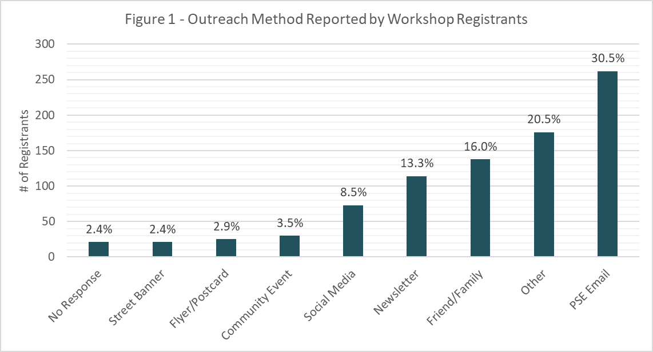

Coordination with Puget Sound Energy
Campaign staff met with representatives from PSE to coordinate Installation Partner recruitment, collaborate on participant outreach, and confirm availability of utility incentives during the 2025 campaign. PSE distributed the RFP for installation services to its Recommended Energy Professional contractor network, provided two email blasts to PSE customers in Thurston County zip codes, and provided Efficiency Boost rebates to all Energize Thurston participants below 120% AMI for the campaign duration.
The PSE email blasts sent midway through the campaign and two weeks before applications closed were highly successful and resulted in a major spike in campaign engagement. In total, the PSE emails brought in 262 workshop registrations, roughly 30% of total workshop registrants.

Workshop Series
Energize Thurston hosted six live educational workshops and one virtual on-demand workshop. Five live workshops were held in person, arranged so each partner jurisdiction could host a workshop. The virtual on-demand workshop was translated and posted with Spanish subtitles. Language translation services were offered in the workshop registration, but no requests were made for this service.
The workshops included information about the two campaign pathways and how to qualify, an explanation of how heat pumps work (ducted, ductless & heat pump water heaters), an overview of energy and cost savings, and information on available rebates and incentives, followed by a Q&A session (Appendix K). A representative from at least two of the four Campaign Installation Partners were present at each workshop to provide technical expertise and answer questions from attendees. Installation Partners also brought demo equipment to in-person events to allow participants to hear and see a heat pump model.
A total of 521 individuals attended the educational workshop series, resulting in 342 unique applications and 440 installation leads. Participants interested in both a heat pump and HPWH submitted one campaign application indicating interest in both equipment, but for lead management purposes, were tracked as two individual installation leads.

Customer Support
The County’s Community Energy Fellow served as the primary point of contact for all program participants for any general program or application questions. SPSHFH provided customer support for LMI Pathway participants, and Installation Partners provided customer support for any installation and technical equipment matters. Customer support included workshop reminders and follow-up emails, a phone line for participants to receive guidance on the program’s application process, and individualized support for participants through the general participant process.
Throughout the duration of the campaign, an estimated 160 phone calls were received through the customer support phone line. Phone calls varied in length from one minute to 25 minutes, with an estimated average time of five minutes in length. Approximately 324 emails were received through the campaign’s general contact email, energize@co.thurston.wa.us.

Summary of Campaign Participation & Installations

Total Installations by Pathway
227 total equipment installations (including both heat pumps and HPWHs) were completed through the 2025 Energize Thurston campaign, including 177 fully or partially subsidized installations and 50 self-funded installations.
Once grant funding was exhausted, the Energize Thurston campaign began accepting applicants to a waitlist for a subsidized installation in a future campaign, depending on when the program receives additional funding. There are 139 participants on the waitlist for a future subsidized installation.

Total Installations by Equipment
The 2025 Energize Thurston campaign offered ducted and ductless heat pumps as well as HPWHs. In the campaign application, participants had the option to request a site assessment for either a heat pump, a water heater, or both. 174 installations were heat pumps and the remaining 53 installations were HPWH.
In addition to income eligibility, specific requirements were issued for participants applying for a subsidized HPWH, including age of existing water heater (10 years or older) and equipment placement in an appropriate location. No HPWH products were available to manufactured homes based on system compatibility, reducing the number of campaign HPWH installations. Fifteen applicants did not meet one of the additional HPWH requirements and were not recommended to move forward with a subsidized installation.
65% of the heat pump space conditioning installations were ducted systems, and 33% were ductless systems, with the remaining installations being hybrid ducted and ductless systems.
Figure 2 shows the breakdown of heat pump equipment installed in each jurisdiction (LMI and Self-Funded participants combined).
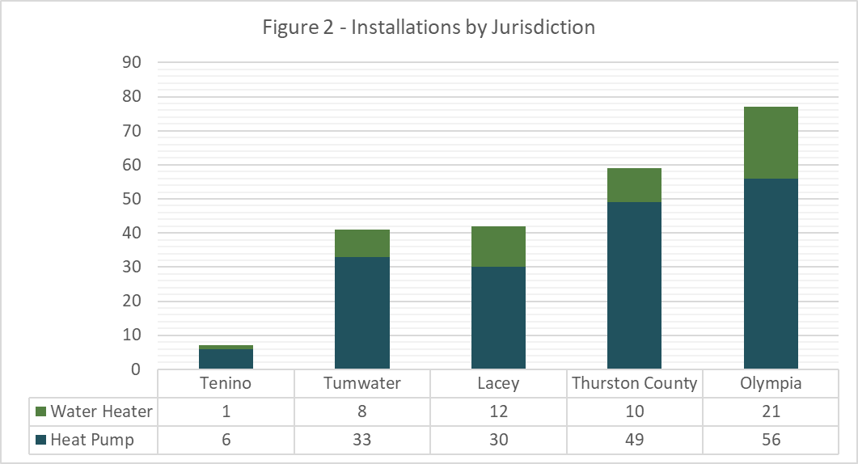

Self-Funded Pathway: Costs & Savings
After applicable rebates, discounts and incentives, self-funded participants invested a total of $572,076 on ductless heat pumps, ducted heat pumps, and heat pump water heaters. The total cost of the 46 self-funded heat pump space conditioning installations, after rebates and discounts are subtracted, was $548,067 for an average of $9,122 per ductless system and $14,648 per ducted system. The total cost of the four self-funded water heater installations (after rebates and discounts) was $24,008 for an average of $6,002 per system.
In total, the campaign’s time-of-sale rebates saved an average of $1,216 per self-funded heat pump installation ($54,750 in total) and $775 per self-funded water heater installation ($3,100 in total) in addition to the group purchase discount on each installation. Table 2 shows the breakdown of the sum and average costs saved by self-funded program participants through the group purchase discount and rebates applied at time-of-sale.
Table 2: Self-Funded Pathway Costs & Savings
 | Group Purchase Discount Sum | Avg. Group Purchase Discount | Rebates Sum. | Avg. Rebates | Total Installation Cost (After rebates & discounts) | Avg. Installation Cost
Heat Pump | $81,433 | $1,809 | $54,750 | $1,216 | $548,067 | $9,122 (Ductless)
 |  |  |  |  |  | $14,648 (Ducted)
Water Heater | $2,424 | $606 | $3,100 | $775 | $24,008 | $6,002
Figure 3 shows the distribution of rebates for self-funded installations.
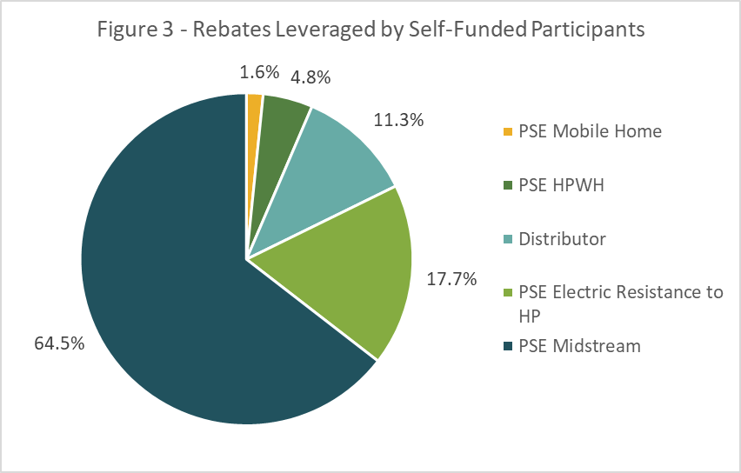
Figure 4 shows the total leveraged incentives for self-funded installations by equipment type.
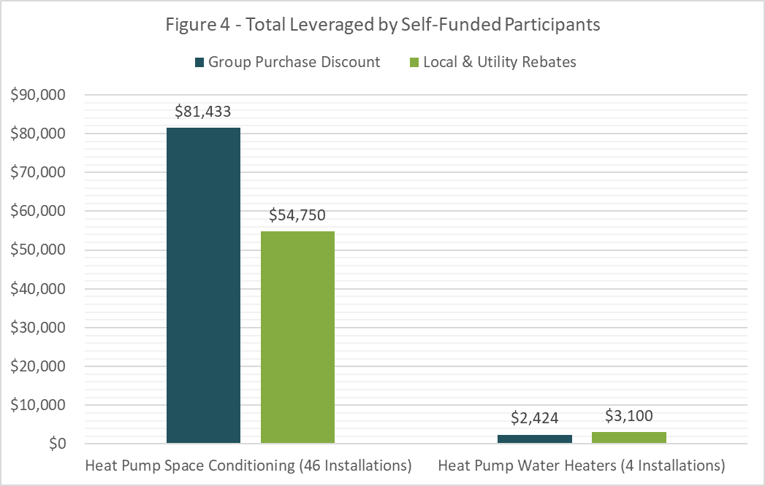

Subsidized Pathway: Costs & Savings
In total, the campaign’s time-of-sale rebates extended grant dollars by $213,320 and group purchase discounts extended grant dollars by $231,724 totaling $445,044 to support subsidized pathway participants. Table 3 summarizes the savings leveraged by subsidized pathway participants through the program-exclusive group purchase discount and time-of-sale rebates.
Table 3: Subsidized Pathway Costs & Savings
 | Group Purchase Discount Sum | Avg. Group Purchase Discount | Rebates Sum | Avg. Rebates | Total Installation Cost (After rebates & discounts) | Avg. Installation Cost
Heat Pump | $202,783 | $1,584 | $173,670 | $1,356 | $1,897,180 | $11,398 (Ductless)
 |  |  |  |  |  | $15,803 (Ducted)
Water Heater | $28,941 | $603 | $39,650 | $826 | $255,091 | $5,314

Figure 5 shows the distribution of rebates for subsidized installations.
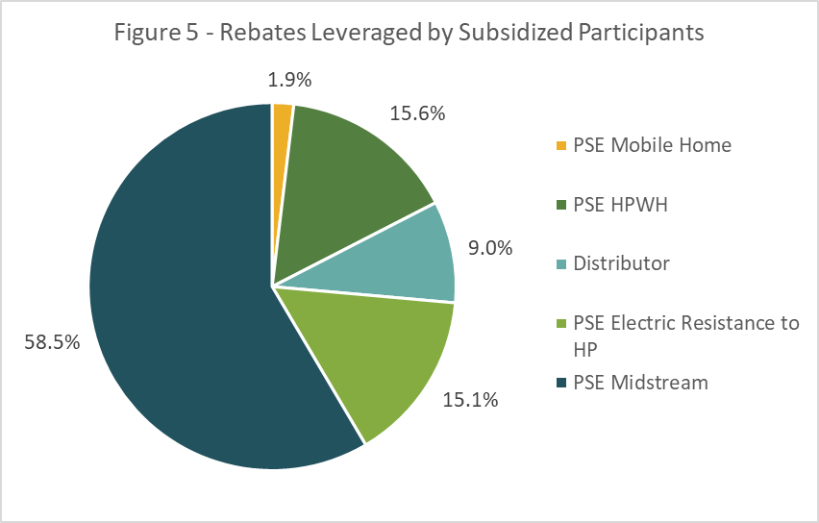

Figure 6 shows the total leveraged incentives for subsidized installations by equipment type.
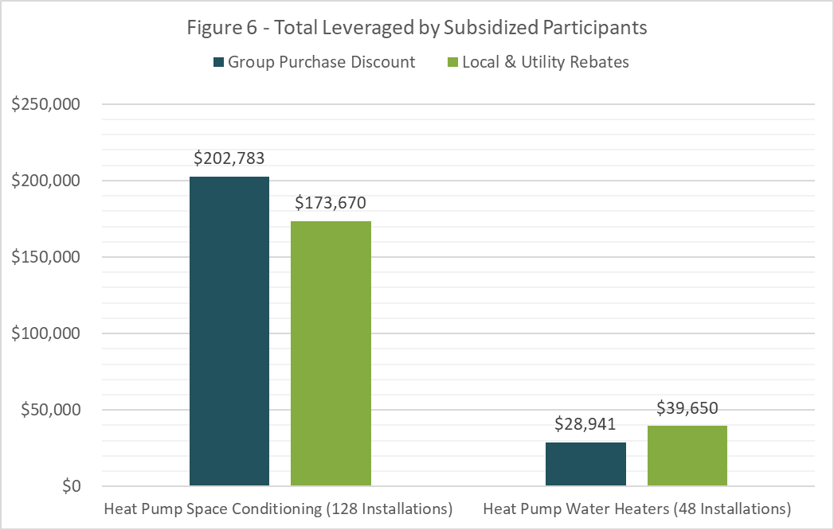

Prior Energy Sources for Heating and Cooling
83% of participants did not have a source of cooling prior to campaign participation. Prior to receiving their heat pump installation, 63% of participants primarily used natural gas as their energy source for heating. Figure 7 shows the distribution of prior heating energy sources for participant households.
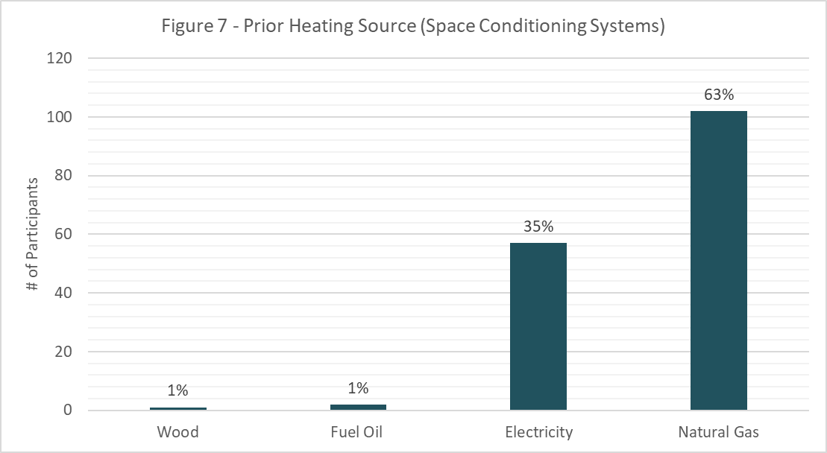

2025 campaign heat pump space conditioning and water heating installation emissions impacts were calculated using data provided by the Rocky Mountain Institute (RMI). Results show end use energy usage based on sub-regional 2015 Energy Information Administration (EIA) Residential Energy Consumption Survey (RECS) data. Data is representative of the Pacific West region and reflects an assumption of appliances in a typical single-family home. Equipment is assumed to be replaced at the end of a 15-year lifecycle. Emissions factors for natural gas, propane, and fuel oil are sourced from the US EIA. Emissions factors for the electricity grid are sourced from the National Renewable Energy Laboratory’s Cambium long-run-marginal-emissions dataset.
Total lifetime greenhouse gas emissions avoided through the 2025 Energize Thurston campaign are estimated to be 2,579 MTCO2e over an assumed 15-year lifecycle of the equipment.

Opted Out Participants
57% of self-funded participants who received a site assessment opted out of moving forward with their heat pump and/or water heater installation. Common reasons provided by participants included high upfront costs, better pricing found through installers outside of the program, and inadequate equipment offered through the fixed price list.

Participant Survey Results
In August 2025, campaign staff distributed a program evaluation survey to all participants who had registered for one of the Energize Thurston educational workshops. The survey prompted responses on the program’s clarity, communication, educational workshop series, and general satisfaction working with Installation Partners and campaign staff. The survey generated a total of 116 responses. 32% of survey respondents indicated their annual household income was less than $50,000, and 40% indicated their annual household income was between $50,000 and $100,000. Remaining participants indicated their income was above $100,000 (20%) or preferred not to answer (8%).
Overall, participants indicated satisfaction with campaign communication, workshops, and resources and provided staff with recommendations for improvements for future campaigns.

Campaign Communication
96% of survey participants who attended a workshop indicated that communication about how the Energize Thurston campaign works was very clear or moderately clear. The remaining 4% of participants indicated communication was moderately unclear or very unclear. Of those participants, a common grievance expressed was frustration over the availability of grant funds in each jurisdiction. Participants suggested the project team offer clearer communication regarding the availability of grant funding, especially later in the campaign.

Educational Workshop Series
97% of campaign evaluation survey respondents felt the information presented at the workshops was very helpful or moderately helpful. The remaining 3% of participants indicated they found the workshops to be moderately unhelpful or very unhelpful.
In general, participants found the workshops to be well organized and were satisfied with the information presented. Many participants liked that there were multiple speakers, including project team members, a SPSHFH representative and the Installation Partners. In-person participants expressed appreciation for the opportunity to hear directly from the Installation Partners and to ask one-on-one questions after the presentation was over. Many survey respondents indicated appreciation for the convenience of the on-demand workshop, which could be watched and referenced from anywhere at anytime throughout the installation process.
Out of the respondents who provided suggestions for improving the workshop series, common responses included using a better audio system for larger workshops to ensure hard-of-hearing participants could listen. Other participants suggested the project team provide hard copy materials at the end of the workshop with information on next steps and a link to the application.

Site Assessments, Installations, and Satisfaction
Out of the survey respondents who attended a workshop, 18% did not proceed with a site assessment. Many of these participants are currently on the waitlist for a subsidized installation or did not qualify for the LMI Pathway.
Of the survey participants who proceeded with a site assessment, 45% worked directly with an Installation Partner through the Self-Funded Pathway and 55% worked with SPSHFH as income-qualified households. Of the LMI Pathway respondents who proceeded with a site assessment, 98% received a heat pump or HPWH installation. The one respondent who did not proceed with an installation was put on the waitlist after grant funds were exhausted in their jurisdiction.
Out of the self-funded survey respondents who proceeded with a site assessment, 75% received a heat pump and/or HPWH installation. The remaining self-funded survey respondents who did not proceed with a heat pump installation were asked to select any and all reasons why they did not move forward. Common reasons included participants receiving a bid that was too expensive (85%), inadequate equipment offered through the program (42%), and better pricing found outside of the program (14%).
Alpine Ductless, LLC: 82% of survey respondents that received a site assessment from Alpine Ductless indicated they were highly satisfied overall working with Alpine, with 9% indicating they were very satisfied overall. Many respondents described the high quality of workmanship provided by Alpine and expressed appreciation for their excellent customer service and salespeople. Of the respondents who indicated they were unsatisfied working with Alpine, the main concerns indicated were pricing and equipment availability.
Participants were also asked to select the strengths of their Installation Partner. 100% of respondents indicated technical expertise as a strength of Alpine with 86% selecting timeliness and communication as strengths. Many participants (73%) agreed customer support was a strength with some (50%) also selecting pricing and equipment offerings as strengths of Alpine.
AirGanic, LLC: 56% of survey respondents who had received a site assessment from AirGanic indicated they were highly satisfied overall working with AirGanic, with 22% indicating they were very satisfied overall. Many respondents mentioned the AirGanic team was professional and efficient during their site assessment and installation. 22% of respondents indicated they were either somewhat unsatisfied or very unsatisfied working with AirGanic and described high pricing and unclear communication as reasons for their dissatisfaction.
When asked to indicate the strengths of AirGanic, the number one response selected by participants was timeliness. Technical expertise was noted by many respondents with some indicating communication as a strength.
Resicon, LLC: 44% of survey respondents that received a site assessment from Resicon indicated they were highly satisfied overall and 50% of respondents indicated they were very satisfied overall. In general, participants mentioned their salespeople were very polite and informative during the site assessment, but communication from Resicon throughout the installation process could be clearer.
Top strengths indicated by participants included technical expertise, equipment offerings, and communication.
Sunset Air, Inc: 79% of survey respondents that received a site assessment from Sunset Air indicated they were highly satisfied overall with Sunset, with 9% indicating they were very satisfied overall. Of the three remaining participants that indicated dissatisfaction, one was placed on the waitlist after funding was exhausted, one participant explained their pricing was too high, and another indicated communication by the salespeople could be better.
The top three strengths of Sunset selected by survey respondents were technical expertise, timeliness, and communication.

Motivation(s) for Participation
In the feedback survey, participants were asked what motivated them to participate in the Energize Thurston campaign. The survey allowed participants to select multiple motivations and offered an option to write in other motivations not pre-listed in the survey. 27% of respondents indicated “energy savings” as a motivating factor, making it the largest motivation indicated by survey respondents. 23% of respondents selected “program exclusive discounts” as a motivation and 21% of participants selected a “reduced carbon footprint.” Other motivations indicated included “vetted installers” (15%), “education on heat pumps” (11%), with the remaining motivations listed under “other” (5%). Other motivations for participation included gaining air conditioning, savings for low-income residents, replacing outdated heating systems, and the health benefits provided by heat pump systems.
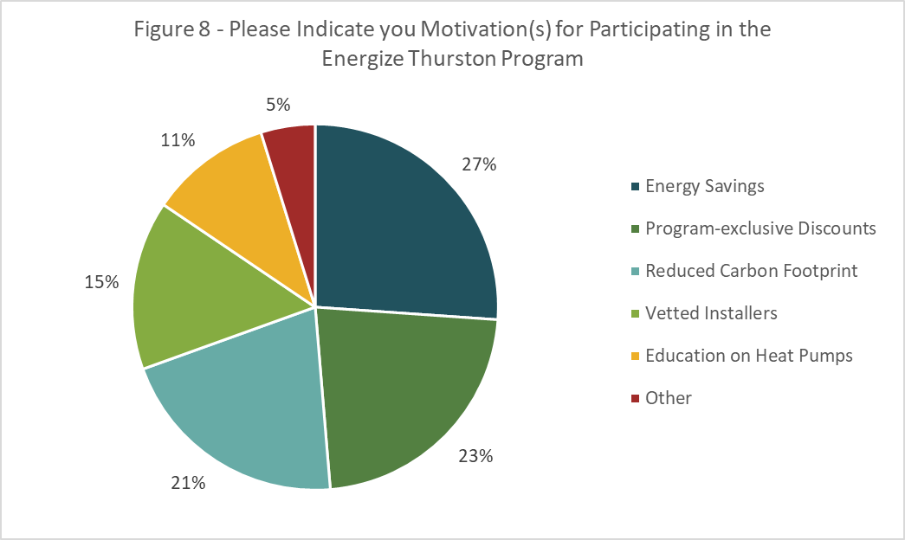

Impact on Quality of Life
Participant survey respondents were asked to share if and how the Energize Thurston program had impacted their quality of life. In general, responses included gratefulness for the cooling aspect of a heat pump space conditioning system, a sense of greater comfort and efficiency with their new system, and an appreciation of the financial discounts for LMI households. The following are a few examples of participant responses:
“We are so grateful to have AC/heat in parts of our mobile home that never were properly cooled and heated before. It’s very comfortable now.” - Subsidized Participant
“Knowing I have up-to-date equipment that I can rely on!” - Subsidized Participant
“We have had a large burden lifted from our shoulders for our heating and cooling future. Thank you from the bottom of our hearts!” - Subsidized Participant
“A much lower power bill. I had Cadet wall heaters which cost me a lot to heat my home. My PSE bill has been in the high to low $50 a month since my Heat Pump was installed and that is great.” - Self-funded Participant
“This is an amazing program and has allowed me the peace of mind to know that my home will be taken care of with sustainable heat and cooling for many years to come. My equipment was old and ready to fail at any time and knowing that I will not have to worry about replacing it is really great. In addition, I do not have to depend on propane or any fossil fuel to maintain my home which makes me feel better about my carbon footprint.” - Subsidized Participant
“It has greatly increased my quality of life, the seamless process made the installation stress free and now we can live comfortably in our home when it is extremely hot in the summer.” - Self-funded Participant

General Campaign Feedback
When asked to provide general suggestions for improving the campaign, common responses included providing clearer communication on when grant dollars had been exhausted, offering a greater variety of heat pump equipment through the program, and providing a clearer explanation of the campaign benefits for self-funded participants.
Survey respondents were asked to indicate any additional energy efficiency upgrades they may be interested in in the future. Selections and results are shown in Figure 9 below.
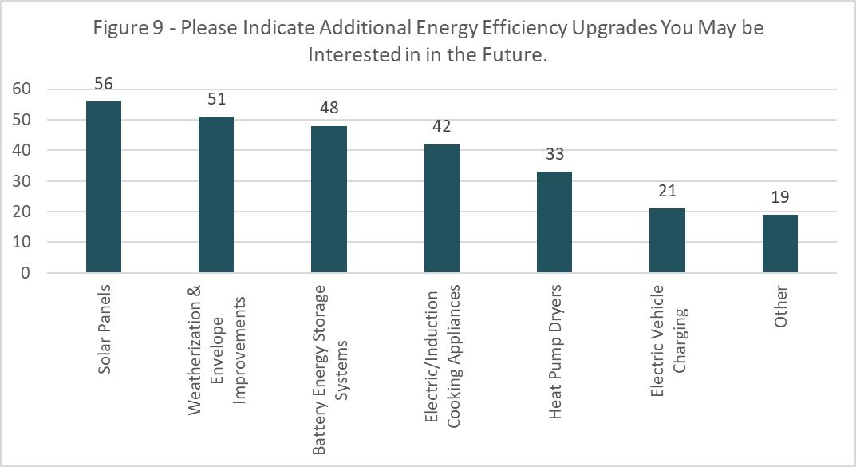

Installation Partners’ Feedback
In August 2025, campaign staff distributed a feedback form to Installation Partners to gather feedback from any employee that supported participants in the Energize Thurston campaign. The survey prompted responses on the RFP process, the workshop series, Monday.com software, and their experience working with program staff. The form received five responses.

RFP & Interview Process
Four of the five respondents participated in the RFP process of Energize Thurston. Two respondents indicated a very positive experience stating the communication from the project team was clear during this process. One respondent indicated a satisfactory experience, and the other indicated a somewhat negative experience with submitting the RFP. A general theme from the Installation Partners was difficulty including a set price list based on system size. One installer stated, “it’s difficult to set a price without ever seeing the home.”

Workshop Series
Four of the five respondents participated in the educational workshop series and provided feedback. All four respondents indicated either a very positive or a somewhat positive experience with the workshops. Suggestions from respondents included greater outreach to increase workshop attendance, clearer messaging on system types and options, and greater clarity on system pricing.

Monday.com Software
Four of the five respondents indicated having a very positive or somewhat positive experience working on the Monday.com software. The remaining respondent did not use Monday.com in their role with the Energize Thurston campaign. Installation Partners stated the software was designed well and easy to keep everything organized. One respondent mentioned it was a little overwhelming to learn at first, but with proper training it was a nice tool to use.

Working with Program Staff
Four of the five respondents worked with program staff and indicated having a very positive experience. One respondent stated the weekly meetings with the project team were very helpful to stay on track and have questions answered in a timely manner.
In general campaign Installation Partners suggested more clarity in communication with regards to participant eligibility and campaign benefits.

Lessons Learned & Suggestions for Improvement
The Energize Thurston campaign staff reflected on their experiences and observations during the 2025 campaign and provided the following feedback. These lessons learned will be considered along with feedback provided by participants and Installation Partners to inform future iterations of Energize Thurston.

General
- Participants were often confused about the differences and benefits of the two program pathways: LMI and Self-Funded. Project staff should provide more clarity on this on public facing materials – website, workshop slide deck, marketing materials, etc.
- The project team should provide more frequent and clearly structured campaign updates to jurisdiction staff not directly involved with the program. Updates should include information on workshop registrations, application and installation progress, and upcoming outreach events.
- The total number of self-funded installations from Energize Thurston 2025 fell short of initial campaign goals. Project staff and partners should develop and target outreach strategies towards self-funded participants, particularly high-income households, to better explain the benefits of the program for non-income qualified households.

Management of Information, Files, and Systems
- Monday.com was a useful tool for managing participant intake and installer oversight. In an effort to prepare Installation Partners for their use and role of Monday.com, the project team created a ‘how-to’ guide with step-by-step information on the process of lead intake and oversight. This was effective, but more training opportunities for Installation Partners on Monday.com could be offered to ensure complete understanding of the software.

Installer Selection, Onboarding, and Reporting
- In 2025, the installer selection and group purchase discount negotiation process as well as the installer oversight process were very time intensive for the project team. The team aimed to provide similarly priced equipment across all systems being offered by the four installation companies but were unable to achieve this in the discount negotiation process in part due to the companies serving different markets and providing different scopes of work. For this reason, the project team should reassess the pros and cons of the Installer Model vs. Distributor Model for contracting with Installation Partners.
- The 2025 RFP selection process resulted in nine complete submissions from contractors, nearly doubling the number received by Energize Olympia in 2024. The project team invested more time and effort into contractor recruitment and hosted the pre-proposal webinar to go over the RFP and answer any questions from interested firms.
- The installer selection committee interviewed at least one representative of each firm selected. In future iterations, the project team should require proposers to bring any additional administrative staff to the interview to assess all staff who would be working with Monday.com.

Communication & Community Outreach/Engagement
- The campaign saw many applicants in the first few weeks after opening applications. Workshop registration and attendance decreased towards the latter half of the campaign. The marketing and outreach budget should be used earlier in the campaign to increase participation from self-funded participants early. In the final two weeks of the campaign, many new self-funded participants referenced the JOLT Advertisements as their first engagement with Energize Thurston.
- Explore greater ways to engage households that do not speak English at home. Continue to offer all marketing and campaign application materials in Spanish and other common languages. Provide non-English speaking residents the opportunity to engage with the campaign without having to request language translation services.

Educational Workshop Series
- Participants appreciated the fact that the Campaign Installation Partners were present at each educational workshop to answer technical questions during Q&A session and unstructured time. The project team should continue to have Campaign Partners present at workshops to allow participants to ask questions directly to technical experts.
- Future iterations of the Energize Thurston Campaign should continue to consider space and audio demands for a large audience. Some participants noted it was hard to hear during the in-person workshops even though a microphone was being used.

Customer Support
- The project team determined that an advisory support services consultant was not necessary to support participants through the campaign. The project team should consider providing an option for participants to sign up for a video consultation call to go through and review participants’ quotes.
- Self-funded participants had the option to receive multiple bids in order to compare quotes from different Installation Partners. The project team provided education and support on quote comparisons via a phone line, email service, and in-person consultation. The project team should continue to offer support with reviewing installer bids and consider developing educational materials to streamline this process for participants.

Appendices

Appendix A – Department of Housing and Urban Development Data for Area Median Income Table
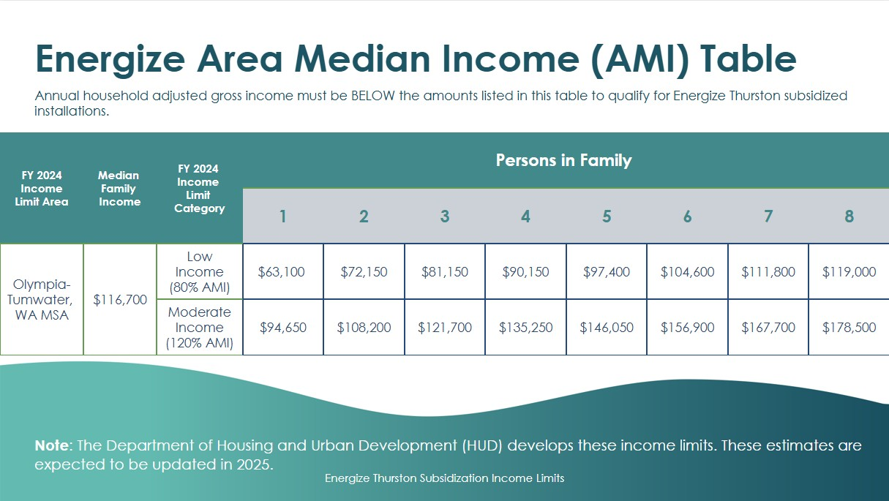

Appendix B – City of Tumwater Statistics
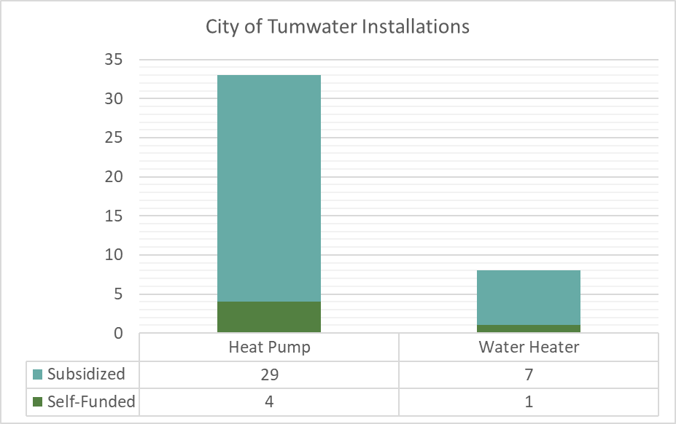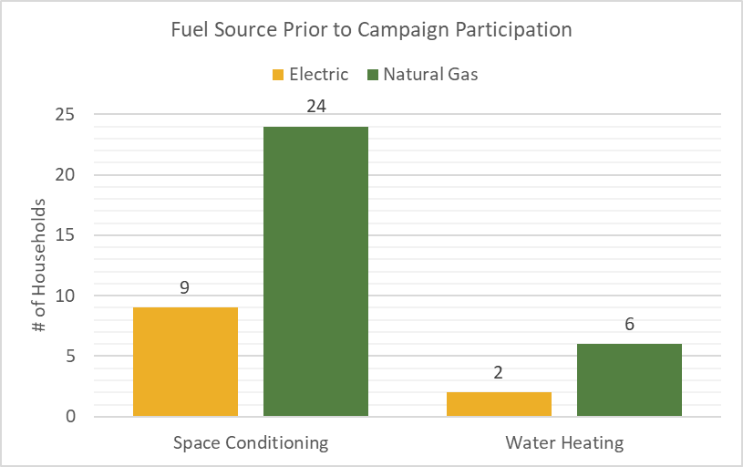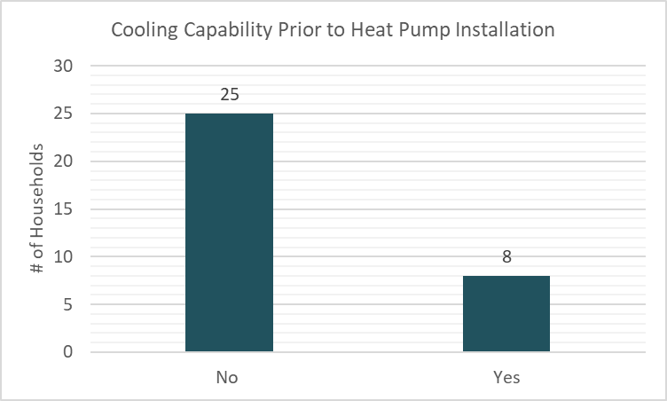
Numbers are from December 2025.
Self-Funded | Group Purchase Discount |  | Time-of-Sale Rebates |  | Total Savings |  | Total Spent
Self-Funded | Sum. | Avg. | Sum. | Avg. | Sum | Avg. | Sum | Avg.
Heat Pump | $8,170 | $2,043 | $4,600 | $1,150 | $12,770 | $3,192 | $42,222 | $10,556
Water Heater | $537 | $537 | $750 | $750 | $1,287 | $1,287 | $6,093 | $6,093

Subsidized | Group Purchase Discount |  | Time-of-Sale Rebates |  | Total Savings |  | Funding Spent
Subsidized | Sum | Avg. | Sum | Avg. | Sum | Avg. | Sum | Avg.
Heat Pump | $51,694 | $1,783 | $34,090 | $1,175 | $85,784 | $2,958 | $412,725 | $14,497
Water Heater | $4,253 | $608 | $5,950 | $850 | $10,203 | $1,458 | $35,226 | $5,032

Estimated lifetime greenhouse gas emissions avoided over assumed 15-year lifecycle: 484.3 MtCO2e. See section Summary of Campaign Participation and Installations for a detailed breakdown of calculation and assumptions.

Appendix C – City of Lacey Statistics
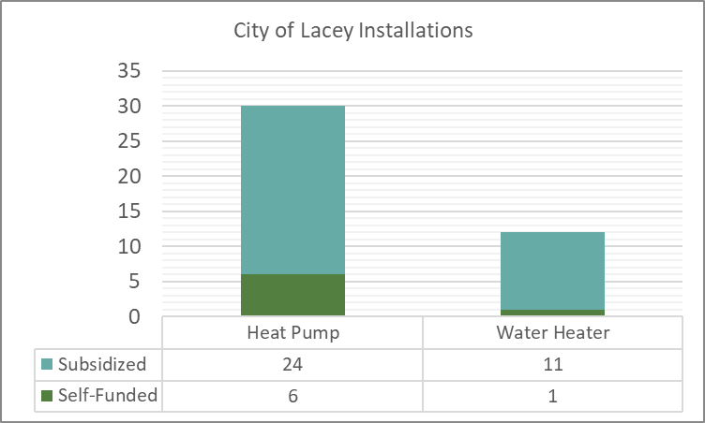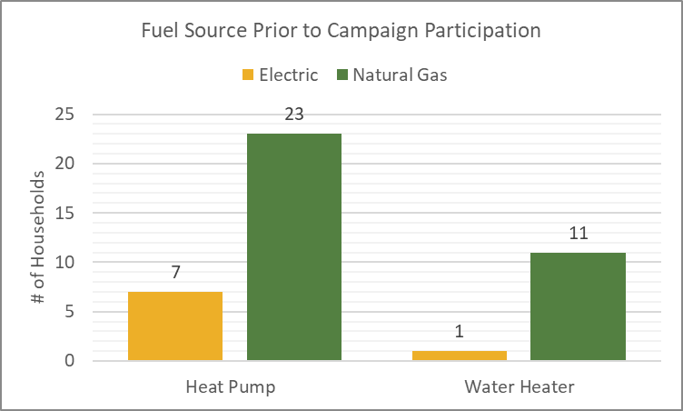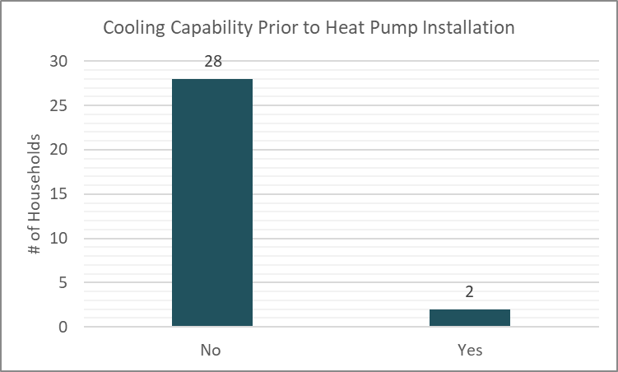Numbers are from December 2025.

Self-Funded | Group Purchase Discount |  | Time-of-Sale Rebates |  | Total Savings |  | Total Spent
Self-Funded | Sum. | Avg. | Sum. | Avg. | Sum | Avg. | Sum | Avg.
Heat Pump | $7,258 | $1,210 | $9,600 | $1,600 | $16,858 | $2,810 | $66,604 | $11,100
Water Heater | $675 | $675 | $750 | $750 | $1,425 | $1,425 | $6,161 | $6,161

Subsidized | Group Purchase Discount |  | Time-of-Sale Rebates |  | Total Savings |  | Funding Spent
Subsidized | Sum | Avg. | Sum | Avg. | Sum | Avg. | Sum | Avg.
Heat Pump | $35,126 | $1,464 | $30,960 | $1,290 | $66,086 | $2,754 | $391,068 | $16,295
Water Heater | $6,817 | $620 | $9,250 | $840 | $16,067 | $1,460 | $56,436 | $5,130

Estimated lifetime greenhouse gas emissions avoided over assumed 15-year lifecycle: 510.9 MtCO2e. See section Summary of Campaign Participation and Installations for a detailed breakdown of calculation and assumptions.

Appendix D – City of Olympia Statistics
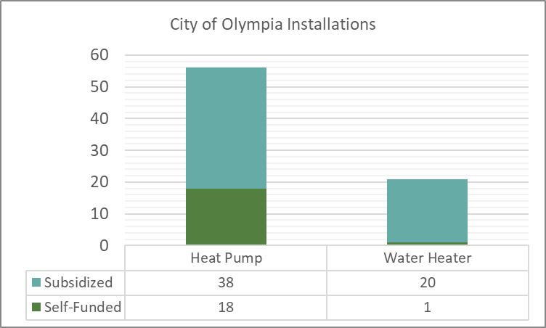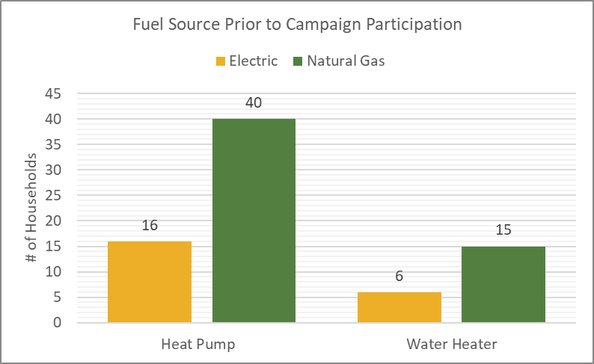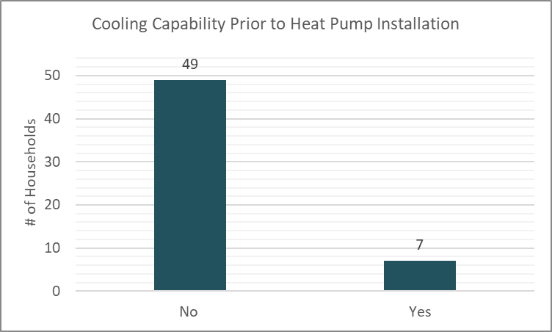
Numbers are from December 2025.
Self-Funded | Group Purchase Discount |  | Time-of-Sale Rebates |  | Total Savings |  | Total Spent
Self-Funded | Sum. | Avg. | Sum. | Avg. | Sum | Avg. | Sum | Avg.
Heat Pump | $27,529 | $1,619 | $16,850 | $991 | $44,379 | $2,610 | $174,451 | $10,262
Water Heater | $675 | $675 | $850 | $850 | $1,525 | $1,525 | $5,408 | $5,408

Subsidized | Group Purchase Discount |  | Time-of-Sale Rebates |  | Total Savings |  | Funding Spent
Subsidized | Sum | Avg. | Sum | Avg. | Sum | Avg. | Sum | Avg.
Heat Pump | $55,788 | $1,468 | $48,260 | $1,270 | $104,048 | $2,738 | $513,781 | $13,520
Water Heater | $12,395 | $590 | $17,650 | $902 | $30,045 | $1,430 | $104,038 | $4,523

Estimated lifetime greenhouse gas emissions avoided over assumed 15-year lifecycle: 885 MtCO2e. See section Summary of Campaign Participation and Installations for a detailed breakdown of calculation and assumptions.

Appendix E – Thurston County Statistics
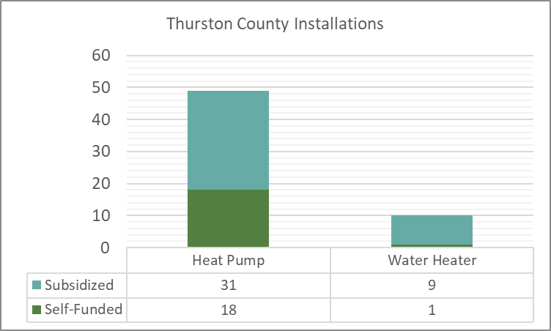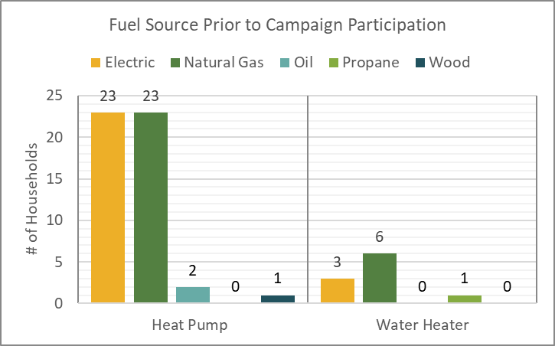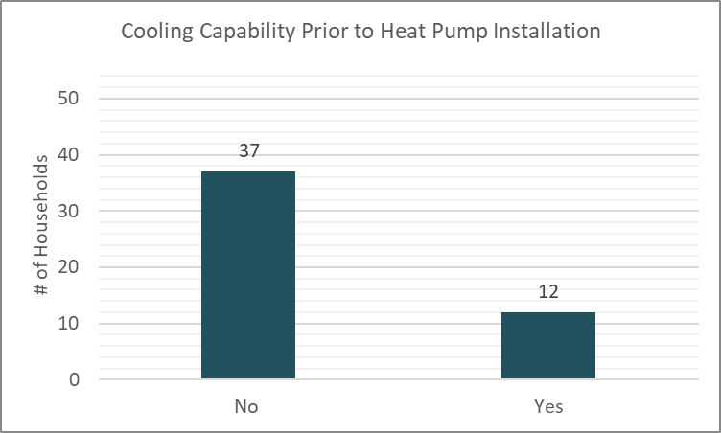Numbers are from December 2025.
Self-Funded | Group Purchase Discount |  | Time-of-Sale Rebates |  | Total Savings |  | Total Spent
Self-Funded | Sum. | Avg. | Sum. | Avg. | Sum | Avg. | Sum | Avg.
Heat Pump | $38,475 | $2,137 | $23,700 | $1,316 | $62,175 | $3,453 | $264,789 | $14,710
Water Heater | $537 | $537 | $750 | $750 | $1,287 | $1,287 | $6,346 | $6,346

Subsidized | Group Purchase Discount |  | Time-of-Sale Rebates |  | Total Savings |  | Funding Spent
Subsidized | Sum | Avg. | Sum | Avg. | Sum | Avg. | Sum | Avg.
Heat Pump | $49,596 | $1,600 | $47,490 | $1,532 | $97,086 | $3,132 | $448,638 | $14,472
Water Heater | $5,614 | $624 | $6,800 | $850 | $12,414 | $1,474 | $45,930 | $5,103

Estimated lifetime greenhouse gas emissions avoided over assumed 15-year lifecycle: 618.4 MtCO2e. See section Summary of Campaign Participation and Installations for a detailed breakdown of calculation and assumptions.

Appendix F – Energize Thurston Contracting Structure
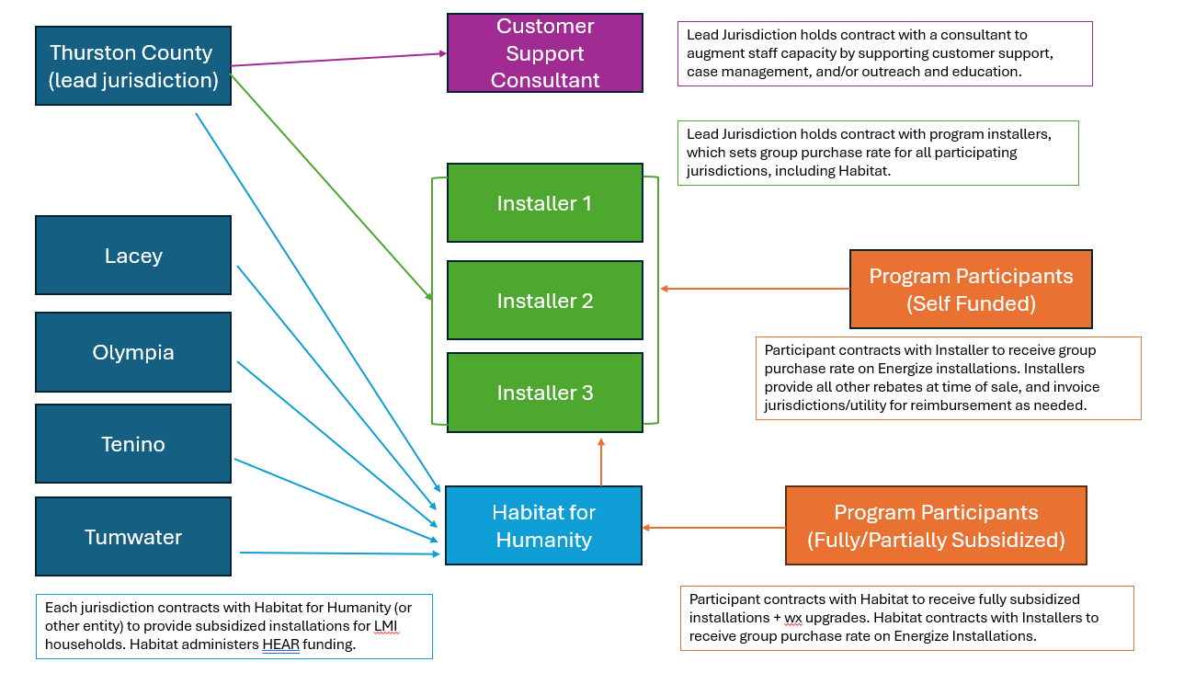

Appendix G – 2025 Energize Thurston Final Request for Proposals

THURSTON COUNTY GOVERNMENT
BOARD OF COUNTY COMMISSIONERS
3000 PACIFIC AVE SE, STE. 200
OLYMPIA WA 98501
REQUEST FOR PROPOSAL (RFP) NO. 24-003-0020
Energize Thurston 2025 Heat Pump and Heat Pump Water Heater Installation Services
RFP Issue Date
December 4, 2024

RFP Documents
This project is a formal competitive procurement and will be advertised in “The Olympian” and is open to all qualified companies. All solicitation documents, including any addenda, are published on the Thurston County website at https://www.thurstoncountywa.gov/tchome/Pages/rfprfq.aspx.

Proposal Due Date

4:00p.m. PST on January 10, 2025

Proposal Acceptance Location

Proposals will be received by:
Office of County Commissioners
3000 Pacific Avenue SE Suite 200
Olympia, Washington 98501
Office Hours: 8am-5pm Monday through Friday

Thurston County reserves the right to reject any and all Proposals, cancel this solicitation, and to waive any informalities or irregularities in procedure.

Table of Contents
SECTION 1 – INTRODUCTION AND PURPOSE …………………………………………………………………3
SECTION 2 – OVERVIEW OF SERVICES REQUESTED ………………………………………………………..3
SECTION 3 – ACQUISITION TIMELINE AND GENERAL REQUIREMENTS ……………………………….5
SECTION 4 – PROPOSAL PREPARATION AND SUBMISSION INSTRUCTIONS ……………………….7
SECTION 5 – EVALUATION AND SELECTION ………………………………………………………………….11
SECTION 6 – CONTRACT TERMS AND CONDITIONS ……………………………………………………….12
SECTION 7 – ATTACHMENTS ………………………………………………………………………………………13
ATTACHMENT 1 – STATEMENT OF WORK …………………………………………………………………..…14
ATTACHMENT 2 – PRICE SCHEDULE TEMPLATE …………………………………………………………….20
ATTACHMENT 3 – PROFESSSIONAL SERVICES SAMPLE CONTRACT ……………………….….…….21
ATTACHMENT 4 – CERTIFICATION ………………………………………………………………………..…….30

SECTION 1 - INTRODUCTION AND PURPOSE
1.1 INTRODUCTION
Energize Thurston 2025 is a heat pump group purchase campaign that makes it faster, easier, and more affordable for Thurston County residents to purchase and install efficient, all-electric heat pumps and heat pump water heaters. Thurston County and the cities of Lacey, Olympia, Tumwater, and Tenino are collaborating to launch this regional campaign to help meet emission reduction goals of the Thurston Climate Mitigation Plan, to reduce household energy costs, and to raise awareness of the climate, health, and economic benefits of building electrification. Energize Thurston is anticipated to run from March to June, 2025.

  - PURPOSE
Thurston County, Board of County Commissioners (COUNTY), is initiating this Request for Proposals (RFP) to establish a roster of qualified heating, ventilation and air conditioning (HVAC) and plumbing contractors to provide installation of heat pump space conditioners and/or heat pump water heaters (HPWHs) for the Energize Thurston campaign. Interested firms may propose to install heat pump space conditioners, HPWH, or both technologies; and are invited to submit proposals individually or to collaborate with other installers to submit a joint proposal. Thurston County will administer the Qualified Installer Roster for the Energize Thurston campaign, and will execute a Professional Services Contract with each selected Installer consistent with the terms of this RFP.

  - MINIMUM QUALIFICATIONS
Contractor shall have the following minimum qualifications to be eligible for an award:
- Contractors must have an HVAC contractor license, and/or plumbing license, in good standing with the State of Washington.
- Space Heat contractors must be a Mitsubishi Diamond Dealer, Daikin Pro Dealer or equivalent.
- Contractors must be a Puget Sound Energy Trade Ally or PSE Recommended Energy Professional.
- To provide services for subsidized installations, contractors must be willing and able to provide prevailing wage quotes and file intent to pay prevailing wage with Washington State Labor and Industries for each subsidized installation they do under this campaign.
- Contractors must not have a federal exclusion.
- Contractors must have expertise in evaluating building performance conditions to properly size heat pump space conditioning and/or heat pump water heater systems.
- Contractors must be able to provide marketing and advertising for Energize Thurston through their existing marketing channels.
An additional qualification that is preferred, but not required:
- Ability to provide Spanish language spoken and written support for workshops and customer service.

SECTION 2 - OVERVIEW OF SERVICES REQUESTED
2.1 PROJECT DESCRIPTION
The purpose of this project is to enable the installation of heat pumps and heat pump water heaters for residences in Thurston County, Washington at a lower total installation cost than that typically offered by the installer. Energize Thurston reduces upfront costs through a group purchase discount provided by the installer, and application of all available rebates as a time-of-sale discount. The campaign also offers fully and partially subsidized installations for low- and moderate-income (LMI) households, which will be administered by campaign partner South Puget Sound Habitat for Humanity (SPSHFH). This RFP will result in selection of a Qualified Installer Roster to provide the installation of residential ductless heat pumps, ducted heat pumps, heat pump water heaters (HPWH), and associated electric panel upgrades, for residents of Thurston County and the cities of Lacey, Olympia, Tumwater, and Tenino, in accordance with the scope of services outlined in Attachment 1.
2.2 BACKGROUND INFORMATION. See Attachment 1 – Statement of Work
2.3 STATEMENT OF WORK. See Attachment 1 – Statement of Work

2.4 CONTRACT PERIOD AND BUDGET
The County anticipates the Contract will be for a maximum duration of twelve (12) months, beginning approximately on January 1, 2025, through December 31, 2025. Contract extension options will be exercised at the sole discretion of the County.

During the campaign period (approximately March – June 2025), the County and partners are allocating grant funds totaling at least $1.7 million to subsidize installations of heat pumps and HPWHs for LMI households. Based on the available grant funding and the geographic scale of Energize Thurston, the project team’s preliminary goals for the campaign are as follows:
- Complete approximately 120-140 total HPWH installations.
- Complete approximately 140-230 total heat pump installations (combination of ducted and ductless).

We expect the above totals to be about equally divided between subsidized installations for LMI participants, and self-funded installations for non-income qualified participants.
Note: The total number of Energize Thurston leads will be divided among all installers that are selected through this RFP process.

All Contracts for installation of heat pumps and HPWHs will be executed between the participant (or SPSHFH) and the selected installer. The Contract between the participant and the selected installer will not identify Thurston County or any of the jurisdiction partners. SPSHFH will only be identified as a party to the Contract for participants receiving a subsidized installation. The selected contractor will be solely liable for any claims, losses or damages arising out of the contract.

2.5 COMPENSATION
A. Payment to Contractor will be based on the negotiated price schedule with the County and actual quantities/labor hours incurred as verified by Contractor quotes and invoices.
B. The negotiated price schedule will be incorporated into the Professional Services Contract with the County, the service contract Contractor enters with the County’s partner, South Puget Sound Habitat for Humanity (SPSHFH), and contract(s) with participants in the Self-Funded Pathway of Energize Thurston (See Attachment 1, Statement of Work (SOW) for more details.)

SECTION 3 – ACQUISITION TIMELINE AND GENERAL REQUIREMENTS

3.1 PROCUREMENT SCHEDULE
Following is the procurement schedule for this RFP. The dates shown below are estimated, are provided for information only, and are subject to change at the sole discretion of the County.

Estimated Solicitation Schedule
Due | Activity
9:00 AM PST on 12/11/2024 | Pre-Proposal Webinar
4:00 PM PST on 12/18/2024 | Questions Due
4:00 PM PST on 12/23/2024 | Responses to Questions posted on County Website
11:00 AM PST on 1/10/2025 | Proposals Due
1/13 – 1/15/25 | Proposal Evaluations
1/17 - 1/23/25 | Interviews (finalists)
1/24/25 | Finalist(s) selected and notified
1/27 – 2/10/25 | Contract Negotiations
3/4/2025 | Contract Start Date

3.2 PRE-PROPOSAL WEBINAR
There will be a Pre-Proposal Webinar at the date and time listed above to inform potential proposers about the Energize Thurston campaign and answer questions about the proposal process. To attend the webinar follow the link: https://teams.microsoft.com/l/meetup-join/19%3ameeting_NjJmYjZhNzAtMWJhMi00MjE2LWI4ZDQtYjU0MmUzMGEyYWUw%40thread.v2/0?context=%7b%22Tid%22%3a%2258528603-91f5-4dc9-989b-ac7359070c1b%22%2c%22Oid%22%3a%223b8123af-4bda-4dc0-8851-2239c547a8da%22%7d
Meeting ID: 240 056 241 818
Passcode: e326hr

3.3 PRE-PROPOSAL INQUIRIES AND ADDENDUM
It is the responsibility of each Proposer to examine the entire RFP and, as necessary, seek clarification in writing (pre-proposal inquiries or PPIs). This RFP may only be modified by a written addendum issued by the County. Proposer shall not rely on verbal responses to inquiries. A verbal reply to an inquiry does not constitute a modification of the RFP or obligation by the County.
All pre-proposal inquiries (PPIs) regarding this RFP shall be directed in writing via e-mail to Thurston County, Board of County Commissioners, to the attention of:
Rebecca Harvey, Climate Mitigation Senior Program Manager
Rebecca.Harvey@co.thurston.wa.us
All PPIs must clearly identify the name of the inquiring company or person and the RFP number, title, and section/page number. The deadline for receipt of PPIs from Proposer is due according to the Solicitation Schedule above, in Section 3.1.

3.4 EXAMINATION BY PROPOSER
Each Proposer is responsible for examining the RFP, including the sample Professional Services Contract (ATTACHMENT 3), prior to submitting a Proposal. Failure to examine such documents and any errors made in the preparation of a Proposal are at the Proposer’s own risk.
The dates contained in this RFP are for informational purposes only. The County makes no warranty as to the accuracy of the dates. Each Proposer shall make its own examination, investigation, and research regarding the proper method of doing the work under this RFP and Contract, all conditions affecting the work to be done, the necessary labor, equipment and materials, and the quantity of work to be performed.
The Proposer agrees that it has satisfied itself by Proposer’s own investigation and research regarding all such conditions, and that Proposer’s conclusion to enter into the Contract and execution of the Contract is based upon such investigation and research, and the Proposer shall make no claim against the County because of any of the estimates, statements, or interpretations made by any officer or agent of the County that may prove to be erroneous in any respect.
3.5 MODIFICATION/WITHDRAWAL OF PROPOSALS
Written requests to modify or withdraw a Proposal received by the County prior to the scheduled time of closing (i.e., 4:00 p.m. PT on the Proposal Due Date) will be accepted and will be corrected after opening. No oral requests will be allowed. Requests to modify or withdraw a Proposal must be addressed and labeled in the same manner as the Proposal and marked as a MODIFICATION or WITHDRAWAL of the Proposal. Requests for withdrawal after the time of closing will be allowed at the County’s sole discretion.
3.6 PROPOSAL FIRM OFFER
Proposal shall remain firm and unaltered after the time of closing (i.e., 4:00 p.m. PST on the Proposal Due Date) and for ninety (90) calendar days from such date. The County and the Proposers may mutually agree to extend the period during which the Proposal shall remain firm and unaltered.

3.7 PROPOSALS ARE PUBLIC RECORD
If your Proposal contains information considered to be exempt from the Public Records Act, Section 42.56 Revised Code of Washington (RCW), those items must be clearly marked as such and may be returned to you upon request once Contract award has been determined.
3.8 CANCELLATION
This RFP may be cancelled at any time and all Proposals may be rejected in whole or in part if the County determined such action to be in the best interest of Thurston County.
3.9 NO OBLIGATION
This solicitation in no manner obligates Thurston County or any of its departments to use any of the proposed services until a valid written Contract is awarded and approved by the appropriate authorities.

3.10 EXPENSES INCURRED
The County will not be responsible for any costs associated with participation in this RFP to include, but not limited to, preparation, submission, or presentation; interviews, if held; negotiation process; and Contract execution. All expenses related to the Proposal are entirely the sole responsibility of the Proposer.
3.11 NONDISCRIMINATION
Thurston County hereby notifies all Proposers that it will affirmatively ensure that all will be afforded full opportunity to submit a Proposal in response to this solicitation and will not be discriminated against because of race, color, creed, ethnicity, religion, national origin, citizenship or immigration status, age, sex, marital status, veteran or military status, sexual orientation, or the presence of any disability. Implementation of this policy shall be consistent with RCW 49.60.400.
3.12 PRIME CONTRACTOR RESPONSIBILITIES
The prime Contractor is solely responsible for fulfillment of any Contract with the County awarded under this RFP and for all performance whether subcontractors are used or not. The County will make Contract payments to the prime Contractor only.

3.13 Debarment Status
The Bidder must indicate on the Certification Form (Attachment 4) whether it or any of its principals is currently debarred, enjoined, or suspended from submitting bids to the County or to any other state or political subdivision and whether the Bidder is an agent of any person or entity that is currently debarred, enjoined or suspended from submitting bids to the County or to any other state or political subdivision. An affirmative response may be considered grounds for rejection of the bid.

SECTION 4 - PROPOSAL PREPARATION AND SUBMISSION INSTRUCTIONS
  - PROPOSAL SUBMISSION
- Proposers shall submit their Proposal to Rebecca Harvey, Climate Mitigation Senior Program Manager via email at Rebecca.Harvey@co.thurston.wa.us.
- Proposals shall clearly identify the RFP# and Project Title in the subject line. The email must be received by the due date shown in the Solicitation Schedule above, in Section 3.1. Proposers are responsible for verifying receipt. The Proposal shall be in a single PDF document.
- Proposals received after the deadline will not be considered for award.

4.2 ELECTRONIC PROPOSAL FORMAT
- Format: Page Size will be 8-1/2” X 11” with at least 1⁄2 margins all around. Typeface should be Times New Roman 12. Narratives shall be single spaced. All text shall be legible and easily read. Security markings, and page numbers should fall within the defined margin area.
- Unnecessary attachments or documents not specifically asked for in this solicitation should be avoided. Elaborate or expensive artwork, paper, bindings, visual and other presentations beyond those sufficient to present a complete and effective response to this solicitation are neither necessary nor desired.
- Proposals shall be assembled in accordance with the format specified below. Failure on the part of the Proposer to clearly and completely provide all the content and information requested below may result in the County’s rejection of the Proposal as nonresponsive. However, the County reserves the right to waive minor informalities and irregularities in the format of a Proposal at its sole discretion.
- Proposers shall adhere to the maximum page counts for the contents indicated below. Any and all pages that exceed the maximum page count for a given section will be removed from that section and not considered. Proposal covers, table of contents, forms, and any attachments that are required contents are not limited as to the number of pages but must not be excessive and must be directly related to the specific content requested.

4.3 PROPOSAL CONTENTS
The proposal contents listed below are required and must be included in the following order:

Cover Page
The cover shall have text and graphics limited to RFP number; RFP name/title; Proposal due date and time; Proposer’s business name and address, email address, telephone number, and contact person’s name.

Cover Letter
The cover letter must discuss the highlights, key features, and distinguishing points of the Proposal. As part of this discussion, please describe specifically why you want to participate in the community endeavor. The cover letter must be prepared and signed by an authorized official of the company and include the following:
- A statement certifying that the Contractor has made its own examination, investigation, and research regarding the proper method of doing the work under the RFP and Contract, all conditions affecting the work to be done, the necessary labor, equipment and materials, and the quantity of work to be performed.
- Statement as to whether the Proposer accepts, or has exceptions, revisions, or additions to the standard Professional Services Contract Terms and Conditions presented in Attachment 3 of this Solicitation. Include an explanation as to why such exception, revision, or addition is requested. It will be up to the discretion of the County whether to accept changes to the standard Contract terms and conditions requested if no objections are included. See also Section 6, Contract Terms and Conditions.

Technical Submission
Provide a narrative with information about the company and proposed approach to the scope of services, not to exceed 10 pages total:
- Qualifications and Experience
- Organizational Capacity: Describe the size and local organizational structure of the proposing installer(s). Note the location of the installer’s principal place of business and any additional locations. Indicate whether the installer proposes to install heat pump space conditioners (ducted and/or ductless systems), heat pump water heaters (HPWH), or both technologies. Provide your best estimate of the number of average installations the installer can complete per week.
  - Heat contractors: please provide documentation that your company is a Mitsubishi Diamond Dealer, Daikin Pro Dealer or equivalent.
  - Water heat contractors: please report if your company is Rheem Pro, AO Smith heat pump certified or equivalent; and provide documentation if applicable.
- Key Personnel: Identify key personnel for this project including roles, experience, and relevant licenses and certificates. Key personnel should include managing staff who will work on the program, such as Owners/Principals; Lead Sales Staff; Lead Installers; and Office Managers who will provide data to Thurston County per the specifications outlined in Attachment 1 - Statement of Work.
- Subcontractors: Identify any subcontractors you plan to use, along with their value to the project, and provide background information on their size, experience, management, licensing, and subcontracting agreement
- A list of infractions or violations cited by the Washington State Departments of Ecology or Agriculture, or any other regulatory agency, or any workplace safety issues cited by the Washington State Department of Labor & Industries/OSHA over the past five years for the company, principal, and applicators. The thoroughness of the list will be verified with the department’s records. Any error or omission may be used as a basis for disqualification.
- Any additional information the Proposer feels is relevant to the general qualifications of the Proposal.
- Approach to the Scope of Services
  - Billing Practices: Provide a representative copy of the customer contract you plan to use in the Energize Thurston project that includes a sample scope of work, equipment to be installed, terms of payment, and installation timeline, from execution of contract to final system commissioning. The sample contract does not count towards the 10-page limit. If partnering installers are submitting a joint proposal, we encourage the customer contract to be consistent between installers.
  - Work Quality:
  - Describe the heat pumps and/or HPWHs, and related products, you plan to use and explain why the products included in your response to this proposal are appropriate for this project.
  - If applicable, describe the site assessment process for space conditioning, including how you size heating/cooling equipment and how you determine whether a ducted or ductless heat pump is appropriate for a site. Indicate whether and how you consider the site’s building performance, such as insulation, building envelope, existing ductwork, and ventilation, when evaluating a site.
  - If applicable, describe the site assessment process for water heating systems, including how you size equipment and how you determine whether a heat pump water heater is appropriate for a site. Indicate what criteria you would use to determine if a water heater is near the end of its life and in need of replacement (note: these criteria will be used to guide grant-funded subsidized installations).
  - Marketing and Educational Practices: Identify any means by which the installer(s) will contribute to outreach efforts for Energize Thurston.
- Community Benefits
  - Workforce Diversity: Describe your firm’s commitments to providing equal employment opportunities, including specific hiring practices, if any, to recruit a diverse workforce. Optionally, identify your current diversity of workforce and whether your firm is a veteran- owned, minority-owned, women-owned, or disability-owned business.
  - Customer Support: Provide descriptions of warranties, training you provide the homeowner, and customer support that ensure the long-term durability, operation, and maintenance of heat pump and HPWH installations. Include information on workmanship warranties provided by your company. Discuss your typical response time on calls, hours of customer service availability, and process for providing status reports after an incident is logged.

- References
  - Provide references from at least three recent residential installations including size, date of installation, total cost, and location, with a contact name and telephone number. If possible, at least one reference should be from a customer whose heat pump or HPWH was installed within the last two years.
  - Provide at least one reference from an organization that your firm has partnered with on any projects related to installation, education, or promotion of heat pumps and/or HPWHs. These organizations may include, but not be limited to Puget Sound Energy, equipment distributors, other Energize programs, nonprofit partners, municipalities, or housing authorities. If possible, this reference should be from a project that was implemented within the last three years.
Pricing Submission
Proposers may use Attachment 2 – Price Schedule Template or a similar form of their own to submit prices. Proposed pricing for subsidized installations should be at prevailing wage rates. Submissions must address the equipment information and pricing as described in the proposal requirements.
Customer contact, site assessments, and cost estimates are to be provided free of charge.
Proposers should present an equipment schedule detailing the equipment manufacturer, size of system, AHRI number, federal tax credit eligibility and HEAR eligibility as well as price. Space heat equipment proposals should include HSPF2 and SEER2 ratings. Heat pump water heater proposals should include Northwest Energy Efficiency Alliance (NEEA) Heat Pump Water Heater Product Tier, and Cool Climate Efficiency (CCE).
Indicate a group purchase discount (percentage discount or fixed discount) to apply across all system sizes. Pricing must include equipment costs, labor costs, and all other associated costs pertaining to the standard installation of a ductless heat pump system, ducted heat pump system, and heat pump water heater. Pricing is to apply to all work described in Attachment 1 - Statement of Work.
Identify any factors or special conditions which would result in additional costs (such as additional refrigerant line, additional heads, ease of access, removal of existing furnace and duct sealing), and provide estimates of additional charges for each such factor or condition. Additionally, pricing schedule must identify the costs associated with extended warranty options and maintenance service plans.
Note that pricing will be considered in concert with other factors, and the selection committee will not necessarily choose the lowest-priced proposals.

Appendix
The Appendix may include any supporting information, such as resumes, references or other data that will support your firm as the best for this project. If present, the Appendix is included in the maximum allowed length of 10 pages for the entire proposal.

SECTION 5 - EVALUATION AND SELECTION
This section describes the method the County will use to evaluate Proposals received in response to this solicitation.
5.1 INITIAL SCREENING OF PROPOSALS
All Proposals will be initially screened for responsiveness and the minimum qualifications outlined in this solicitation. Those Proposals that do not clearly meet the minimum qualifications may be considered nonresponsive and may not be further evaluated.
5.2 EVALUATION CRITERIA
The County will evaluate and score the Proposals based on the following criteria:
Criteria | Maximum Points
Qualifications and Experience | 25
Approach to the Scope of Services | 25
Community Benefits | 20
References | 10
Pricing Schedule | 20
Total possible score | 100

5.3 FINALIST INTERVIEWS
Interviews will be held at the sole option of the County. Proposers selected for interviews will be selected at the sole discretion of the County. If interviews are conducted, selected Proposer should plan to have the identified key personnel assigned to the project team make the presentation. Selected Proposers may be asked to provide supplemental or additional information for review by the evaluation committee prior to the interviews. The interviews may be conducted electronically.
5.4 EVALUATION PROCESS
The County will evaluate and rank the Proposals according to the evaluation criteria in Section 5.2. If interviews are held, then the County will score the companies interviewed and conduct a final evaluation and ranking of the Proposers based on the criteria listed in Section 5.2 and interviews.
5.5 SELECTION AND NEGOTIATION
The County will select the highest-ranked qualified Proposers based on the criteria and evaluation process outlined above. The County will initiate negotiations (as necessary) with the Proposers who, in the sole opinion of the County, best meet the County’s needs as outlined in this solicitation. The number of Proposers selected to serve on the Qualified Installer Roster will be determined based on the number and quality of proposals.
The County intends to award without discussions/negotiations based on the pricing submitted with the Proposal but reserves the right to hold discussions/negotiations with the highest ranked Proposers on any aspect of the Contract and/or fee schedule for purposes of executing the Contract.
Although the County may open discussions with the highest-ranked Proposers, consideration or negotiations resulting in a Contract are not guaranteed. If the County is unsuccessful in negotiating with a selected Proposer or if negotiations do not proceed in a timely fashion, the County reserves the option to terminate negotiations and proceed with the next-highest ranked Proposer, and so on, until an agreement is reached or the process is terminated.

5.6 BOARD APPROVAL AND CONTRACT EXECUTION
The County will be required to make a recommendation to and obtain approval from the Board of County Commissioners prior to any Contract award.
Once the County has finalized and issued a Contract for signature, the successful Contractor must sign the Contract and provide any outstanding documents, including, but not limited to, certificates of insurance and W-9 (or equivalent). The County will sign the Contract only upon receipt of all required documents.

SECTION 6 - CONTRACT TERMS AND CONDITIONS
Attachment 3 is a sample of the Contract that will be entered into between Thurston County and the successful Proposers with incomplete information to be added based upon the final negotiations between the County and the successful Proposers. Proposers who want additional or modified Contract terms must include the requested change(s) in their initial Proposal for the change(s) to be subsequently considered. Note that any Contract negotiated between the County and a successful Proposer is subject to review by a County attorney from the Thurston County Prosecuting Attorney’s Office and approval by the Board of County Commissioners prior to being submitted to that Proposer for signature and final execution by the County.
6.1 INSURANCE
See the insurance provisions listed in Attachment 3 – Sample Contract for minimums the Contractor will be required to maintain at their own expense during the term of service. A current Certificate of Insurance (COI) executed on the appropriate form must be submitted prior to execution of the Contract.
6.2 COMPLIANCE WITH LAWS
All work must be performed in accordance with applicable federal, state, and local regulations. This includes, but is not limited to, all transportation, environmental, health, and safety regulations.
6.3 RECORDS
Contractor must agree at such time and in such form as the County may require to furnish the County reasonable periodic reports and documents as it may request pertaining to the work or services undertaken pursuant to the Contract Agreement, the costs and obligations incurred or to be incurred in connection therewith, and any other matter covered by the Agreement. Contractor will maintain accounting records in accordance with accepted accounting principles and practices to substantiate all invoiced amounts.

SECTION 7 – ATTACHMENTS
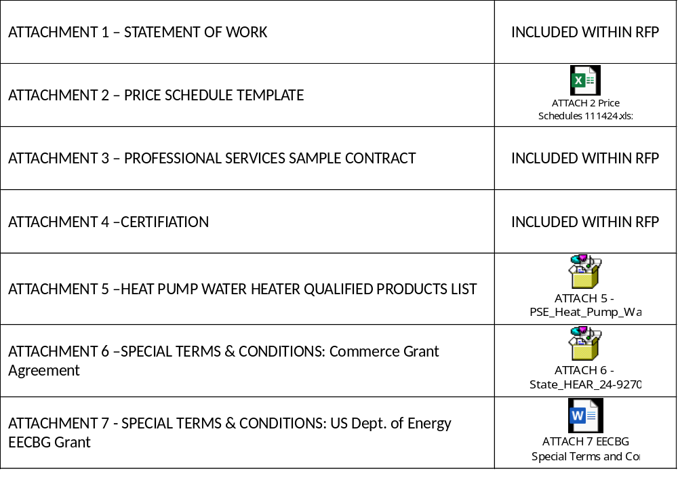

ATTACHMENT 1 - STATEMENT OF WORK

1.0 BACKGROUND
Energize Thurston 2025 is a heat pump group purchase campaign that makes it faster, easier, and more affordable for Thurston County residents to purchase and install efficient, all-electric heat pumps and heat pump water heaters. Energize Thurston is supported by a partnership among Thurston County (County); the cities of Lacey, Olympia, Tumwater, and Tenino (“partner jurisdictions”); and South Puget Sound Habitat for Humanity (SPSHFH). The Energize Thurston campaign provides funding contributed by the partner jurisdictions, through SPSHFH, to cover the costs of subsidized installations for participants in the low- and moderate-income (LMI) Pathway as described below.

This RFP is being issued to establish a roster of qualified heating, ventilation and air conditioning (HVAC) and plumbing contractors to install approximately 140-230 total heat pump space conditioners and approximately 120-140 total heat pump water heaters (HPWHs) in homes throughout Thurston County. Members of the Qualified Installer Roster will receive leads from Energize Thurston and will work with homeowners to design and quote a heat pump/HPWH solution based on program guidelines. Thurston County will administer the Qualified Installer Roster for the Energize Thurston campaign and will execute an Agreement with each selected Installer consistent with the terms of this RFP.

Energize Thurston will offer two participant pathways based on income qualification:
- LMI Pathway: Energize Thurston will provide fully subsidized equipment installations for low-income households (<80% area median income; AMI) and partially subsidized installations for moderate-income households (≥80% but <120% AMI). Campaign partner SPSHFH will administer this pathway by contracting directly with installers on the Qualified Installer Roster to coordinate site assessments and subsidized installations for LMI participants. The installers will invoice SPSHFH for the work performed. (Moderate-income households will pay a cost share to SPSHFH.)
- Self-Funded Pathway: Energize Thurston will provide a group purchase discount to participants with household incomes ≥120% AMI. Self-funded participants will also benefit from free educational workshops, guidance on relevant incentives and financing, streamlined installation, and customer support. Self-funded homeowners will contract directly with contractors on the Qualified Installer Roster. Contractors and homeowners are responsible for coming to agreement regarding design of and quote for a heat pump and/or HPWH solution based on the Energize Thurston program guidelines.

2.0 SCOPE OF SERVICES
To remain in good standing on the Qualified Installer Roster and continue to receive leads from Energize Thurston over the campaign duration, selected installers must fulfill the following responsibilities.

A. Campaign Administration and Reporting
Thurston County will host a project kick-off meeting for all selected installers and Energize Thurston partners to finalize the campaign plan and timeline, review partner roles and expectations, and provide training on the “Monday.com” software for lead management, participant tracking, and project reporting. Partners will hold weekly check-ins to ensure installers are meeting all roster obligations and timelines as detailed in the sections below.

Installer Responsibilities:
- Attend campaign kick-off meeting and software training.
- Attend weekly check-in meetings.
- Provide weekly participant progress reports through “Monday.com” software. Weekly reporting must be submitted by Monday at 12:00 pm PST for the previous week’s work. All discrepancies must be resolved prior to the next reporting period. At a minimum, progress reports should include the following:
  - Contact status/Lead follow-up
  - Dates of scheduled/completed site assessments
  - Dates of contract signing
  - Dates of scheduled installation
  - Dates of targeted completion
  - Issued quotes and final invoices (both of which document program equipment, pricing, and rebates)
- Upload all relevant documentation to Monday.com as described in sections D and E below.
- Maintain all Minimum Qualifications listed in Section 1.3 of this RFP and maintain all minimum insurance requirements listed in Attachment 3 – Sample Contract, through the duration of the contract.

Campaign Staff Responsibilities:
- Organize, schedule, and lead a project kick-off meeting.
- Organize, schedule, and lead weekly project check-in meetings.
- Provide free software access and a reporting template to installers and campaign partners.
- Verify that Installer progress reports are submitted with all required data.

B. Outreach and Education Support
Prior to campaign launch and for most of the campaign duration, campaign staff will promote Energize Thurston and deliver educational workshops virtually and at public locations in Thurston County and each of the partner cities. Selected installers are expected to play a supporting role in Energize Thurston outreach and education.
Installer Responsibilities:
- Participate in in-person community workshops as requested (exact number TBD, likely no more than four).
- Conduct additional marketing and outreach to promote Energize Thurston, as described in the installer’s proposal.
- Educate individual homeowners during site assessments about the heating, cooling and/or water heating needs of their home, appropriate equipment and its use, weatherization considerations, etc.

Campaign Staff Responsibilities:
- Coordinate community events and workshops.
- Provide marketing and outreach materials for use by the installer and project partners.
- Provide materials about general heat pump/HPWH use and maintenance, and weatherization information for installers to leave for participants post-installation.

C. Lead Management
During the campaign duration (estimated March to June 2025), interested Thurston County residents will register and attend campaign workshops (in-person and virtual). After attending a workshop, they may choose to complete an Energize Thurston application that indicates a) whether they are applying for the LMI Pathway or the Self-Funded Pathway; and b) if they request a site assessment for a heat pump space conditioning system, HPWH, or both.
As prospective participants are identified, their names and contact information will be provided to the selected installers. Leads will be provided to installers in an equitable manner to be determined prior to the campaign launch.
It is anticipated that the campaign will result in installations of approximately 140-230 heat pump space conditioners and approximately 120-140 HPWHs, about equally divided between the subsidized LMI Pathway and the Self-Funded Pathway. The total number of leads provided to each Installer will depend on the number of installers selected for the Qualified Installer Roster.
Note: A lead does NOT guarantee the Installer a contract with a homeowner to get paid for performing a heat pump or HPWH installation; it is the responsibility of the Installer to convert the lead into a contract with the homeowner or SPSHFH to perform an installation for payment. Energize Thurston will rotate Installers based on leads assigned, rather than on actual installations.
Installer Responsibilities:
- Contact the provided leads within three (3) business days of receiving their contact information to schedule a site assessment.
- For LMI participant leads, coordinate with SPSHFH on contacting the participant and scheduling the site assessment.
Campaign Staff and/or SPSHFH Responsibilities:
- Manage participant applications and verify the eligibility of all prospective Energize leads.
- Track applications and leads in Monday.com software, including which jurisdiction participants live in for tracking purposes.
- Request income eligibility information and coordinate income verification for LMI Pathway applicants.
- Provide participant names, addresses, and contact information to the selected installers in a manner to be determined prior to the campaign launch.

D. Site Assessments and Project Quotes
Once Installer has received the lead, and assuming the homeowner responds to Installer’s contact, Installer is expected to follow up as described below. For the LMI Pathway, Installer will work with SPSHFH and the homeowner to complete the site assessment, quote, and installation. For the Self-Funded Pathway, Installer will work directly with the homeowner.

Installer Responsibilities:
- Conduct a free site visit and assess the heating/cooling and/or water heating needs of the home, preferably using a repeatable load calculation methodology.
  - Based on the site assessment, recommend the appropriate equipment for the customer, which may be a ducted heat pump, ductless heat pump, heat pump hot water heater, or other equipment.
  - Inform customers of weatherization considerations, such as air sealing and insulation, that may affect customer satisfaction and savings from the equipment.
  - The Installer may provide introductions and supporting materials to banks, credit unions, and other interested financing entities as needed; however, any financing product offered by the Installer must be pre-approved by Thurston County.

- Within ten (10) business days of completing the site visit, provide a free quote to the homeowner for the installation work. Quotes will include all associated costs to perform the work at that house, including heat pump and/or HPWH equipment, electrical upgrades if needed, taxes, labor and permitting.
  - Quotes must be consistent with all equipment and labor pricing as described in the Installer’s proposal.
  - Quotes must include all eligible rebates and incentives offered by the utility, manufacturer, state, city or county, labor union, etc., as well as information about relevant federal tax credits.
  - If requested by participant, load calculation data backing up the system size recommendation should be provided with the quote.
  - For LMI installations, the quote must be prevailing wage.
    - Installations funded by the State HEAR Program are subject to Washington State Prevailing Wage Requirements.
    - Installations funded by the Bipartisan Infrastructure Law, which includes EECBG, are required to follow Davis-Bacon Act standards including US Department of Labor Prevailing Wage Requirements.
  - For LMI participants receiving installations of ducted heat pump systems, the quote must include duct sealing as needed, up to an established threshold to be determined prior to campaign launch.
  - Quotes should also take into consideration each owner’s self-identified financial limitations including, if applicable, any owner-arranged financing with a bank, credit union or other financing entity.
- The Installer must submit quotes and associated documentation through the Monday.com software.

Campaign Staff and/or SPSHFH Responsibilities:
- Review Installer quotes to verify consistency with the price schedule provided in the Installer’s proposal, including the provision of all applicable rebates as a time-of-sale discount.
- For LMI Pathway participants, issue notice to proceed to Installer after quote is verified.

E. Heat Pump and HPWH Installations
Installer Responsibilities:
- Upon receiving notice to proceed from Energize Thurston campaign staff and/or SPSHFH, the Installer will be expected to promptly execute a contract:
  - With SPSHFH for the LMI Pathway
  - With the homeowner for the Self-Funded Pathway
- The Installer will make a best-faith effort to conduct heat pump installations and complete contracted work for individual houses within a reasonable timeframe upon receipt of the necessary heat pump/HPWH equipment.
- Installations should be completed in a workmanlike manner, taking into consideration the preferences of the owner while minimizing project costs and maximizing effectiveness.
- The installations will be carried out by the selected Installer in conformance with all applicable laws, codes, and jurisdictional requirements.
- The Installer will be responsible for securing all required permits, completing, and submitting all incentive applications, and scheduling and passing all jurisdictional inspections.
- To provide services for subsidized installations, the selected installer must meet federal requirements for grant management, including an active registration on SAM.gov.
- Installer must include a generally visible decal including the Climate Commitment Act (CCA) logo on all equipment purchased with state HEAR funding. Installer must take a photo of this decal and include with project documentation.
- The Installer must submit invoices and all relevant documentation through the “Monday.com” software, providing proof of installation and passed inspections and the following data:
  - Year home was built
  - Type of home
  - Total cost of installation(s)
  - All rebates provided as a time-of-sale discount
  - Information on space conditioning equipment (if applicable)
    - Primary space heating fuel type prior to installation
    - Heating equipment prior to installation
    - Presence of AC before upgrade
    - Type of space conditioning heat pump installed (ducted or ductless)
    - (if ductless) Total heads installed and room location(s)
    - Square footage served by space conditioning system
    - AHRI certification # of installed equipment
  - Information on water heating equipment (if applicable)
    - Primary water heating fuel type prior to installation
    - Water heating equipment and equipment age prior to installation
    - AHRI certification # of installed equipment

Campaign Staff and/or SPSHFH Responsibilities:
- Verify that invoices are submitted with required documentation, that prices are consistent with the price schedule provided in the Installer’s proposal, and that all applicable rebates are applied as a time-of-sale discount.
- SPSHFH will reimburse Installers for completed invoices for participants in the LMI Pathway.
- Provide CCA logo decals to installer to place on HEAR-funded equipment.
- Reimburse the Installer for any local rebates if applicable.

F. Heat Pump and HPWH Equipment Requirements
Energize Thurston minimum equipment specifications for heat pumps must meet the following criteria:
- Consortium for Energy Efficiency (CEE) highest efficiency tier for 2025:

2025 CEE Split ASHP Speciﬁcation
CEE Level | SEER2 | EER2 | HSPF2 | COP at 5°F* | Capacity Ratio˘
CEE Tier 1
Path A | ≥ 16.0 | ≥ 9.8 | ≥ 8.5 | ≥ 1.75 | ≥ 60% at 5°F/47°F
Path B | ≥ 16.0 | ≥ 11.0 | ≥ 8.0 | ≥ 1.75 | ≥ 45% at 5°F/47°F
CEE Advanced Tier
Refer to the DOE Cold Climate Heat Pump Challenge Speciﬁcation
2025 CEE Packaged ASHP Speciﬁcation
CEE Level | SEER2 | EER2 | HSPF2 | COP at 5°F* | Capacity Ratio˘
CEE Tier 1 | ≥ 15.2 | ≥ 10.0 | ≥ 7.2 | ≥ 1.75 | ≥ 45% at 5°F/47°F

- System must be AHRI Certified as a variable speed heat pump, mini-split or multi-split heat pump and use inverter technology and be a minimum of ¾ ton in heating mode.
- For ductless heat pump only installations, at least one indoor head must be installed in the main living (high-flow) area of the home; bedroom only installations do not qualify for the campaign.

Energize Thurston minimum equipment specifications for heat pump water heaters must meet the following criteria:
- Must be Northwest Energy Efficiency Alliance (NEEA) Tier 3 or 4 heat pump water heater on Puget Sound Energy’s HPWH qualified product list (included as a separate attachment to this RFP).
- (TBD) Existing equipment must meet a minimum age requirement (e.g., 5 or 10 years) to be determined by campaign staff prior to the campaign launch

In addition to the above requirements, all equipment installed in qualifying LMI households that is funded with HEAR grants must meet the following HEAR program requirements:
- Remove all fossil fuel equipment where technically and economically feasible.
- All air-source heat pumps must be listed on the Northeast Energy Efficiency Partnership’s (NEEP) Cold Climate Air Source Heat Pump (ccASHP) Product List, or meet the most recent ENERGY STAR Cold Climate product criteria. For a full list of ENERGY STAR Cold Climate Certified equipment, visit www.pse.com/en/rebates/hear and scroll down to the section titled “Equipment requirements.”
- All equipment must be ENERGY STAR Certified or CEE North Region Certified.
- All equipment that uses refrigerants must follow the statutory global warming potential (GWP) limits from the Washington State Department of Ecology and the U.S. Environmental Protection Agency (EPA), and where technically and economically feasible, must use low GWP refrigerants listed by the EPA’s Significant New Alternatives Policy (SNAP) Program, or the California Air Resources Board (CARB).

ATTACHMENT 2 – PRICE SCHEDULE TEMPLATE

The Price Schedule template is included separately (Excel) on the ATTACHMENTS Page in Section 7.

ATTACHMENT 3 – PROFESSIONAL SERVICES SAMPLE CONTRACT

THURSTON COUNTY GOVERNMENT
BOARD OF COUNTY COMMISSIONERS
3000 PACIFIC AVE SE, STE. 200
OLYMPIA WA 98501

PROFESSIONAL SERVICES CONTRACT
THIS CONTRACT is entered into in duplicate originals between THURSTON COUNTY, a municipal corporation, with its principal offices at 3000 Pacific Ave S.E., Olympia, WA 98501, hereinafter “COUNTY,” and [LEGAL NAME OF COMPANY] with its principal offices at [CONTRACTOR’S ADDRESS] hereinafter “CONTRACTOR.”
In consideration of the mutual benefits and covenants contained herein, the parties agree as follows:
  - DURATION OF CONTRACT
The term of this Contract shall begin on the date last executed below and shall terminate on Month Day, Year, unless terminated sooner or extended by written Amendment to the contract. Options to extend the contract will be exercised at the sole discretion of the County.

  - SERVICES PROVIDED BY THE CONTRACTOR
The CONTRACTOR represents that it is qualified and possesses the necessary expertise, knowledge, training, and skills, and has the necessary licenses and/or certification to perform the services set forth in this Contract.
The CONTRACTOR shall perform the following services:
- A detailed description of the services to be performed by the CONTRACTOR is set forth in ATTACHMENT 1, Statement of Work, which is attached and incorporated herein.
- The CONTRACTOR agrees to provide its own labor and materials. Unless otherwise provided for in the Contract, no material, labor, or facilities will be furnished by the COUNTY.
- The CONTRACTOR shall perform according to standard industry practice of the work specified by this Contract.
- The CONTRACTOR shall complete its work in a timely manner and in accordance with the schedule agreed to by the parties.
- The CONTRACTOR shall, from time to time, during the progress of the work, confer with the LMD and/or COUNTY. At the LMDS and/or COUNTY’S request, the CONTRACTOR shall prepare and present status reports on its work.

  - SERVICES PROVIDED BY THE COUNTY AND CONTRACTOR
To assist the CONTRACTOR in fulfilling its duties under this Contract, the COUNTY may provide the following:
- Relevant information as exists.
- Coordination with other County Departments or other Consultants as necessary.
- Service documents, or other information identified in ATTACHMENT 1, Statement of Work.

  - CONTRACT REPRESENTATIVES
Each party to this Contract shall have a contract representative. Each party may change its representative upon providing written notice to the other party. The parties’ representatives are as follows:
For Contractor:
Name
Title
Mailing Address
City, State, and Zip
Phone | (xxx)
Email

For County:
Name
Title
Mailing Address | 3000 Pacific Ave SE, Ste. X
City, State, and Zip | Olympia WA 98501
Phone | (360)
Email | @co.thurston.wa.us

  - COMPENSATION
- CONTRACTOR shall be paid for the services performed per the Contract Documents; Request for Proposal (RFP) #24-003-0020, this Contract, Contracts entered with the County’s partner, South Puget Sound Habitat for Humanity (SPSHFH) and participants of the Low-and-Moderate Income (LMI) program. The Contract Documents previously listed are each incorporated herein by reference.
- This is a non-financial contract and the maximum amount payable by the COUNTY to the CONTRACTOR under this Contract is $0.
- In the event the CONTRACTOR has failed to perform any substantial obligation to be performed by the CONTRACTOR under this Contract and such failure has not been cured within ten (10) days following notice from the COUNTY, then the COUNTY may, in its sole discretion, upon written notice to the CONTRACTOR, request the County’s partner, SPSHFH withhold any and all leads to the CONTRACTOR, without penalty until such failure to perform is cured or otherwise adjudicated. “Substantial” for purposes of this Contract means faithfully fulfilling the terms of the Contract with variances only for technical or minor omissions or defects.
- The CONTRACTOR will not be paid for any billings or invoices presented for payment prior to the execution of the Contract or after its termination.

  - AMENDMENTS AND CHANGES IN WORK
- In the event of any errors or omissions by the CONTRACTOR in the performance of any work required under this Contract, the CONTRACTOR shall make any, and all necessary corrections without additional compensation. All work submitted by the CONTRACTOR shall be certified by the CONTRACTOR and checked for errors and omissions. The CONTRACTOR shall be responsible for the accuracy of the work, even if the work is accepted by the COUNTY.
- No amendment, modification or renewal shall be made to this Contract unless set forth in a written Contract Amendment, signed by both parties and attached to this Contract. Work under a Contract Amendment shall not proceed until the Contract Amendment is duly executed by the COUNTY.

  - HOLD HARMLESS AND INDEMNIFICATION
- The CONTRACTOR shall hold harmless, indemnify and defend the COUNTY, its officers, officials, employees and agents, from and against any and all claims, actions, suits, liability, losses, expenses, damages, and judgments of any nature whatsoever, including costs and attorneys’ fees in defense thereof, for injury, sickness, disability or death to persons or damage to property or business, caused by or arising out of the CONTRACTOR’S acts, errors or omissions or the acts, errors or omissions of its employees, agents, subcontractors or anyone for whose acts any of them may be liable, in the performance of this Contract. Claims shall include, but not be limited to, assertions that information supplied or used by the CONTRACTOR or subcontractor infringes any patent, copyright, trademark, trade name, or otherwise results in an unfair trade practice. PROVIDED HOWEVER, that the CONTRACTOR’S obligations hereunder shall not extend to injury, sickness, death, or damage caused by or arising out of the sole negligence of the COUNTY, its officers, officials, employees, or agents. PROVIDED FURTHER, that in the event of the concurrent negligence of the parties, the CONTRACTOR’S obligations hereunder shall apply only to the percentage of fault attributable to the CONTRACTOR, its employees, agents, or subcontractors.
- In any and all claims against the COUNTY, its officers, officials, employees and agents by any employee of the CONTRACTOR, subcontractor, anyone directly or indirectly employed by any of them, or anyone for whose acts any of them may be liable, the indemnification obligation under this Section shall not be limited in any way by any limitation on the amount or type of damages, compensation, or benefits payable by or for the CONTRACTOR or subcontractor under Worker’s Compensation acts, disability benefits acts, or other employee benefits acts, it being clearly agreed and understood by the parties hereto that the CONTRACTOR expressly waives any immunity the CONTRACTOR might have had under Title 51 RCW. By executing the Contract, the CONTRACTOR acknowledges that the foregoing waiver has been mutually negotiated by the parties and that the provisions of this Section shall be incorporated, as relevant, into any Contract the CONTRACTOR makes with any subcontractor or agent performing work hereunder.
- The CONTRACTOR’s obligations here under shall include, but are not limited to, investigating, adjusting, and defending all claims alleging loss from action, error or omission, or breach of any common law, statutory or other delegated duty by the CONTRACTOR, the CONTRACTOR’S employees, agents or subcontractors.

  - INSURANCE
- Professional Legal Liability: The CONTRACTOR, shall maintain Professional Legal Liability or Professional Errors and Omissions coverage appropriate to the CONTRACTOR’S profession and shall be written subject to limits of no less than $2,000,000 per loss.
The coverage shall apply to liability for a professional error, act or omission arising out of the scope of the CONTRACTOR’S services defined in this Contract. Coverage shall not exclude bodily injury or property damage. Coverage shall not exclude hazards related to the work rendered as part of the Contract or within the scope of the CONTRACTOR’S services as defined by this Contract including testing, monitoring, measuring operations, or laboratory analysis where such services are rendered as part of the Contract.
- Workers ’Compensation (Industrial Insurance): The CONTRACTOR shall maintain workers’ compensation insurance as required by Title 51 RCW and shall provide evidence of coverage to the Thurston County Risk Management Division.
The CONTRACTOR shall send to Thurston County at the end of each quarter written verification that premium has been paid to the Washington State Department of Labor and Industries for Industrial Insurance coverage. Alternatively, the CONTRACTOR shall provide certification of approval by the Washington State Department of Labor and Industries if self- insured for Workers Compensation.
- Commercial General Liability: The CONTRACTOR shall maintain Commercial General Liability coverage for bodily injury, personal injury, and property damage, subject to limits of no less than $1,000,000 per loss. The general aggregate limit shall apply separately to this Contract and be no less than $2,000,000.
- The CONTRACTOR shall provide Commercial General Liability coverage which does not exclude any activity to be performed in fulfillment of this Contract. Specialized forms specific to the industry of the CONTRACTOR will be deemed equivalent provided coverage is no more restrictive than would be provided under a standard Commercial General Liability policy, including contractual liability coverage.
- The CONTRACTOR’S Commercial General Liability insurance shall include the COUNTY, its officers, officials, employees, and agents with respect to performance of services, and shall contain no special limitations on the scope of protection afforded to the COUNTY as additional insured.
- The CONTRACTOR shall furnish the COUNTY with evidence that the additional insured provision required above has been met. An acceptable form of evidence is the endorsement pages of the policy showing the COUNTY as an additional insured.
- If the CONTRACTOR’S liability coverage is written as a claim made policy, then the CONTRACTOR must evidence the purchase of an extended reporting period or “tail” coverage for a three-year period after project completion, or otherwise maintain the coverage for the three-year period.
- If the Contract is over $50,000 then the CONTRACTOR shall also maintain Employers Liability Coverage with a limit of not less than $1 million.
- Automobile Liability: The CONTRACTOR shall maintain Business Automobile Liability insurance with a limit of no less than $1,000,000 each accident combined Bodily Injury and Property Damages. Coverage shall include owned, hired, and non-owned automobiles.
- Other Insurance Provisions:
- The CONTRACTOR’S liability insurance provisions shall be primary with respect to any insurance or self-insurance programs covering the COUNTY, its elected and appointed officers, officials, employees, and agents.
- Any failure to comply with reporting provisions of the policies shall not affect coverage provided to the COUNTY, its officers, officials, employees, or agents.
- The CONTRACTOR’S insurance shall apply separately to each insured against whom the claim is made or suit is brought, except with respect to the limits of the insurer’s liability.
- The CONTRACTOR shall include all subcontractors as insureds under its policies or shall furnish separate certificates and endorsements for each subcontractor. All coverage for subcontractors shall be subject to all of the requirements stated herein.
- The insurance limits mandated for any insurance coverage required by this Contract are not intended to be an indication of exposure nor are they limitations on indemnification.
- The CONTRACTOR shall maintain all required policies in force from the time services commence until services are completed. Certificates, policies, and endorsements expiring before completion of services shall be promptly replaced.
- Verification of Coverage and Acceptability of Insurers: The CONTRACTOR shall place insurance with insurers licensed to do business in the State of Washington and having A.M. Best Company ratings of no less than A-, with the exception that Excess and Umbrella Coverage used to meet the requirements for limits of liability or gaps in coverage need not be placed with insurers or re-insurers licensed in the State of Washington.
- Certificates of Insurance shall show the Certificate Holder as Thurston County and include c/o of the Office or Department issuing the Contract. The address of the Certificate Holder shall be shown as the current address of the Office or Department.
- Written notice of cancellation or change shall be mailed to the COUNTY at the following address:
Attn: Rebecca Harvey, Sr. Program Mgr.
Climate Mitigation, Board of County Commissioners
3000 Pacific Ave SE, Ste. 200
Olympia, Washington 98501
- The CONTRACTOR shall furnish the COUNTY with properly executed certificates of insurance or a signed policy endorsement which shall clearly evidence all insurance required in this section prior to commencement of services. The certificate will, at a minimum, list limits of liability and coverage. The certificate will provide that the underlying insurance contract will not be canceled or allowed to expire except on thirty (30) days prior written notice to the COUNTY.
- The CONTRACTOR or its broker shall provide a copy of any and all insurance policies specified in this Contract upon request of the Thurston County Risk Management Division.
  - TERMINATION
- The COUNTY may terminate this Contract for convenience in whole or in part whenever the COUNTY determines, in its sole discretion, that such termination is in the best interests of the COUNTY. The COUNTY may terminate this Contract upon giving ten (10) days written notice by Certified Mail to the CONTRACTOR. In that event, the COUNTY shall pay the CONTRACTOR for all costs incurred by the CONTRACTOR in performing the Contract up to the date of such notice. Payment shall be made in accordance with Section 5 of this Contract.
- In the event funding for this project is withdrawn, reduced, or limited in anyway after the effective date of this Contract, the COUNTY may summarily terminate this Contract notwithstanding any other termination provision of the Contract. Termination under this paragraph shall be effective upon the date specified in the written notice of termination sent by the COUNTY to the CONTRACTOR. After the effective date, no charges incurred under this Contract are allowable.
- If the CONTRACTOR breaches any of its obligations here under, and fails to cure the breach within ten (10) days of written notice to do so by the COUNTY, the COUNTY may terminate this Contract, in which case the COUNTY shall pay the CONTRACTOR only for the costs of services accepted by the COUNTY, in accordance with Section 5 of this Contract. Upon such termination, the COUNTY, at its discretion, may obtain performance of the work elsewhere, and the CONTRACTOR shall bear all costs and expenses incurred by the COUNTY in completing the work and all damage sustained by the COUNTY by reason of the CONTRACTOR’S breach. If, subsequent to termination, it is determined for any reason that (1) the CONTRACTOR was not in default, or (2) the CONTRACTOR’S failure to perform was not its fault or its subcontractor’s fault or negligence, the termination shall be deemed to be a termination under subsection a of this section.

  - ASSIGNMENT, DELEGATION, AND SUBCONTRACTING
- The CONTRACTOR shall perform the terms of the Contract using only its bonafide employees or agents who have the qualifications to perform under this Contract. The obligations and duties of the CONTRACTOR under this Contract shall not be assigned, delegated, or subcontracted to any other person or company without the prior express written consent of the COUNTY.
- The CONTRACTOR warrants that it has not paid, nor has it agreed to pay any company, person, partnership, or company, other than a bona fide employee working exclusively for CONTRACTOR, any fee, commission, percentage, brokerage fee, gift, or other consideration contingent upon or resulting from the award or making of this Contract.

  - NON-WAIVER OF RIGHTS
The parties agree that the excuse or forgiveness of performance, or waiver of any provision(s) of this Contract does not constitute a waiver of such provision(s) or future performance or prejudice the right of the waiving party to enforce any of the provisions of this Contract at a later time.

  - INDEPENDENT CONTRACTOR
- The CONTRACTOR’S services shall be furnished by the CONTRACTOR as an Independent Contractor and not as an agent, employee, or servant of the COUNTY. The CONTRACTOR specifically has the right to direct and control CONTRACTOR’S own activities in providing the agreed services in accordance with the specifications set out in this Contract.
- The CONTRACTOR acknowledges that the entire compensation for this Contract is set forth in Section 5 of this Contract, and the CONTRACTOR is not entitled to any County benefits, including, but not limited to: vacation pay, holiday pay, sick leave pay, medical, dental, or other insurance benefits, fringe benefits, or any other rights or privileges afforded to Thurston County employees.
- The CONTRACTOR shall have and maintain complete responsibility and control over all its subcontractors, employees, agents, and representatives. No subcontractor, employee, agent, or representative of the CONTRACTOR shall be or deem to be or act or purport to act as an employee, agent or representative of the COUNTY.
- The CONTRACTOR shall assume full responsibility for the payment of all payroll taxes, use, sales, income or other form of taxes, fees, licenses, excises, or payments required by any city, county, federal or state legislation which is now or may during the term of this Contract be enacted as to all persons employed by the CONTRACTOR and as to all duties, activities and requirements by the CONTRACTOR in performance of the work on this project and under this Contract and shall assume exclusive liability therefore, and meet all requirements thereunder pursuant to any rules or regulations.
- The CONTRACTOR agrees to immediately remove any of its employees or agents from assignment to perform services under this Contract upon receipt of a written request to do so from the COUNTY’S contract representative or designee.

  - COMPLIANCE WITH LAWS
The CONTRACTOR shall comply with all applicable federal, state, and local laws, rules and regulations in performing this Contract.
  - INSPECTION OF BOOKS AND RECORDS
The COUNTY may, at reasonable times, inspect the books and records of the CONTRACTOR relating to the performance of this Contract. The CONTRACTOR shall keep all records required by this Contract for six (6) years after termination of this Contract for audit purposes.
  - NON-DISCRIMINATION
The CONTRACTOR, its assignees, delegates, or subcontractors shall not discriminate against any person in the performance of any of its obligations hereunder on the basis of race, color, creed, ethnicity, religion, national origin, citizenship or immigration status, age, sex, marital status, veteran or military status, sexual orientation, or the presence of any disability. Implementation of this provision shall be consistent with RCW 49.60.400.
  - OWNERSHIP OF MATERIALS/WORK PRODUCED
- Material produced in the performance of the work under this Contract shall be “works for hire” as defined by the U.S. Copyright Act of 1976 and shall be owned by the COUNTY. This material includes, but is not limited to, books, computer programs, plans, specifications, documents, films, pamphlets, reports, sound reproductions, studies, surveys, tapes, and/or training materials. Ownership includes the right to copyright, patent, register, and the ability to transfer these rights. The COUNTY agrees that if it uses any materials prepared by the CONTRACTOR for purposes other than those intended by this Contract, it does so at its sole risk and it agrees to hold the CONTRACTOR harmless therefore to the extent such use is agreed to in writing by the CONTRACTOR.
- An electronic copy of all or a portion of material produced shall be submitted to the COUNTY upon request or at the end of the job using the word processing program and version specified by the COUNTY.

  - DISPUTES
Differences between the CONTRACTOR and the COUNTY, arising under and by virtue of this Contract, shall be brought to the attention of the COUNTY at the earliest possible time in order that such matters may be settled, or other appropriate action promptly taken. Any dispute relating to the quality or acceptability of performance and/or compensation due to the CONTRACTOR shall be decided by the COUNTY’S Contract representative or designee. All rulings, orders, instructions, and decisions of the COUNTY’S contract representative shall be final and conclusive, subject to the CONTRACTOR’S right to seek judicial relief pursuant to Section 18.
  - CHOICE OF LAW, JURISDICTION AND VENUE
- This Contract has been and shall be construed as having been made and delivered within the State of Washington, and it is agreed by each party hereto that this Contract shall be governed by the laws of the State of Washington, both as to its interpretation and performance.
- Any action at lawsuit, inequity, or judicial proceeding arising out of this Contract shall be instituted and maintained only in any of the courts of competent jurisdiction in Thurston County, Washington.

  - CONFIDENTIALITY
The Contractor, its employees, agents, and subcontractors and their employees, shall maintain the confidentiality of all information provided by the County or acquired by the Contractor in performance of this Contract, except upon the prior written consent of the County or an order entered by a court of competent jurisdiction. The Contractor shall promptly give the County written notice of any judicial proceeding seeking disclosure of such information.

  - SEVERABILITY
- If a court of competent jurisdiction holds any part, term, or provision of this Contract to be illegal, or invalid in whole or in part, the validity of the remaining provisions shall not be affected, and the parties’ rights and obligations shall be construed and enforced as if the Contract did not contain the particular provision held to be invalid.
- If any provision of this Contract is indirect conflict with any statutory provision of the State of Washington, that provision which may conflict shall be deemed inoperative and null and void insofar as it may conflict and shall be deemed modified to conform to such statutory provision.
- Should the COUNTY determine that the severed portions substantially alter this Contract so that the original intent and purpose of the Contract no longer exists, the COUNTY may, in its sole discretion, terminate this Contract.

  - ENTIRE AGREEMENT
The parties agree that this Contract is the complete expression of its terms and conditions. Any oral or written representations or understandings not incorporated in this Contract are specifically excluded.
  - NOTICES
Any notices shall be effective if personally served upon the other party or if mailed by registered or certified mail, return receipt requested, to the addresses set out in Section 4.
Notice may also be given by facsimile with the original to follow by regular mail. Notice shall be deemed to be given three days following the date of mailing or immediately if personally served. For service by facsimile, service shall be effective upon receipt during working hours. If a facsimile is sent after working hours, it shall be effective at the beginning of the next working day.
The parties hereto acknowledge that the waiver of immunity set out in Section 7.b. was mutually negotiated and specifically agreed to by the parties herein.
[CONTRACTOR’S COMPANY NAME] |  | For the  BOARD OF COUNTY COMMISSIONERS  Thurston County, Washington
- SAMPLE - |  | - SAMPLE -
Authorized Signature Date |  | Authorized Signature Date
Name |  | Name
Title |  | Title

Approved as to form:
JON Tunheim
Prosecuting Attorney
By:
Scott Cushing, Sr. Deputy Prosecuting Attorney

ATTACHMENT 4 - CERTIFICATION
REQUEST FOR PROPOSAL NO. 24-003-0020
ENERGIZE THURSTON 2025 CAMPAIGN

The undersigned hereby certifies they have examined, read, and thoroughly understands the Sample Professional Services Contract including insurance requirements and the method by which payment will be made for said work.
THE SOLICITATION DOCUMENTS, including any addenda, are published on the Thurston County’s website under ‘Doing Business with the County‘ at: Current Contract Opportunities (thurstoncountywa.gov)
THE UNDERSIGNED UNDERSTANDS AND ACKNOWLEDGES THAT THE SOLICITATION AND ALL ADDENDA HAVE BEEN EXAMINED PRIOR TO SUBMISSION OF A STATEMENT OF QUALIFICATIONS (SOQ).

THE PROPER FULL LEGAL NAME OF THE COMPANY OR ENTITY RESPONDING TO THIS SOLICITATION MUST BE WRITTEN IN THE SPACE PROVIDED BELOW. THIS SUBMITTAL FORM MUST BE FULLY AND ACCURATELY COMPLETED AND SIGNED BELOW BY A PERSON AUTHORIZED TO BIND THE PROPOSER, OR THE SUBMITTAL MAY BE REJECTED IN ENTIRETY:

SUBMITTED BY:
(legal name of entity)
AUTHORIZED SIGNATURE:
PRINT NAME AND TITLE:
ADDRESS:
CITY/STATE/ZIP:
TELEPHONE NO.: |  |  |  |  |  |  |  |  |  | E-MAIL ADDRESS:
THIS ENTITY IS INCORPORATED IN: |  |  |  |  |  |  |  |  |  |  |  |  | TAX ID:
THIS ENTITY IS A: (check the applicable option) |  |  | CORPORATION |  |  |  |  |  |  |  | □ | LIMITED PARTNERSHIP |  |  |  |  |  |  |  |  |  | □
 |  |  | GENERAL PARTNERSHIP |  |  |  |  |  |  |  | □ | UNINCORPORATED ASSOCIATION |  |  |  |  |  |  |  |  |  | □
 |  |  |  | LIMITED LIABILITY COMPANY |  |  |  |  |  |  | □ | SOLE PROPRIETORSHIP |  |  |  |  |  |  |  |  |  | □
IS BIDDER AUTHORIZED TO TRANSACT BUSINESS IN WASHINTON? |  |  |  |  |  |  |  |  |  |  |  |  |  |  |  | YES |  | □ | NO |  | □
NAME/TITLE OF COMPANY CONTACT:
CONTACT PHONE: |  |  |  |  |  |  |  |  | CONTACT EMAIL:
WASHINGTON CONTRACTOR’S LICENSE NO:

HAS YOUR FIRM or any of its principals BEEN debarred, ENJOINED, or suspended from submitting BIDS to THURSTON County, WASHINGTON, or any other state or political subdivision WITHIN THE PAST THREE YEARS? | YES | □ | NO | □
has your firm defaulted on any project in the last THREE YEARS? | YES | □ | NO | □
HAS YOUR FIRM HAD ANY TYPE OF BUSINESS, CONTRACTING OR TRADE LICENSE, REGISTRATION OR CERTIFICATION REVOKED OR SUSPENDED IN THE PAST THREE YEARS? | YES | □ | NO | □
HAS YOUR FIRM AND ITS PRINCIPALS/OWNERS BEEN CONVICTED OF ANY CRIME RELATING TO ITS CONTRACTING BUSINESS IN THE PAST TEN YEARS? | YES | □ | NO | □
HAS YOUR FIRM BEEN FOUND IN VIOLATION OF ANY LAW APPLICABLE TO ITS CONTRACTING BUSINESS (LICENSING LAWS, TAX LAWS, WAGE AND HOUR LAWS, PREVAILING WAGE LAWS, ENVIRONMENTAL) WHERE THE RESULT OF SUCH VIOLATION WAS THE PAYMENT OF A FINE, BACK PAY DAMAGES, OR ANY OTHER PENALTY IN THE AMOUNT OF $5000 OR MORE? | YES | □ | NO | □

potential Bidders are responsible for determining the accuracy and completeness of aLL solicitation documents they receive from any source, including The county.
The undersigned acknowledges receipt of the following Addenda:

ADDENDUM NO. 1 DATE: ____________ INITIAL: ____________

ADDENDUM NO. 2 DATE: ____________ INITIAL: ____________

ADDENDUM NO. 3 DATE: ____________ INITIAL: ____________

Appendix H – RFP Scoring Template
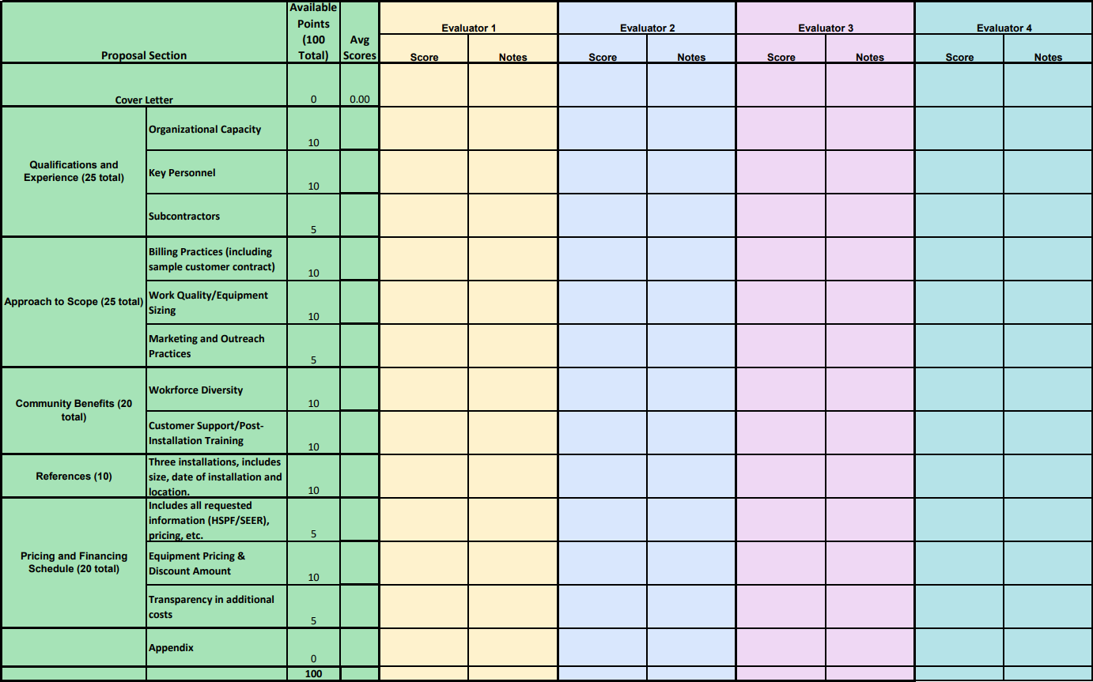

Appendix I – Energize Thurston 2025 Proposer Interview Questions
Reviewer Installer Total Score
- We asked in the RFP to provide your best estimate of the number of average installations your firm can complete per week. Could you please confirm this estimate, as well as the location of your office and the geographic area you can cover? Score:

- Describe the process for in-office management of a large volume of leads, from receipt of lead information from Campaign Staff through customer contact, site assessment, installation, and processing of relevant paperwork. Please provide an approximate timeline for this process. Score:

- Habitat for Humanity is a non-proﬁt organization that has a limited capacity to provide large amounts of up-front funds. How are you able to negotiate payment terms when contracting for a high number of subsidized installations? Score:

- Please describe how you assess a home and determine what equipment is needed, including assessment of building conditions that affect equipment efficiency and how you determine whether a ducted or ductless heat pump is appropriate for a site.
Follow up (all): For ducted systems, how do you assess the condition of current ductwork?
Follow up : Please also describe how you determine if the water heater is in need of replacement and whether a heat pump water heater is appropriate for a site. Score:

- How do you explain system size to customers, and how do you consider their need for back- up or supplemental heating? Score:

- Please tell us about the equipment that you proposed and if you foresee any potential changes to the equipment and/or any potential supply chain issues as a result of the phaseout of the existing R410 refrigerant systems. Score:

- Identify any partnerships associated with your company which offer ﬁnancing arrangements, manufacturer discounts, or other incentives that you will be able to offer prospective customers. Score:

- How do you describe potential savings to customers and communicate other beneﬁts such as local utility rebates, other available rebates, and federal tax credits? Score:

- How will your company contribute to outreach efforts in partnership with Energize Thurston? Do you have any advertising planned that could include Energize Thurston information? Do you have any materials that would help the workshop series?
Score:
- Describe your installation process including how you minimize disruption during preparation, installation, ﬁnal testing, and cleanup. Please include acquisition of permits, inspections, and any other necessary requirements. Score:

- Explain the health, safety, and environmental record of your company. Have there been any communications with Washington OSHA’s Department of Labor and Industries Division of Occupational Safety and Health and Washington Department of Ecology regarding workplace issues in the past three years? Score:

- How do you support customer education at installation and sign off? What is your customer training and handoff procedure? Scor
- How do you handle customer complaints and call-backs? Score:

- Do you have any plans to provide innovative mentoring, technical training, or professional development opportunities to veterans, people with disabilities, people of color and women in your workforce in relation to this project? Score:

- Do you have any questions for us? Score: ____

Appendix J - Outreach Tabling Metrics
Event No. | Date | Jurisdiction | Time | Hours | Outreach Event | Staff Present | Connections | Notes
Total |  |  |  | 40 |  |  | 188
1 | 3/1/2025 | Thurston | 10am - 3pm | 5 | Thurston Conservation District Native Plant Festival & Sale | Julia | 59 | Great engagement. A good amount of people had heard of Energize Olympia before and were excited to see the program expand beyond the city.
2 | 3/22/2025 | Olympia | 10am - 1pm | 3 | Olympia Farmers Market | Julia/Dominic | 21 | Ok engagement. Roughly half of who we talked to seemed genuinely interested in attending a workshop.
3 | 4/3/2025 | Thurston (Yelm) | 10am - 12pm | 2 | Yelm Timberland Library | Julia | 10 | Primary goal was to boost registration numbers for the Yelm workshop. Lots of parents who were occupied with their kids.
4 | 4/12/2025 - 4/13/2025 | Thurston (Lacey) | 10am - 5pm | 7 | OMB Big Home & Garden Show @ St. Martin's | Installation Partners | n/a | Sunset Air, Alpine Ductless, and ORCAA were each present with a booth and engaged residents about Energize.
5 | 4/19/2025 | Tumwater | 10am - 1pm | 3 | Tumwater Earth Day Event | Alyssa | n/a
6 | 4/19/2025 | Olympia | 10am - 1pm | 3 | Olympia Earth Day Event | Julia | 15 | Slow Event. Lots of earth day volunteers were present, but outreach tables were tucked away from the restoration work.
7 | 4/19/2025 | Tenino | 10am - 1pm | 3 | Tenino Earth Day Event | Rebecca | 6
8 | 4/19/2025 | Thurston  (Lacey) | 1pm - 4pm | 3 | Solid Waste Earth Day Event | Julia/Linsey | 22 | Kid focused event. Many people had heard of Energize before and had great questions about the program and heat pumps.
9 | 4/27/2025 | Olympia | 10am - 1pm | 3 | Olympia Farmers Market | Julia | 24 | Tabling with Solarize.
10 | 5/3/2025 | Tenino | 10am - 3pm | 5 | Tenino Farmers Market | Julia | 4 | Super slow; lots of people from out of the county.
11 | 5/14/2025 | Olympia | 11am - 2pm | 3 | Spring Fling - Capitol Campus | Julia/Dominic | 26 | Lower turnout than expected. I believe a lot of people work from home.

Appendix K – Workshop Slide Deck



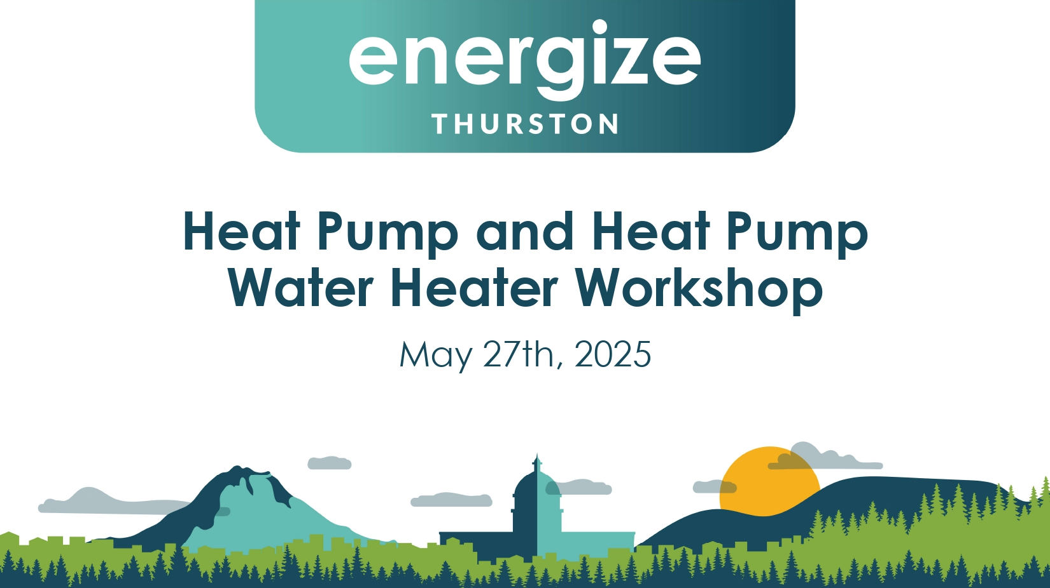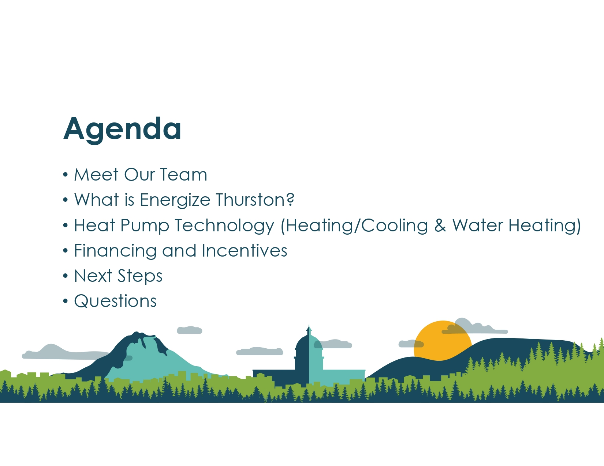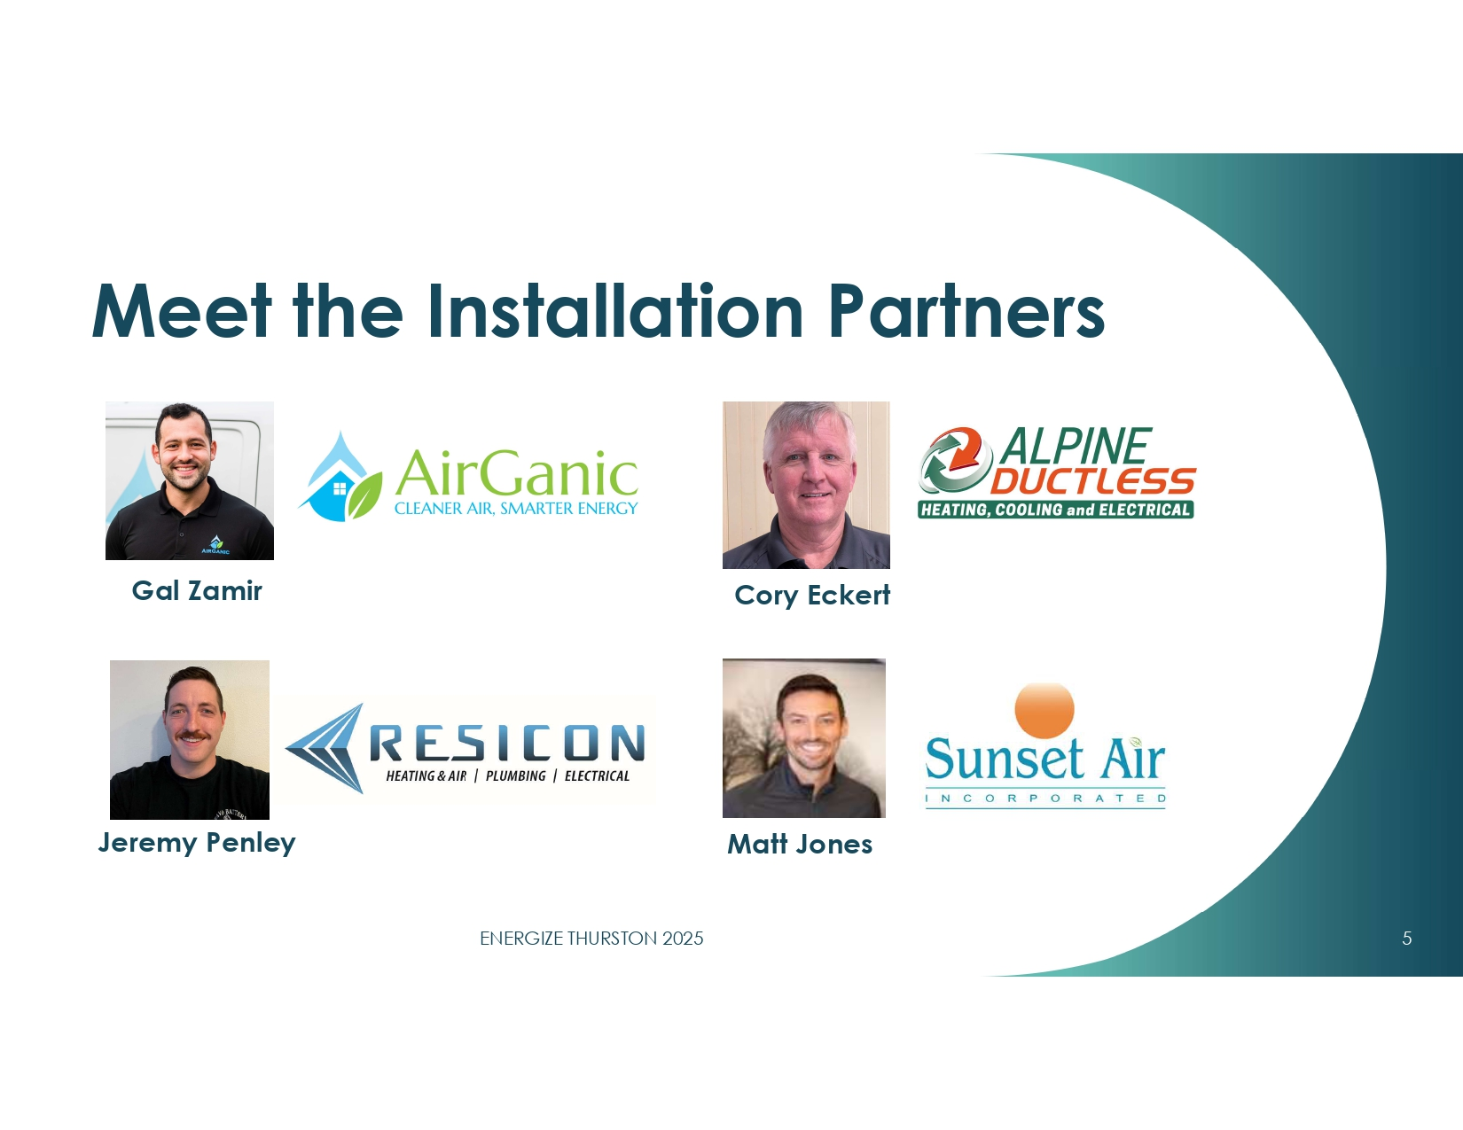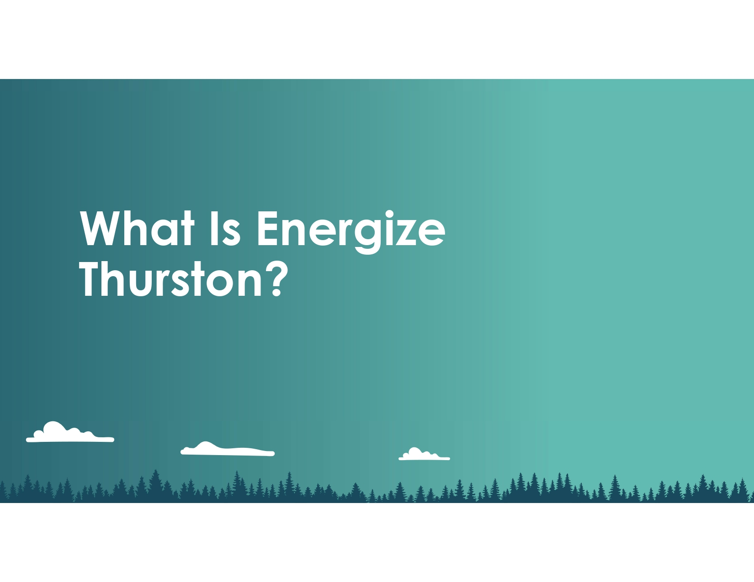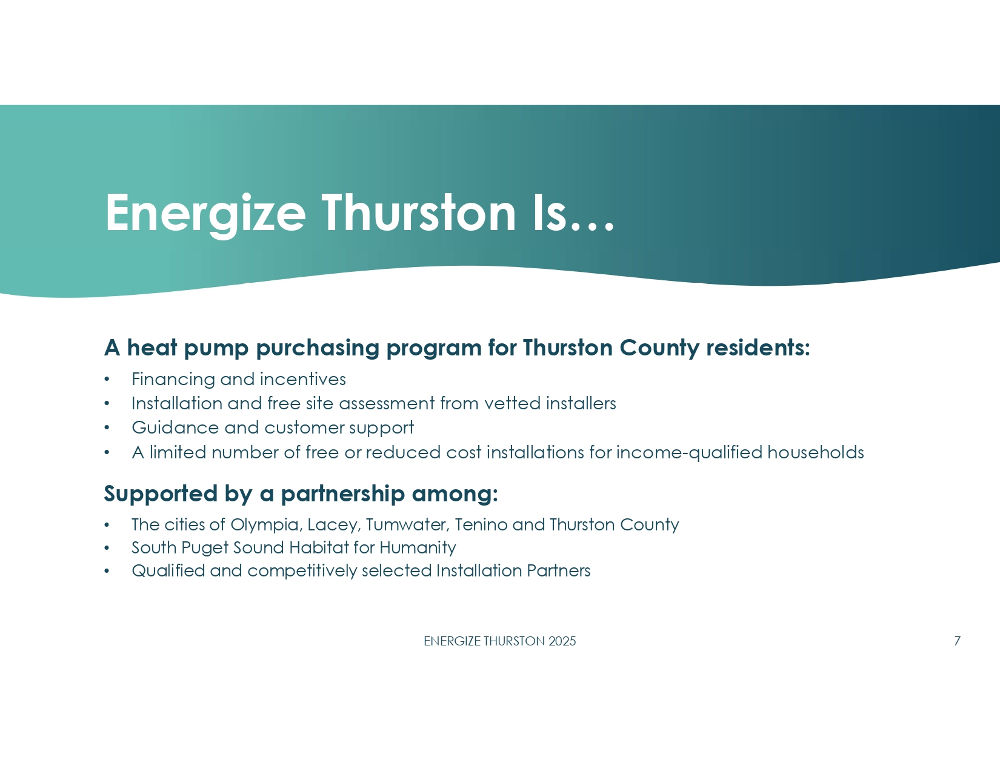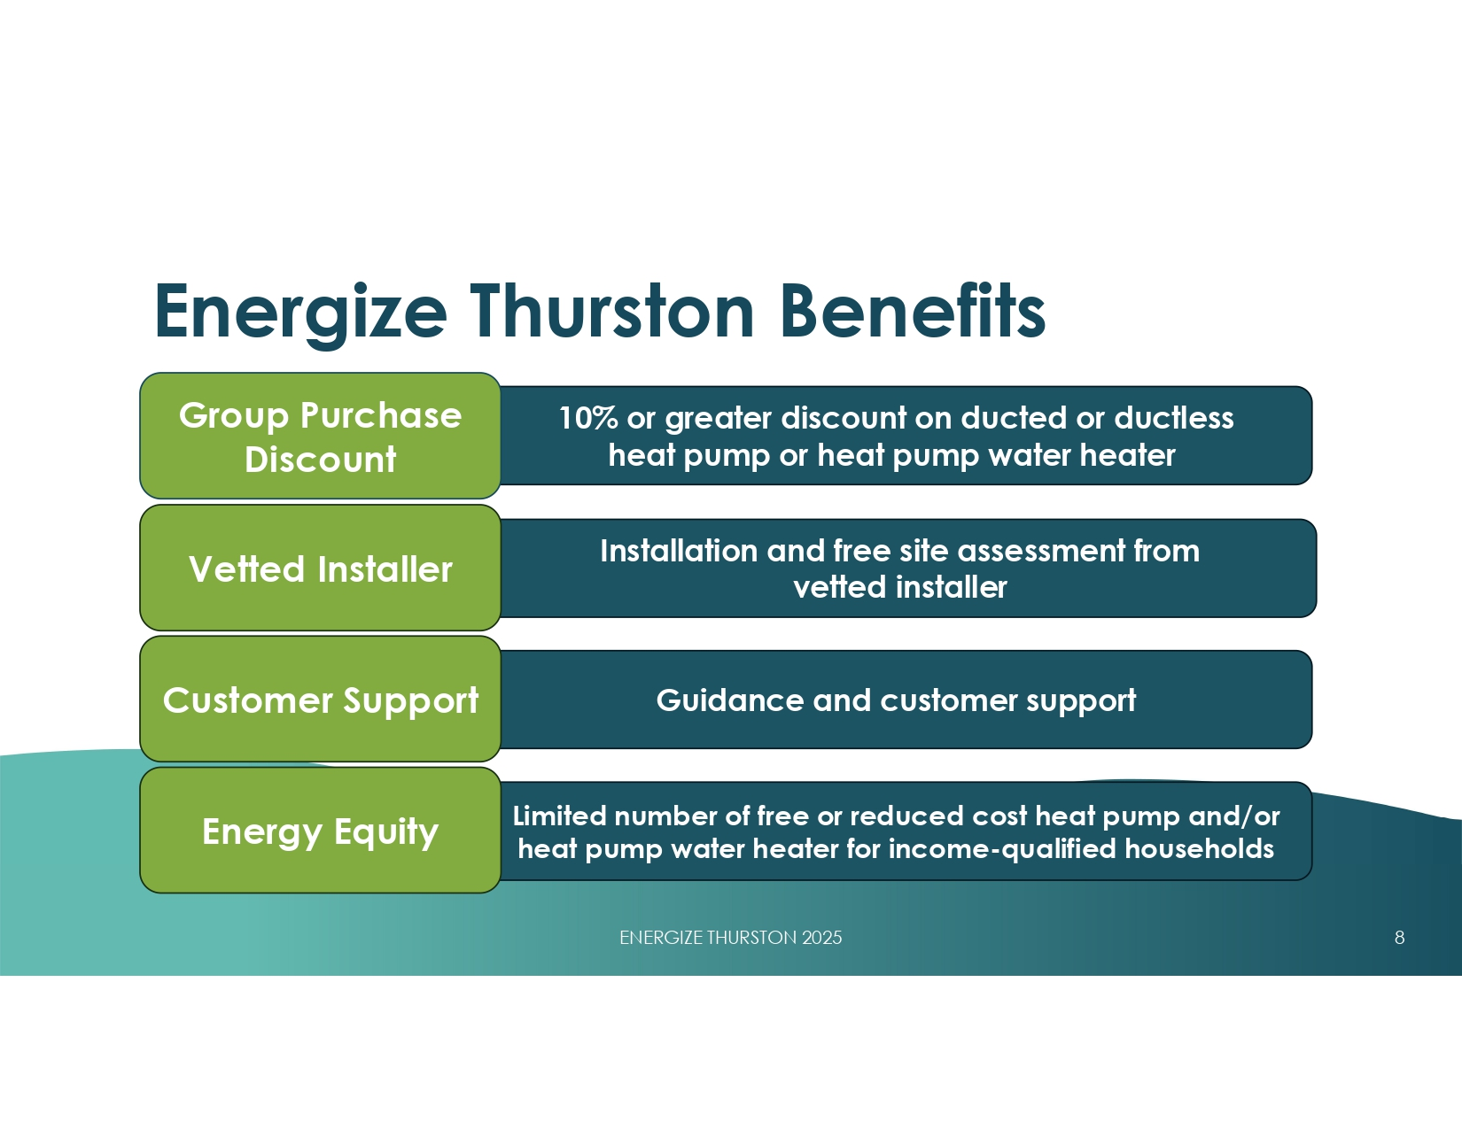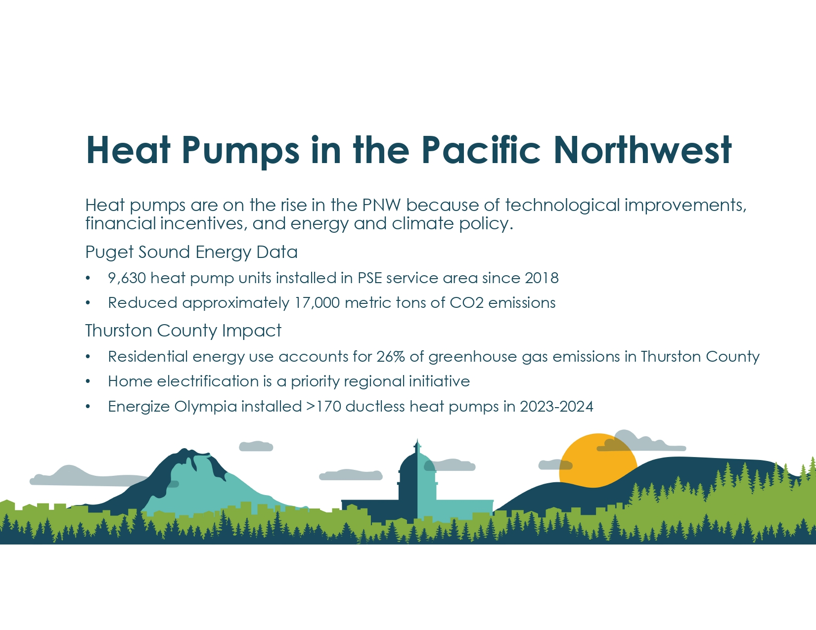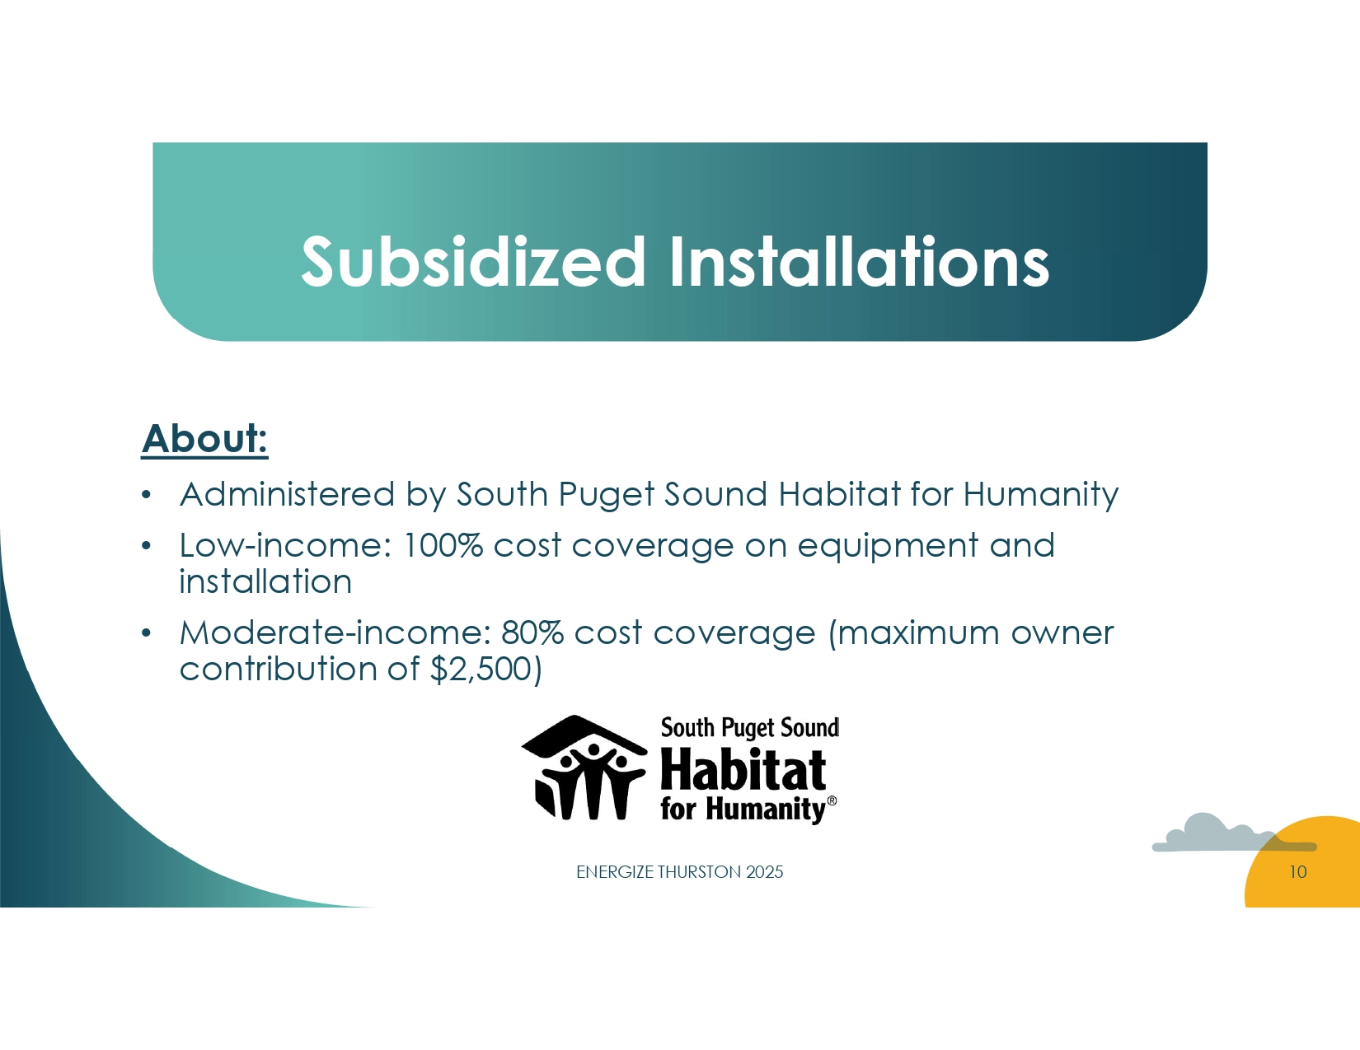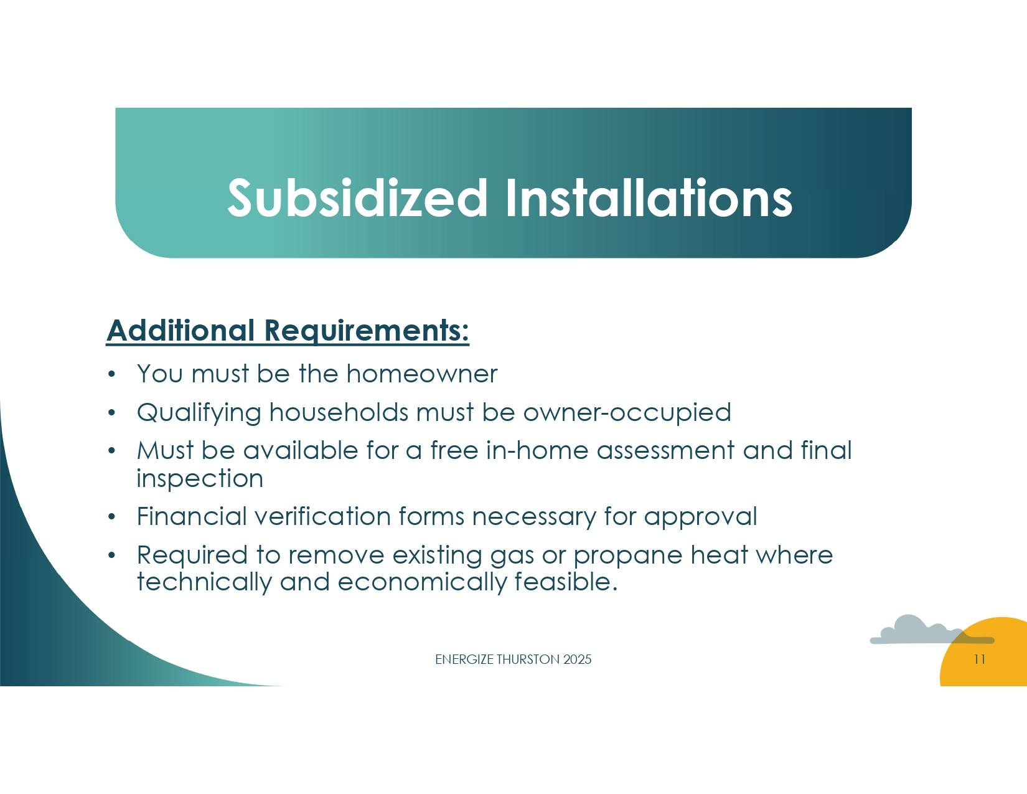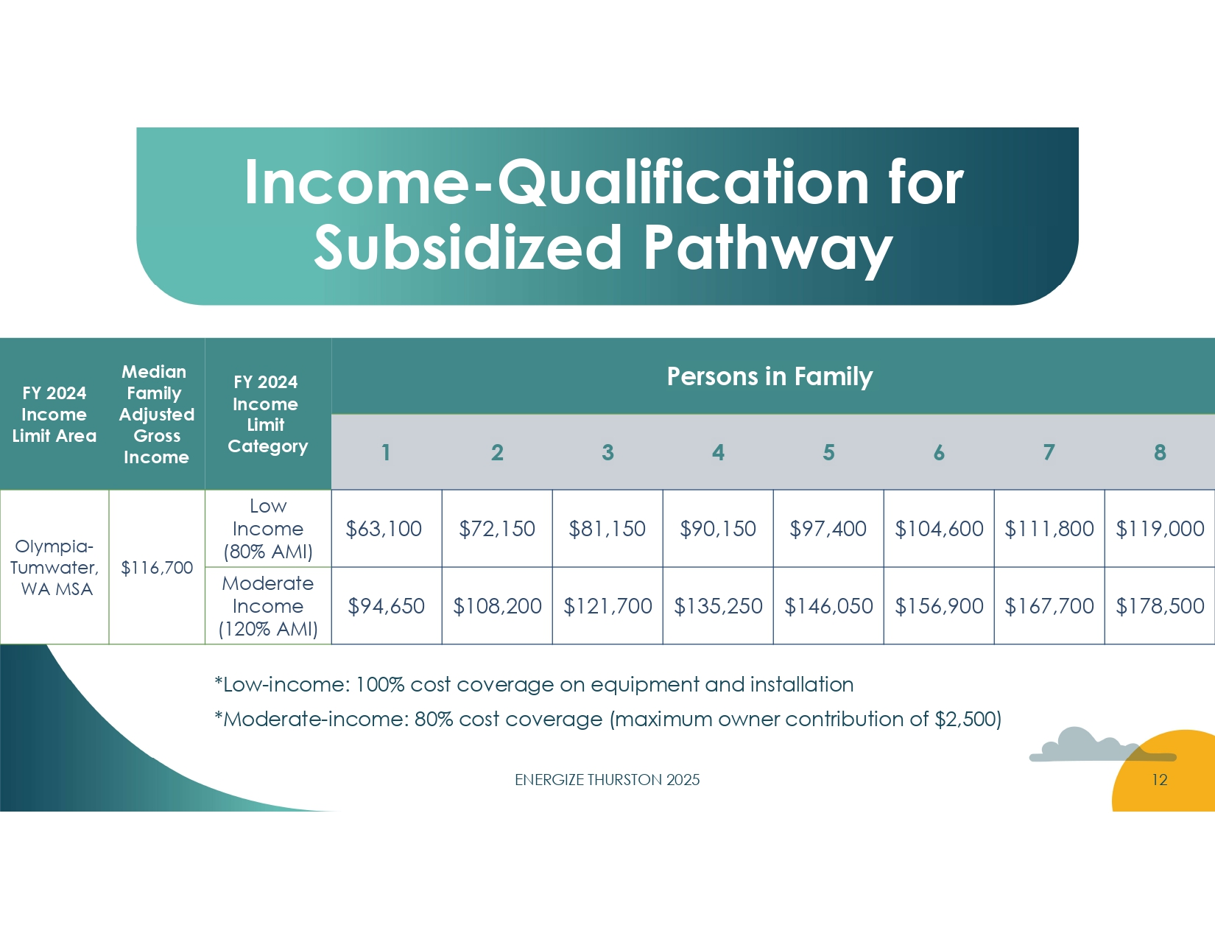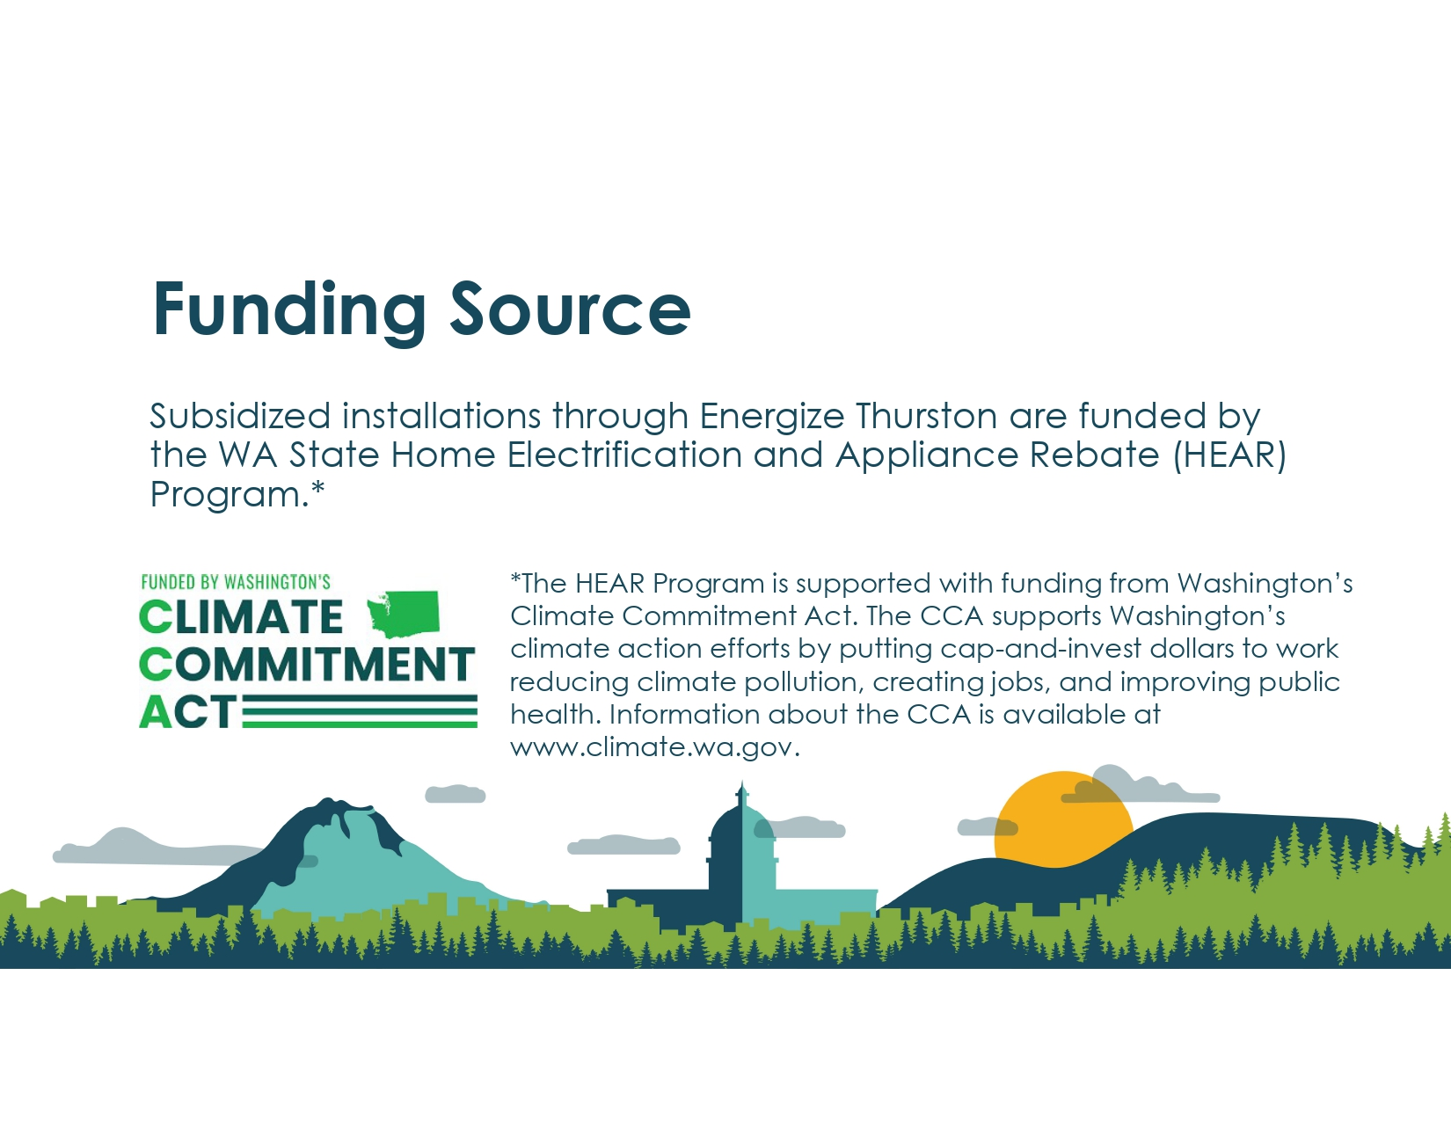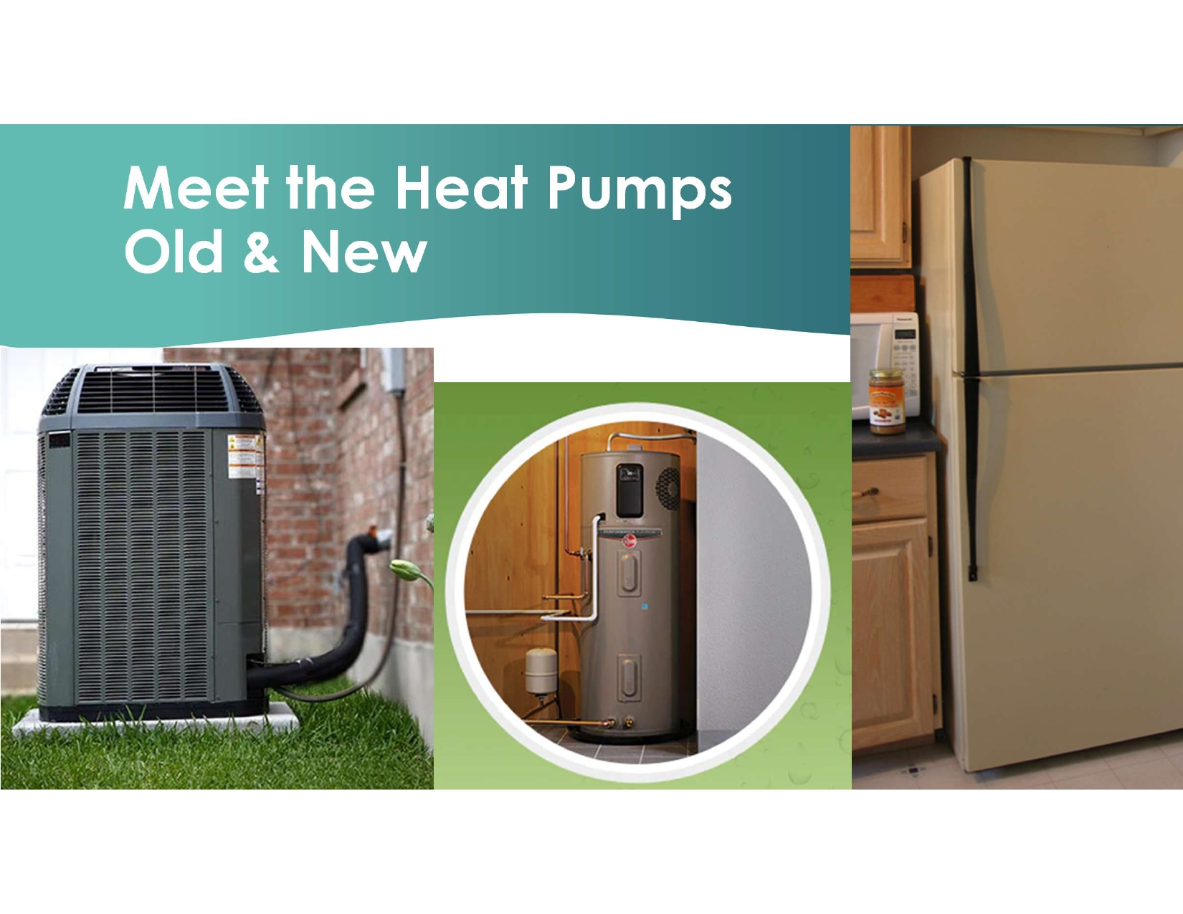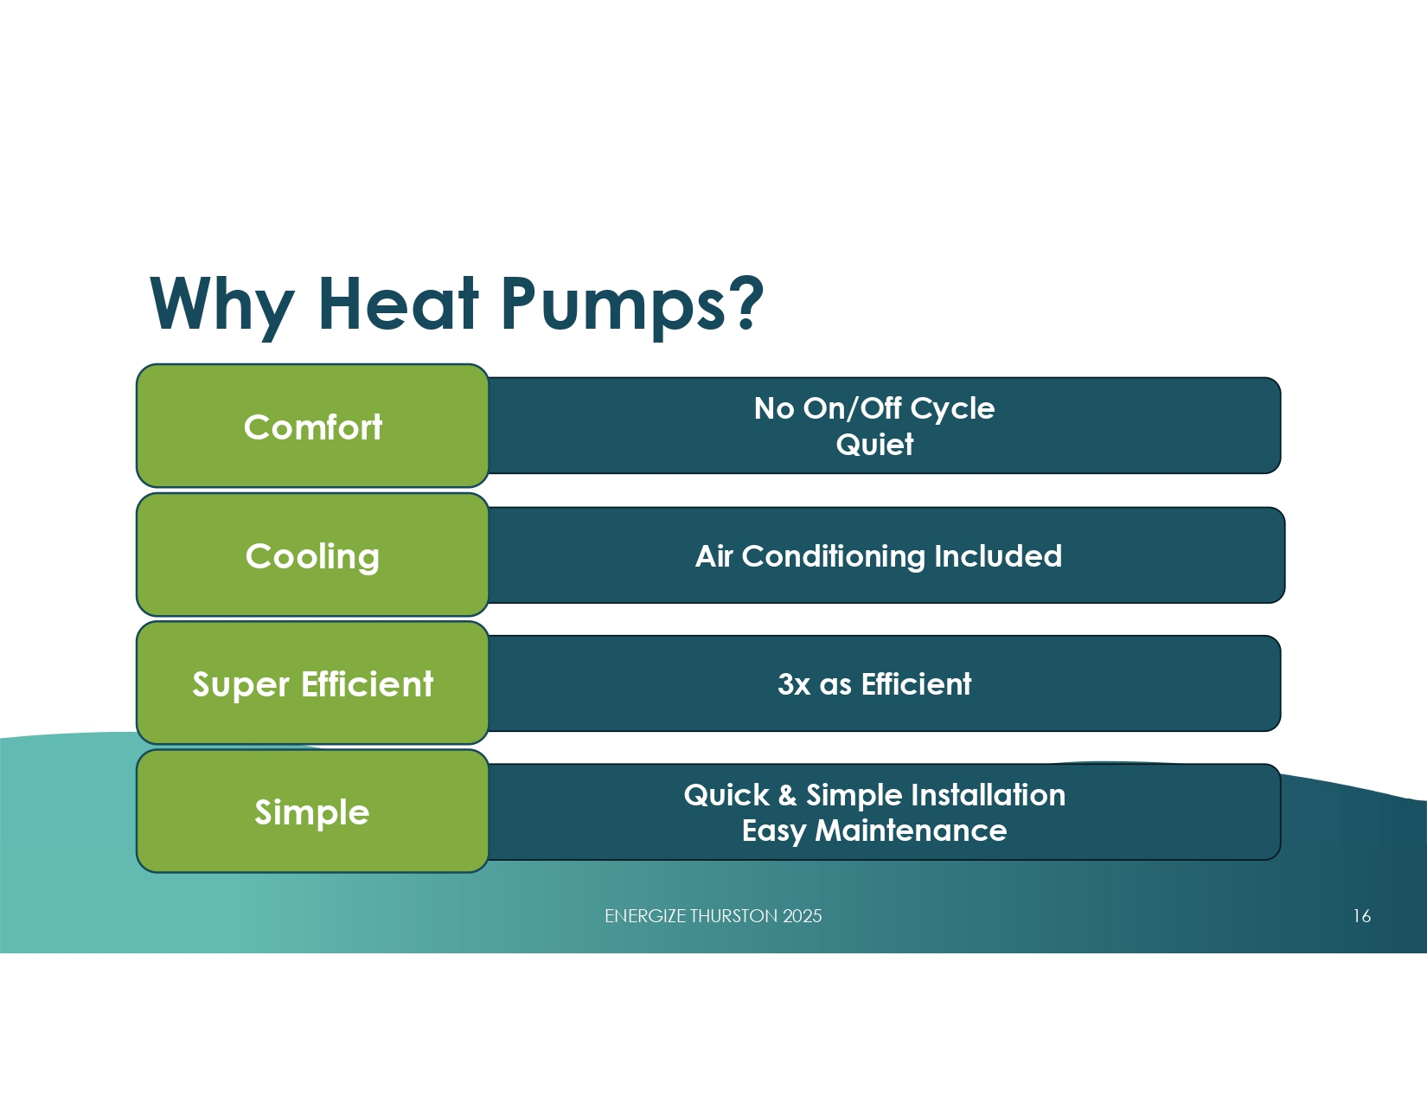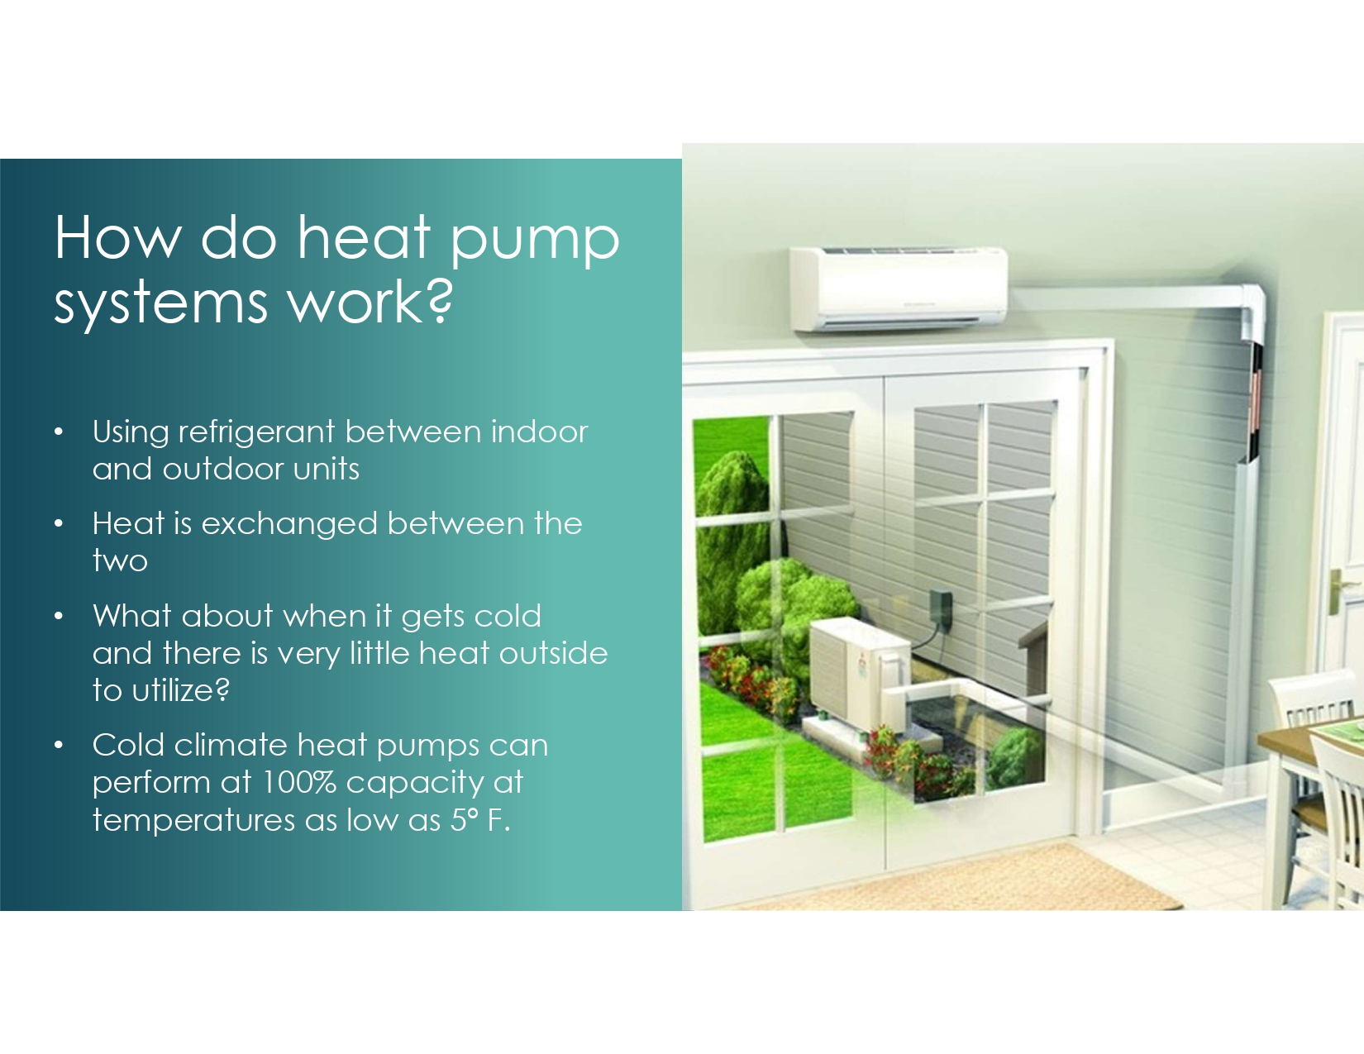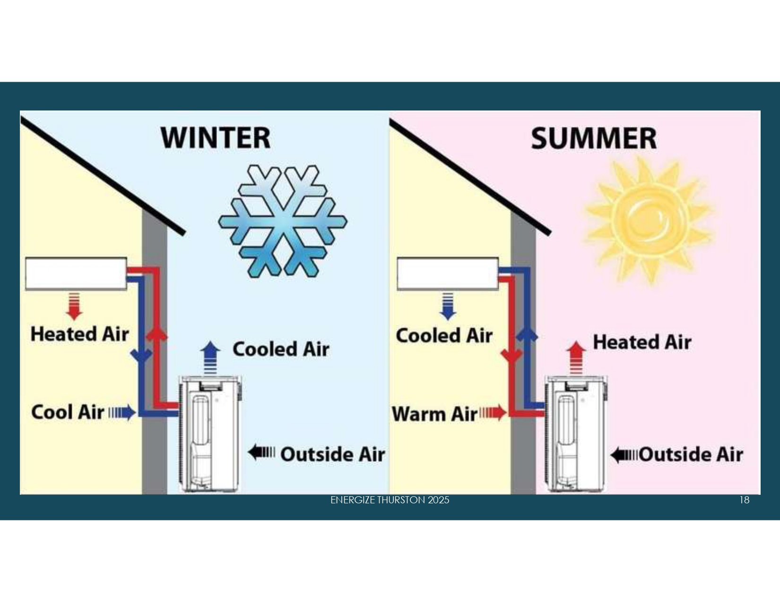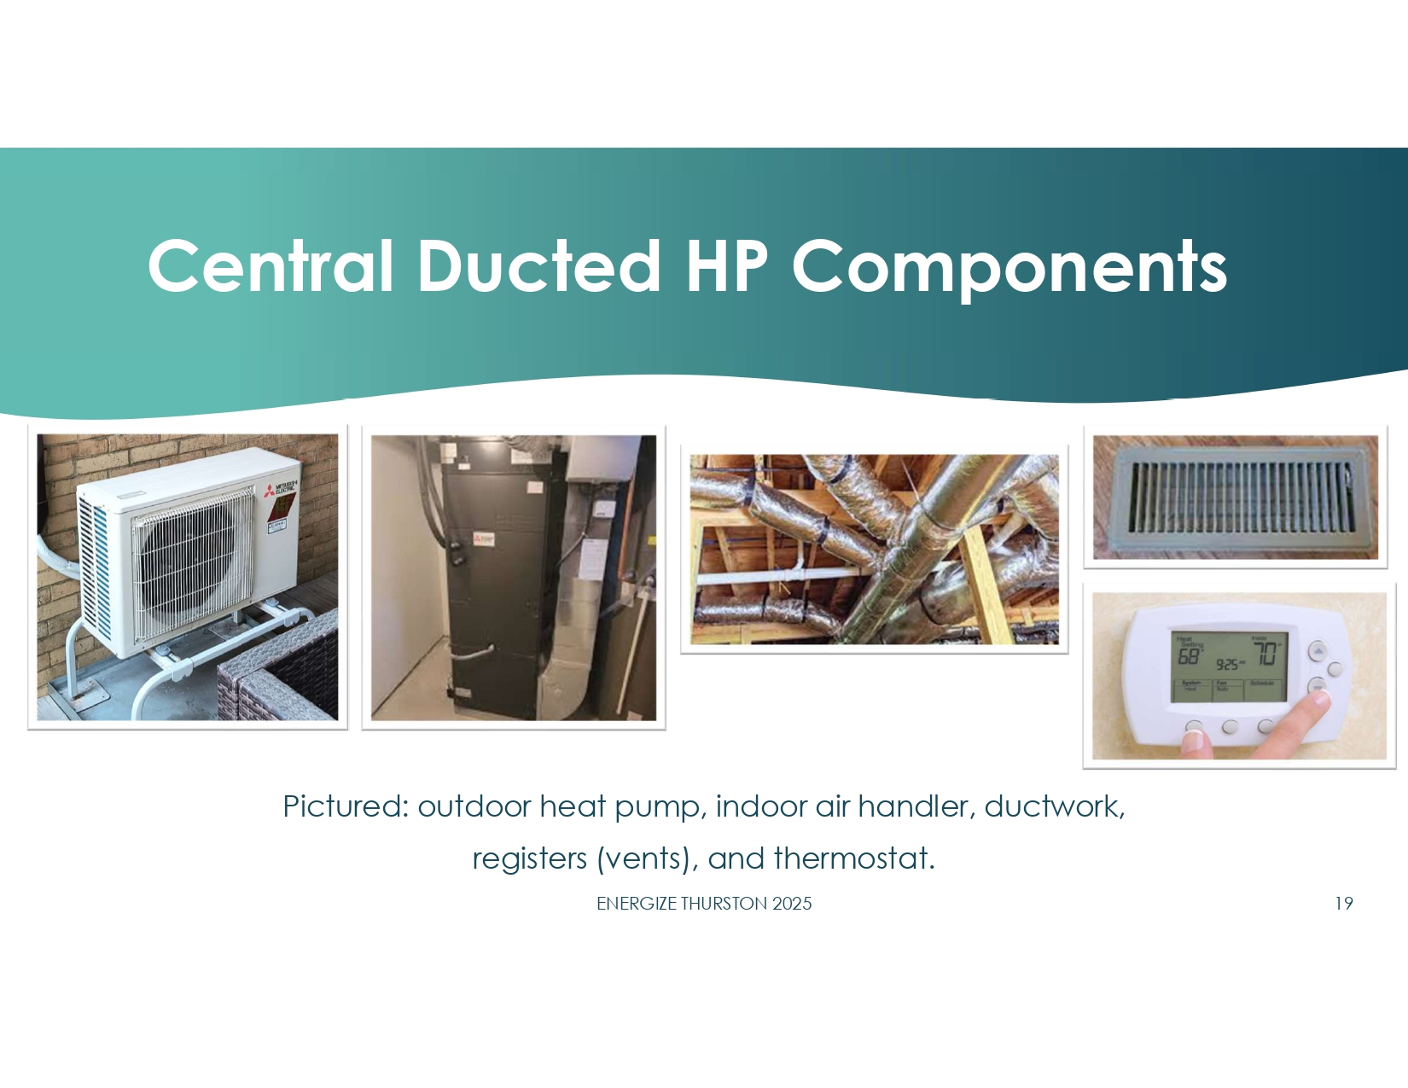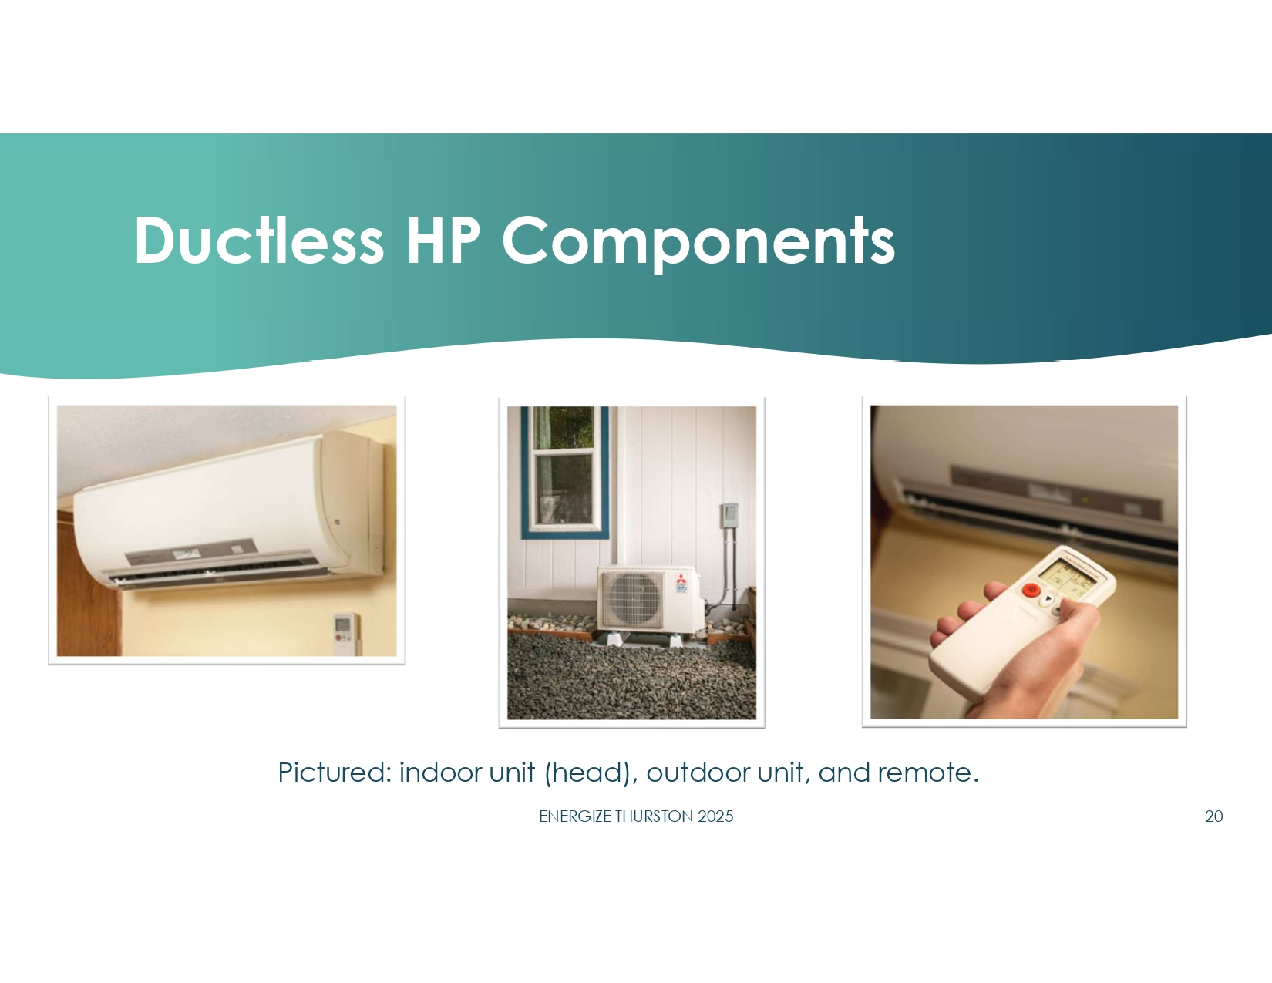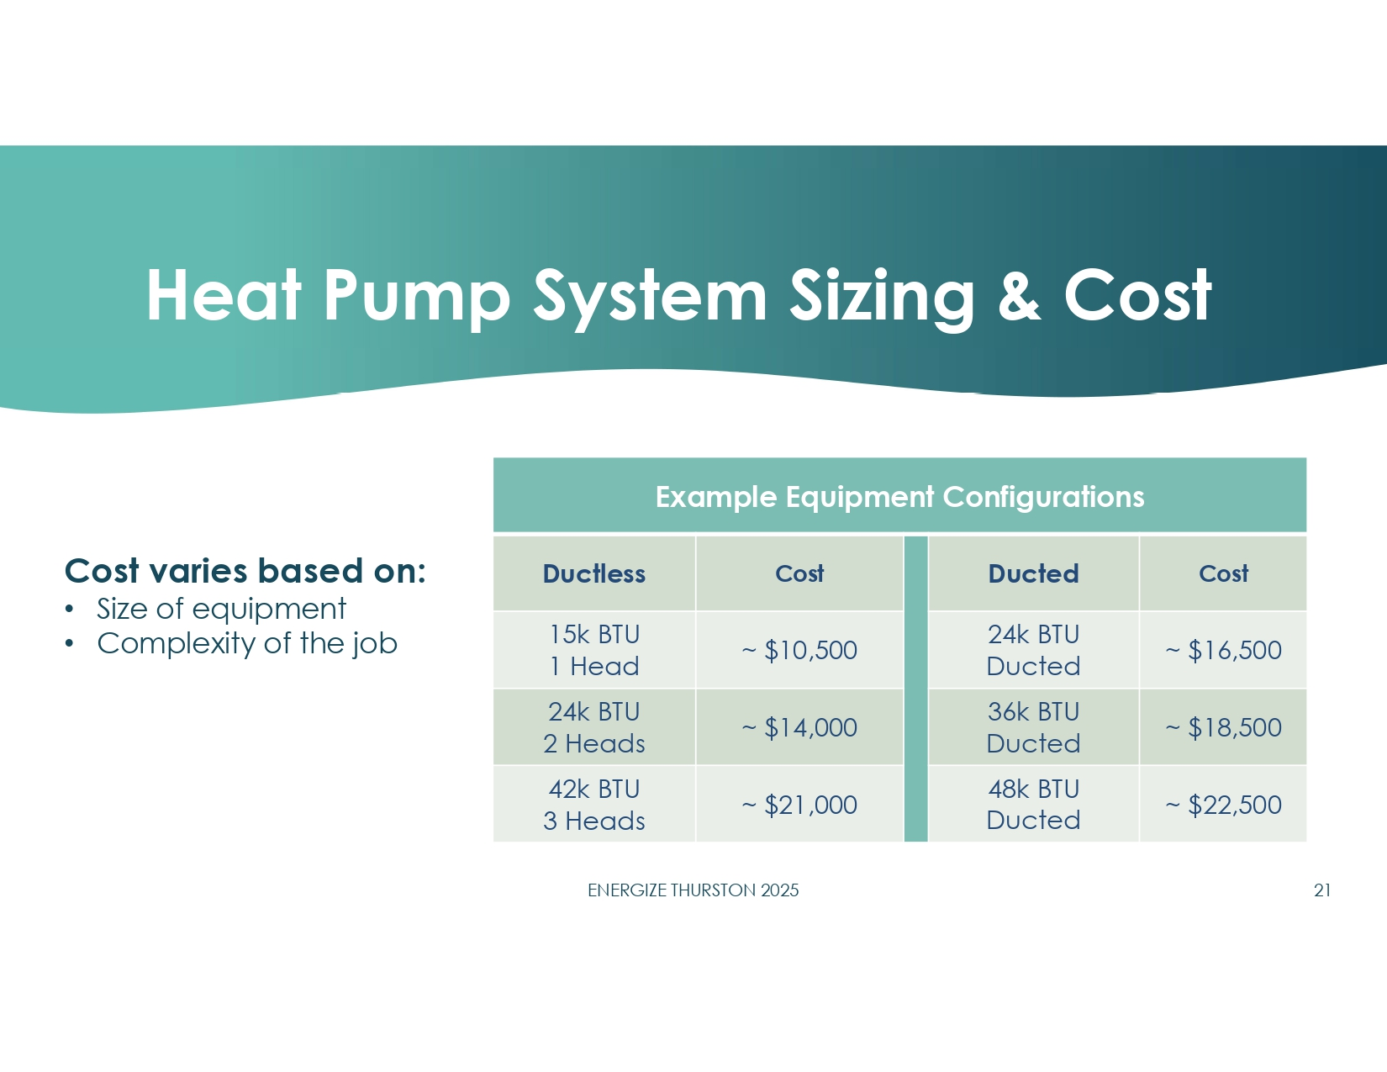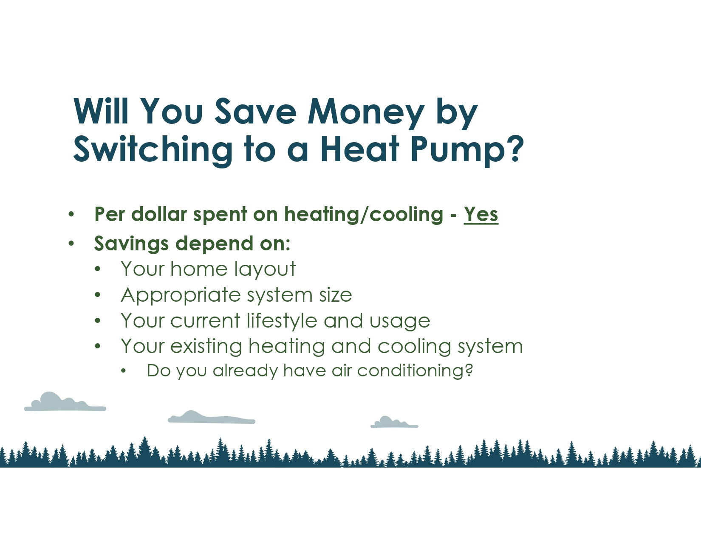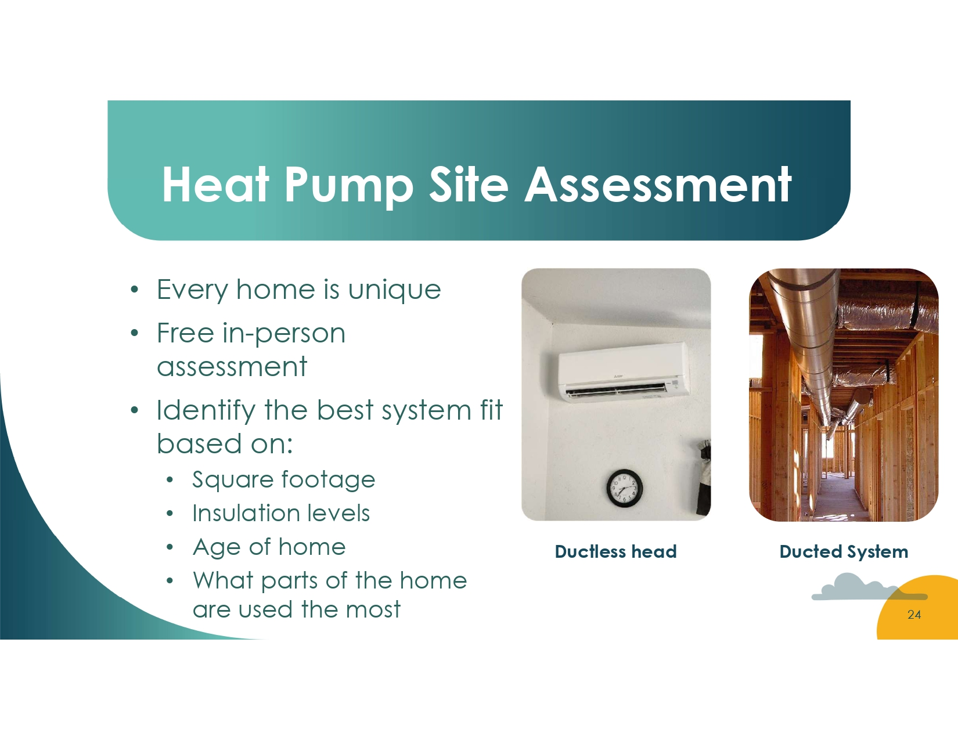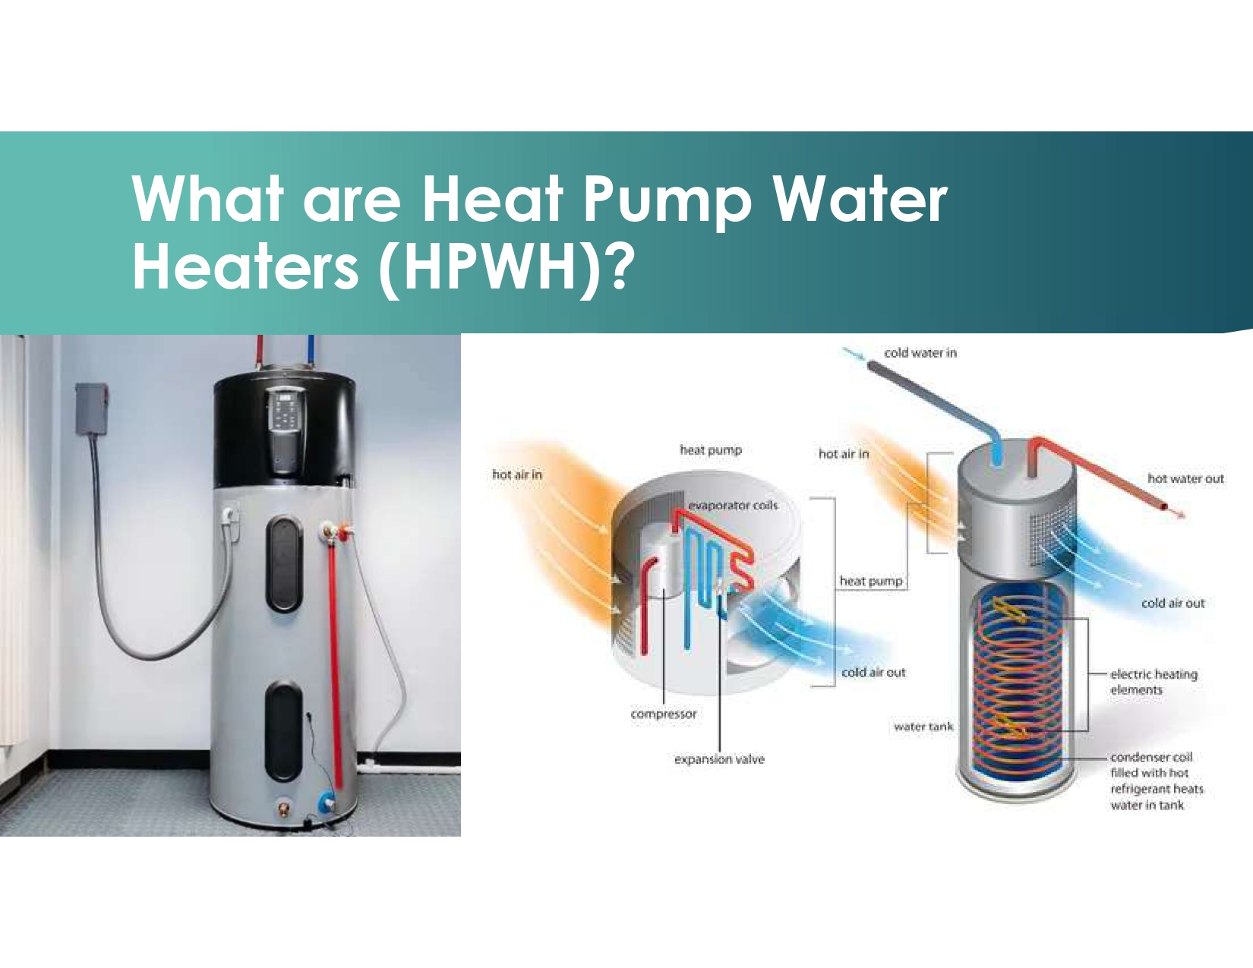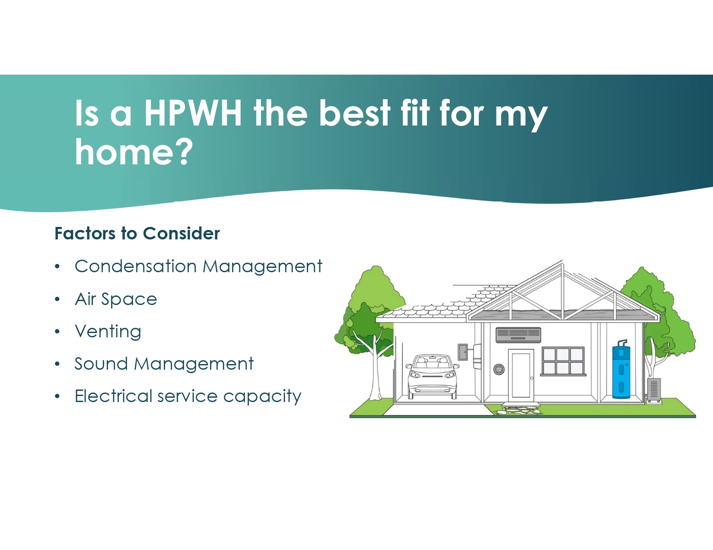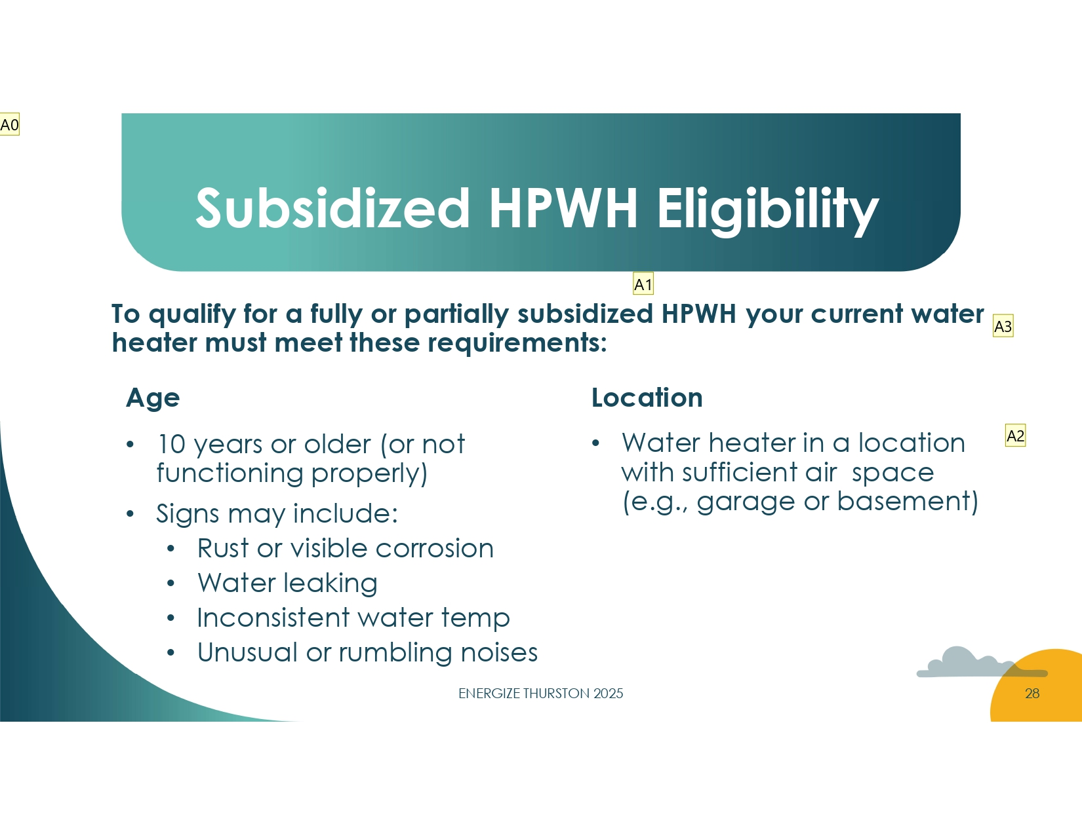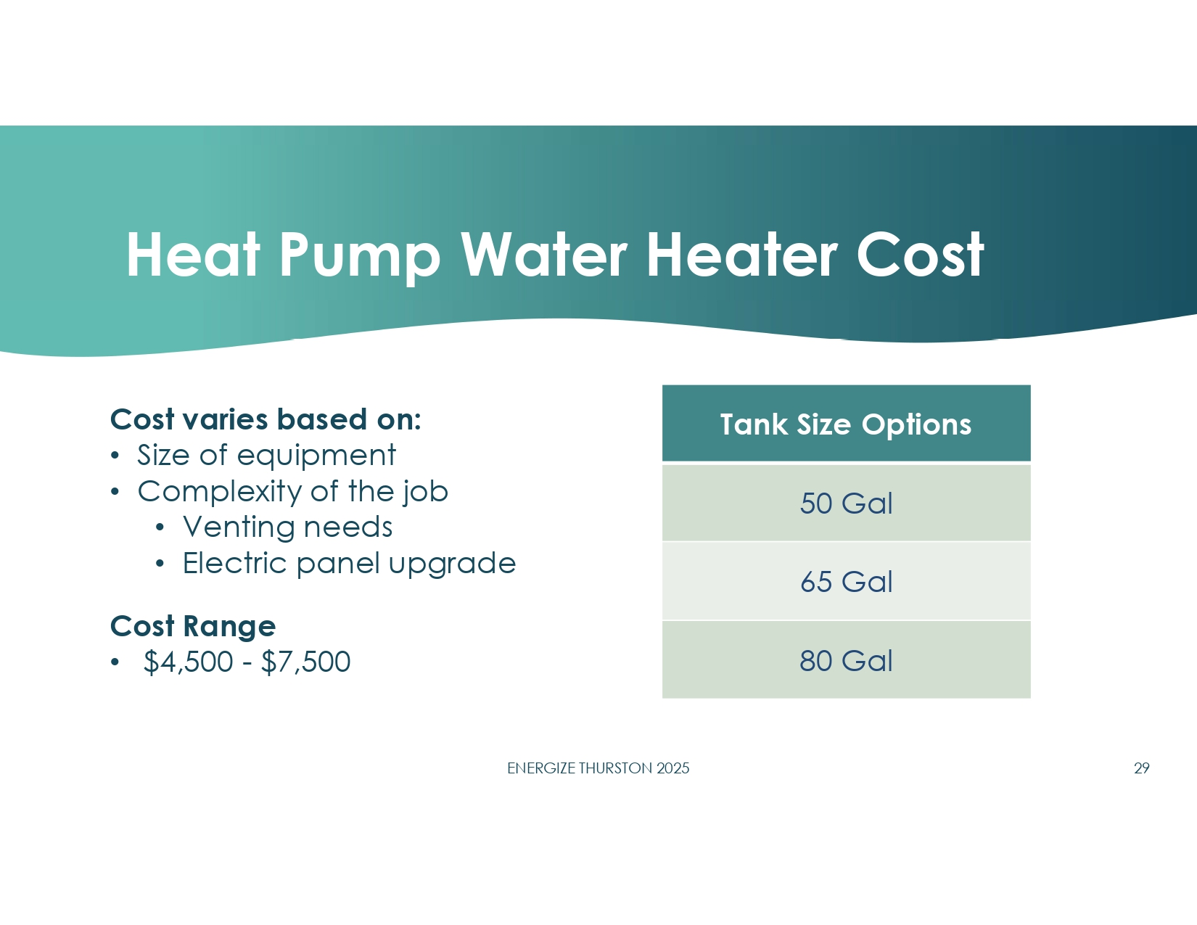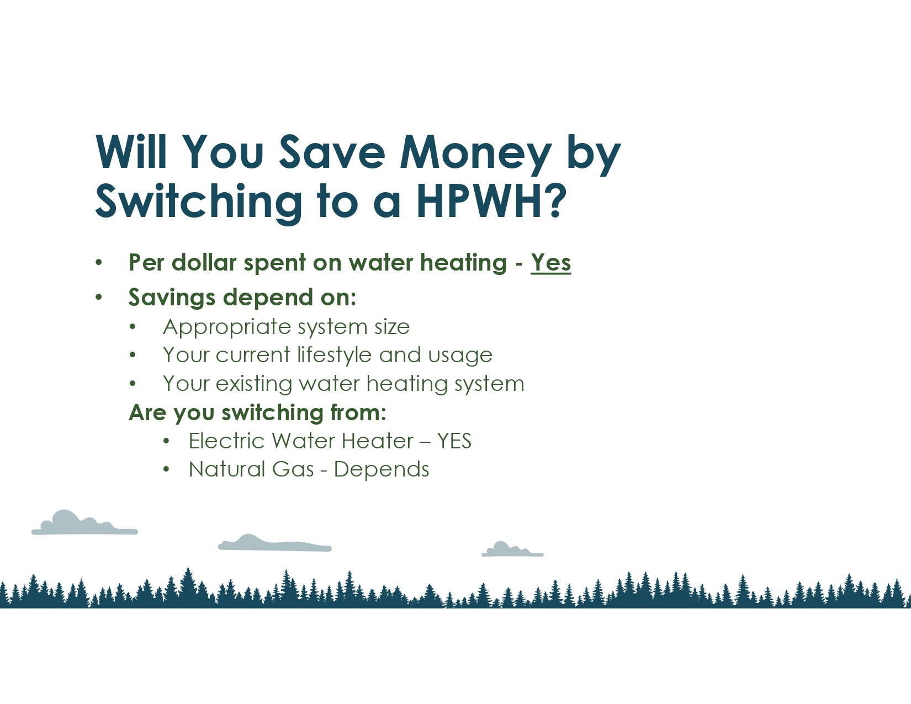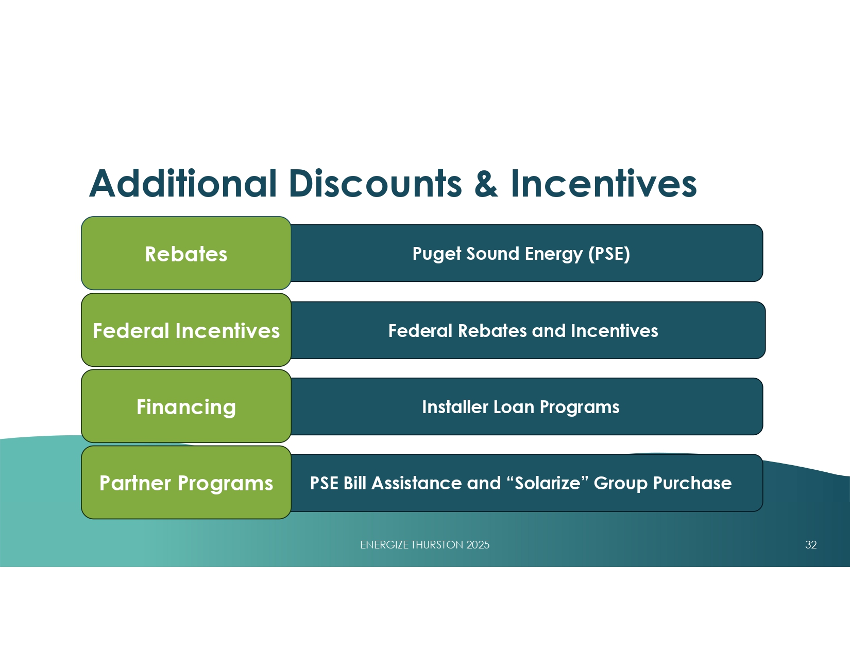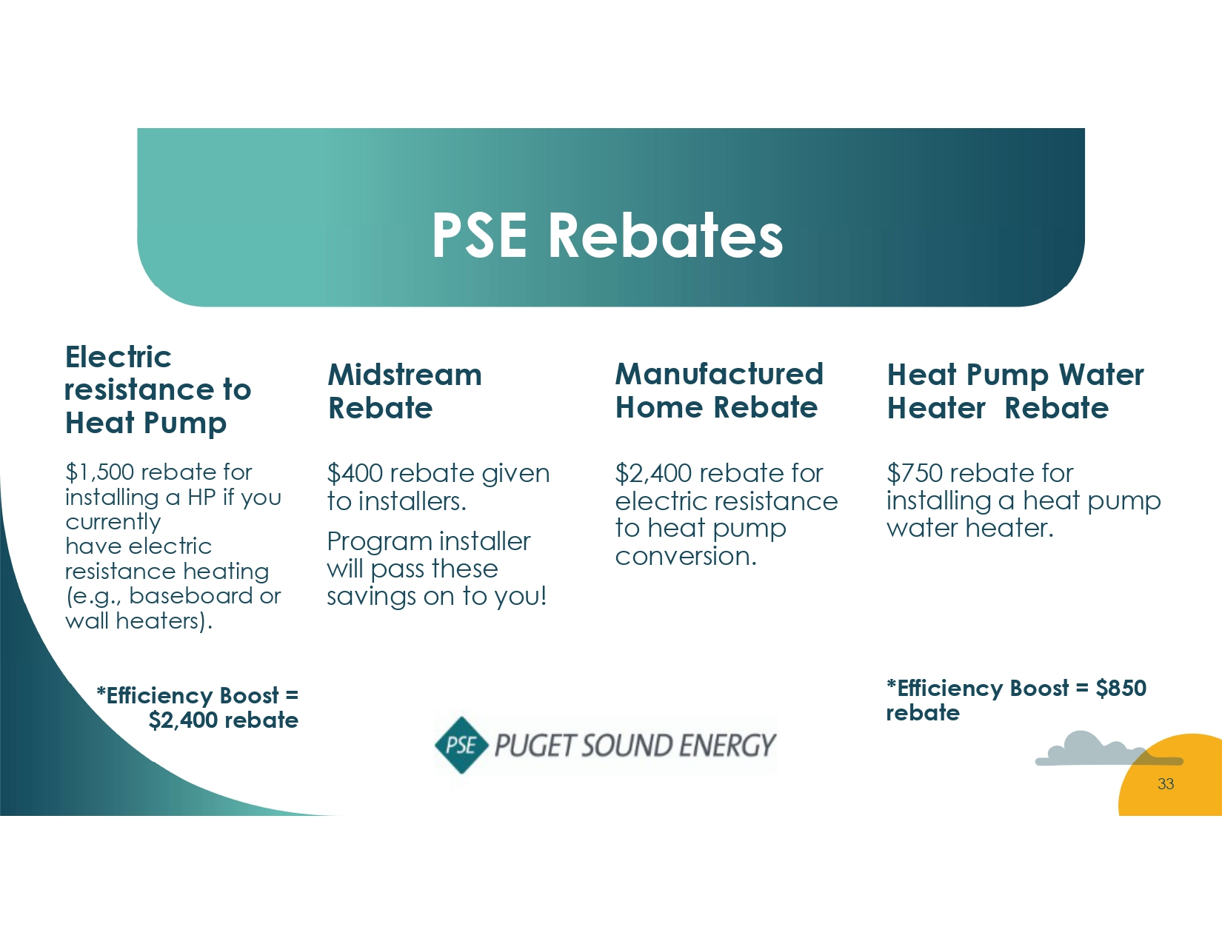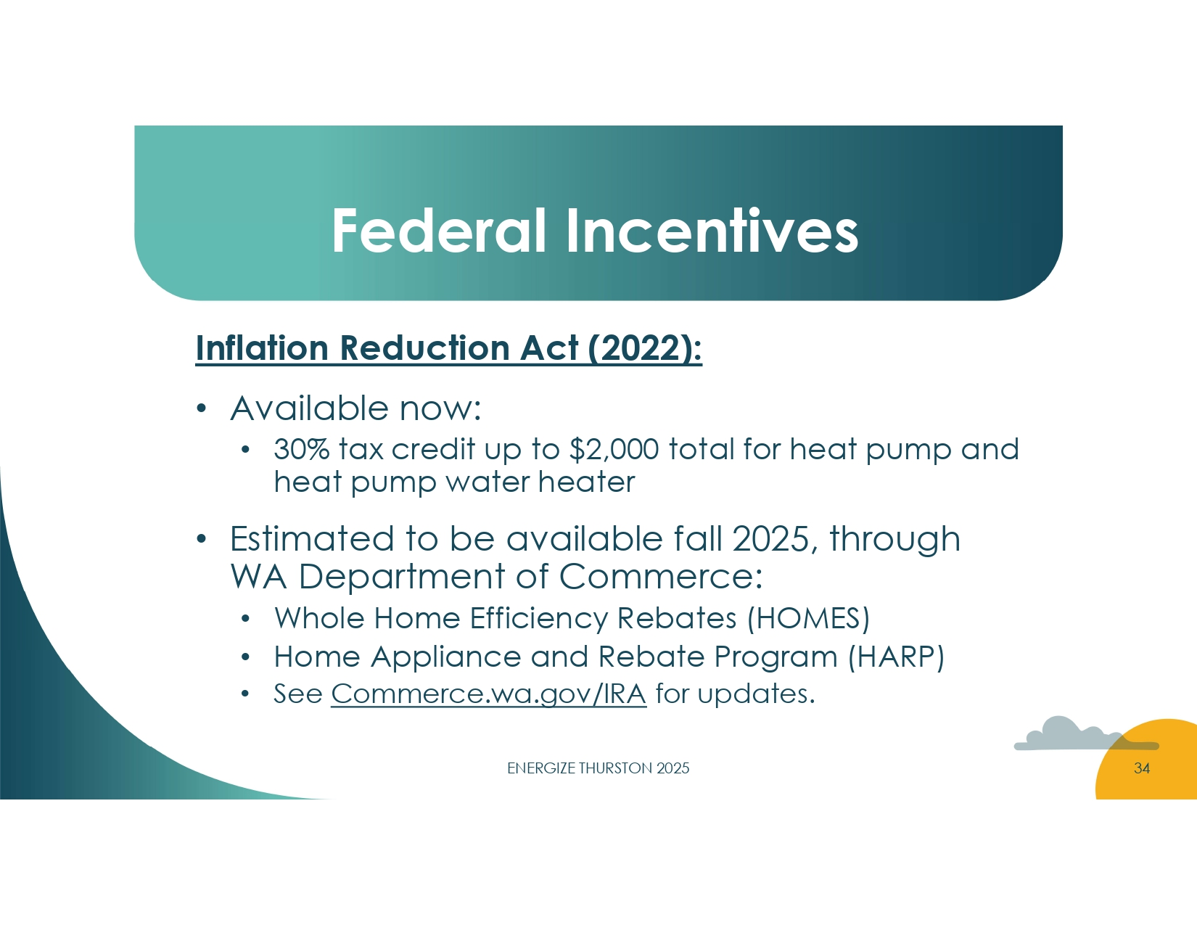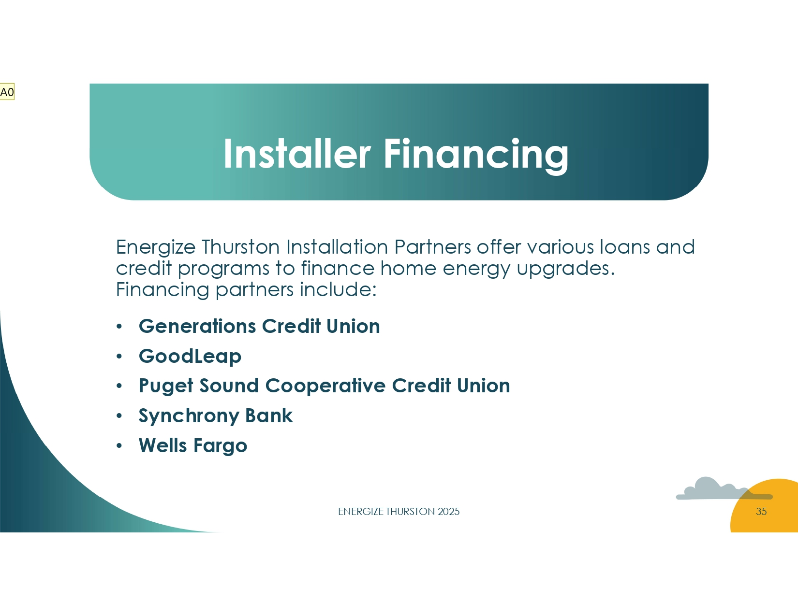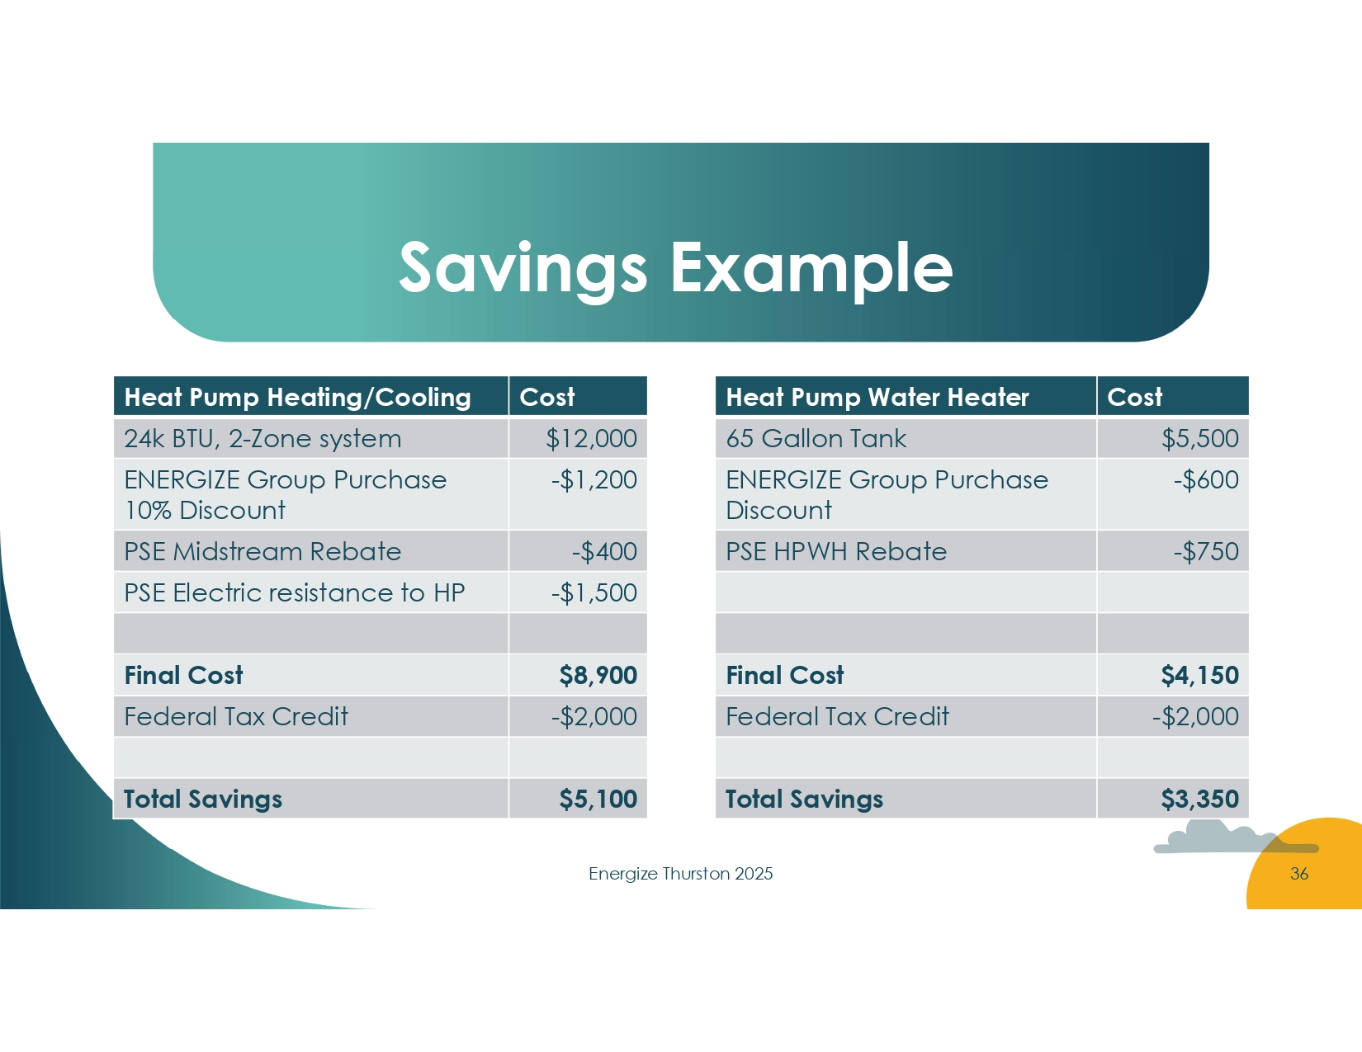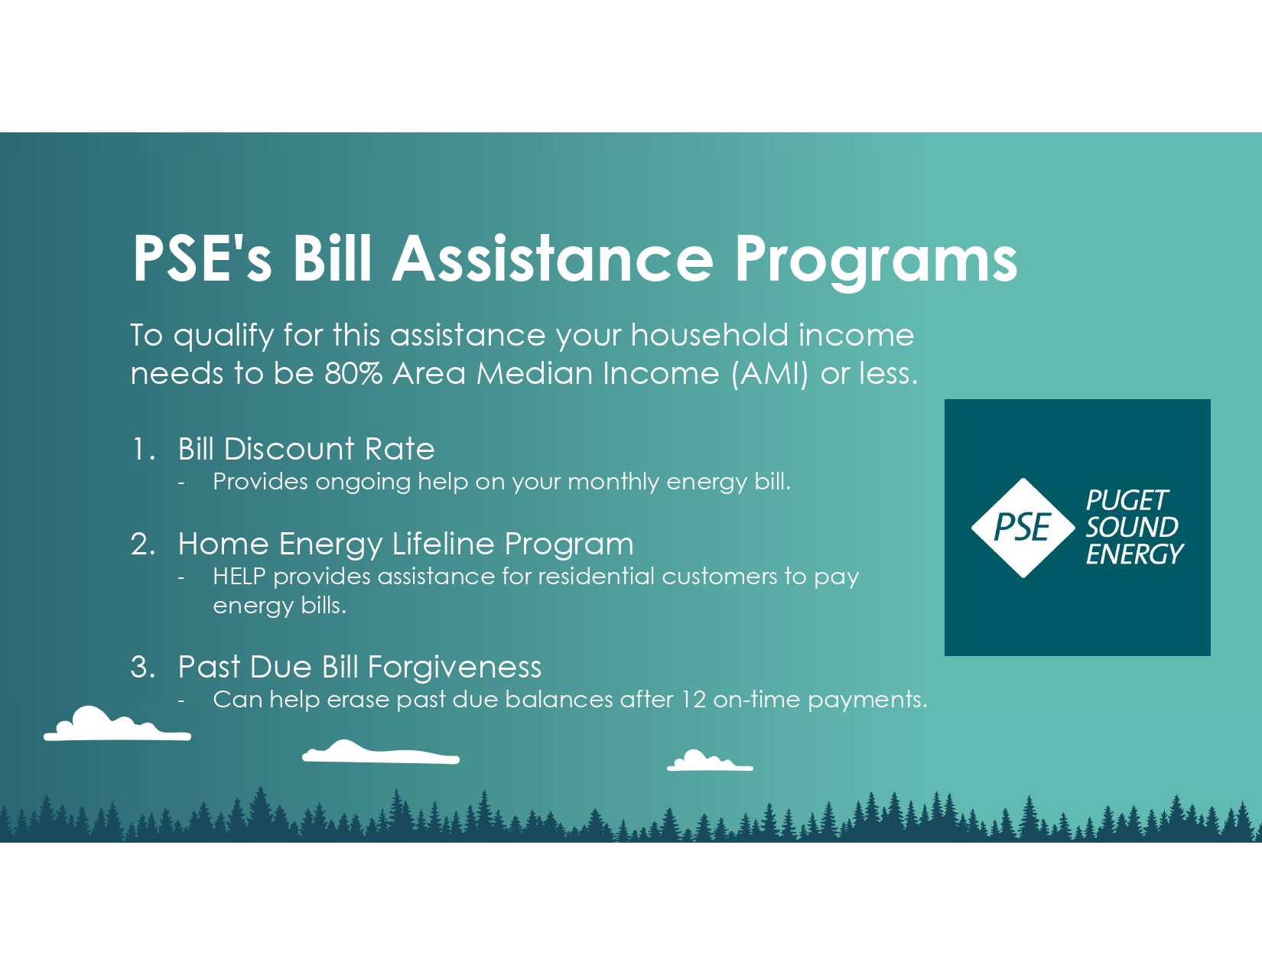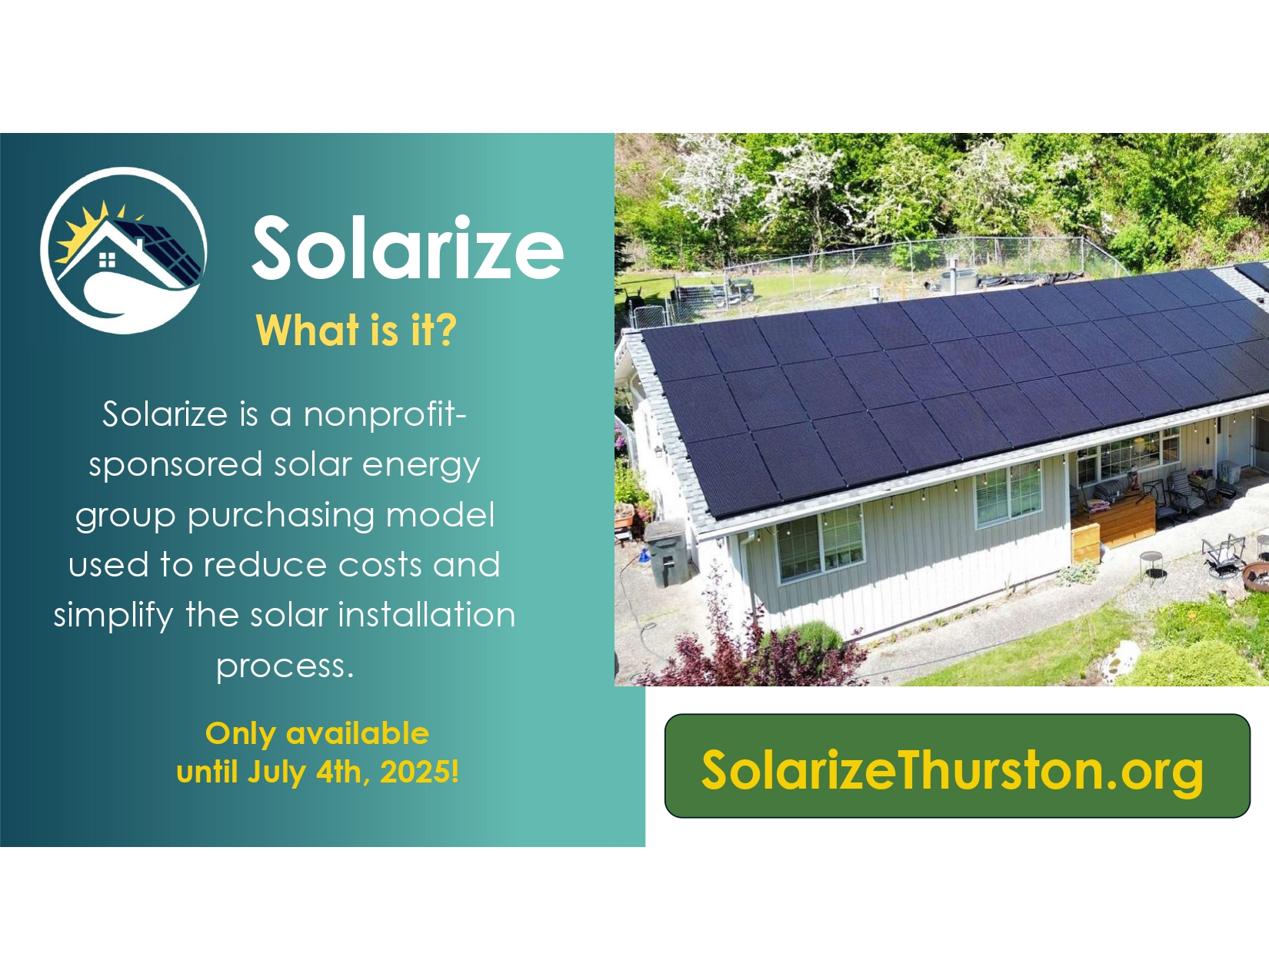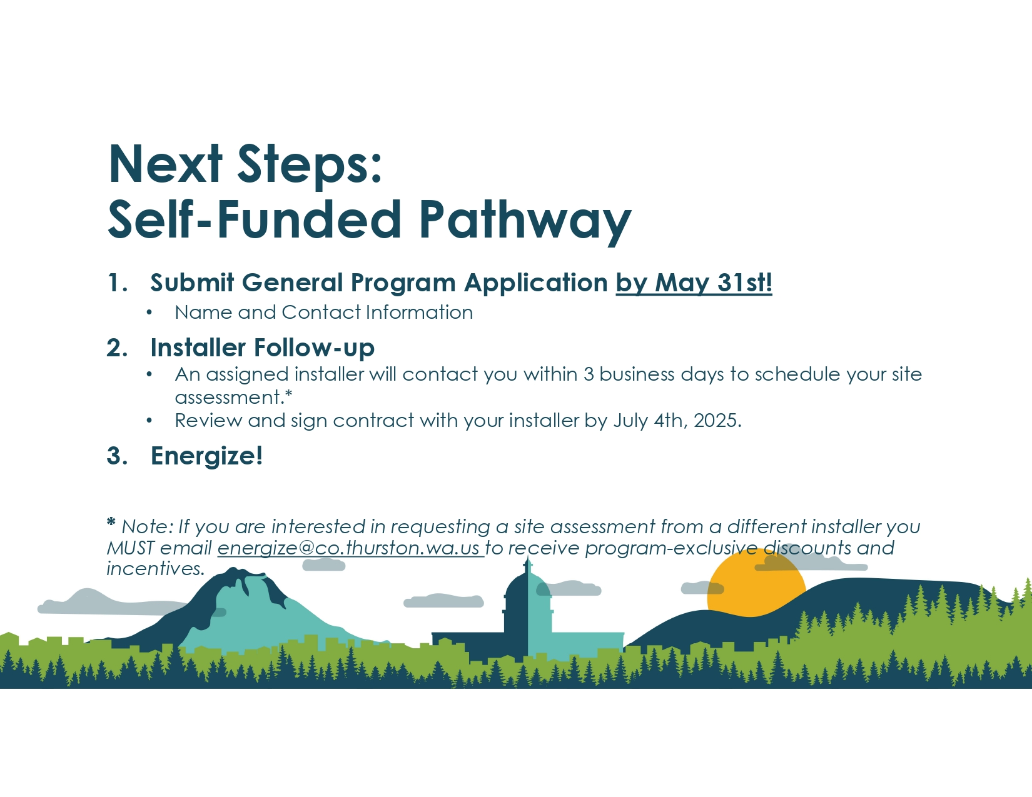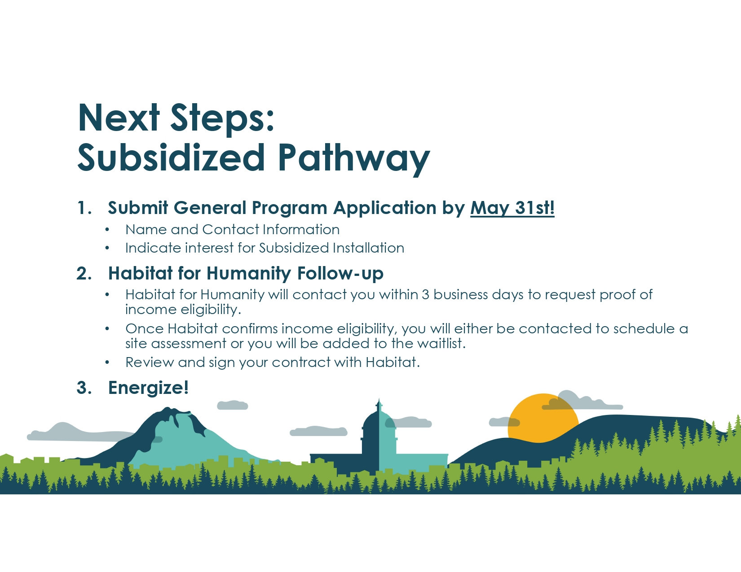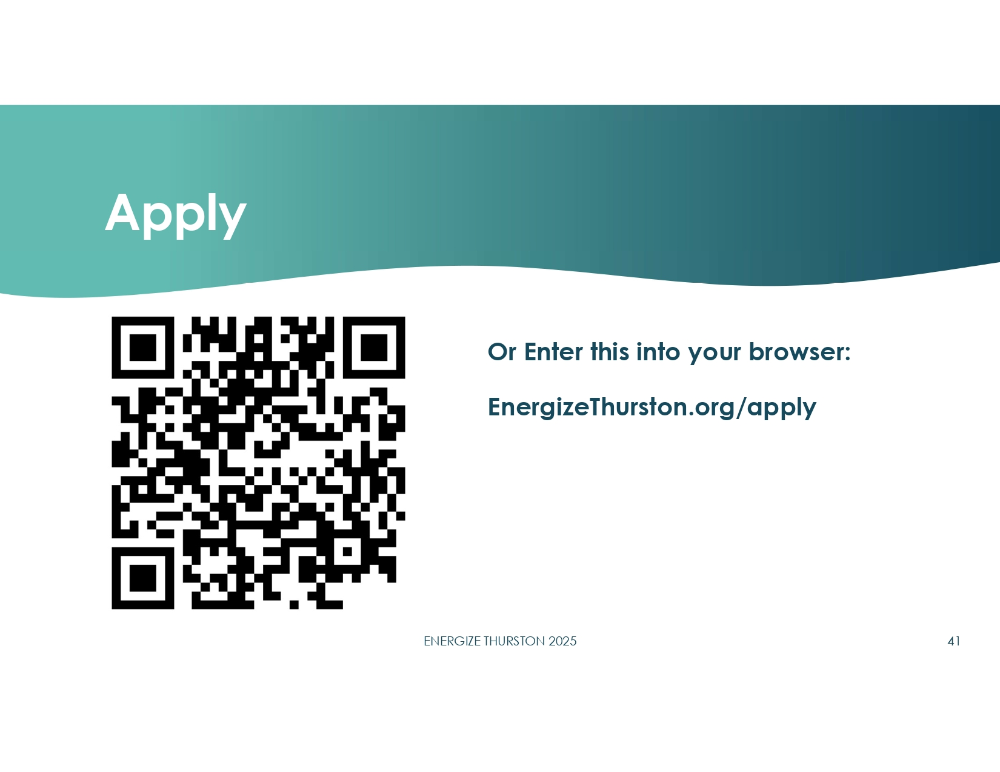

Appendix L –Workshop Series Metrics
Workshop Details | Workshop 1: Tumwater | Workshop 2: Virtual | Workshop 3: Yelm | Workshop 4: Lacey | Workshop 5: Tenino | Workshop 6: Olympia | On-Demand Workshop
Date | March 20th | March 24th | April 7th | April 22nd | May 6th | May 26th | n/a
Time | 6:30pm | 6:30pm | 6:30pm | 6:30pm | 6:30pm | 6:30pm | n/a
Location | Tumwater High School | ZOOM | Yelm Timberland Regional Library | Lacey Timberland Regional Library | Tenino Timberland Regional Library | Olympia Timberland Regional Library | Virtual
Installers Present | Alpine  Resicon  Sunset | All | All | All | Alpine  Resicon  Sunset | Alpine  Sunset | All
Workshop Participants | Workshop 1: Tumwater | Workshop 2: Virtual | Workshop 3: Yelm | Workshop 4: Lacey | Workshop 5: Tenino | Workshop 6: Olympia | On-Demand Workshop
Registrations | 87 | 137 | 31 | 75 | 7 | 64 | 459
Attendees | 68 | 62 | 20 | 49 | 6 | 46 | 270
Leads | 60 | 81 | 10 | 34 | 2 | 22 | 118
Requests for Language Translation | 0 | 0 | 0 | 0 | 0 | 0 | Spanish Subtitles

See section on Summary of Campaign Participation & Installations for explanation of estimation.
Income limits were defined using the Department of Housing and Urban Development (HUD) data. See appendix A for Area Median Income (AMI) chart.
Actualized funding percentage spent on low-and moderate-income pathways can be found in the section Incentives, Rebates, and Financing below.
Nineteen participants were on the Energize Olympia 2024 waitlist and were not required to attend an Energize Thurston workshop or submit a new program application.
The goal for subsidized HPWH installations was developed based on an expectation that all awarded EECBG funding would be received in time for the 2025 campaign. However, only City of Olympia’s EECBG grant was received in 2025; Thurston County and City of Lacey plan to apply their allocations to the 2026 campaign.
The Home Electrification and Appliance Rebates Program is supported with funding from Washington’s Climate Commitment Act. The CCA supports Washington’s climate action efforts by putting cap-and-invest dollars to work reducing climate pollution, creating jobs, and improving public health. Information about the CCA is available at www.climate.wa.gov.
Thurston County and the City of Lacey were each awarded EECBG formula grants in the amounts of $81,040 and $115,460, respectively, but have been delayed in receiving the funds. The cities of Tumwater and Tenino did not meet the population threshold to qualify for this EECBG formula funding.
City of Lacey allocated about 12% of its HEAR grant to the City's existing matching rebate program, and the rest to Energize Thurston.
Associated activities are described in the section Community Outreach and Education below.
The full 2025 Energize Thurston Request for Proposals can be found in Appendix G.
The Energize Thurston 2025 Proposer Interview Questions can be found in Appendix I.
AirGanic, LLC offered this group purchase discount on their equipment prices only. Labor costs were fixed regardless of system size.
Full information on community outreach events can be found in Appendix J.
Workshop Series Metrics can be found in Appendix L.
Results assume effective efficiencies of 100% for electric resistance space heaters; 95% for natural gas, propane, and fuel oil furnaces; and 498% for air conditioners. Results assume air source heat pumps have a season weighted heating efficiency of 290% and season weighted cooling efficiency of 557%. Results assume an effective efficiency of 93% for electric resistance water heaters and 70% for natural gas, propane, and fuel oil water heaters. Results assume a listed energy factor of 385% and effective efficiency of 296% for heat pump water heaters. Results assume a 65‐gallon tank for heat pump water heaters and a 50‐gallon tank otherwise.
Updated statistics as of 1/15/26.
Energize partners have been awarded grants from the Washington State Home Electrification and Appliance Rebate (HEAR) Program and the U.S. Department of Energy’s Energy Efficiency and Conservation Block Grant (EECBG) Program. The HEAR Program is supported with funding from Washington’s Climate Commitment Act. The CCA supports Washington’s climate action efforts by putting cap-and-invest dollars to work reducing climate pollution, creating jobs, and improving public health. Information about the CCA is available at www.climate.wa.gov.
According to YouTube Analytics, approximately 270 viewers watched to the end.

